!
CELEBRATING EASTER WITH TEARS OF LOVE AND CHEERS OF JOY!
Dr. Tesfa G. Gebremedhin West Virginia University,
Historically, it seems evident that the donkey is a blessed domestic animal considering the longest-time of her association with the Lord, Jesus Christ. The donkey together with the other animals met baby Jesus for the first time when He was born in the stable in Bethlehem of Judea. The donkey with the other animals clustered together to keep baby Jesus and mother Mary warm and comfortable in the stable. When baby Jesus was born in the stable, the donkey witnessed the glorious bright star shining in the sky, the smell of incenses, the incarnation of perfect love of the shepherds, and the wise men falling to the ground on their knees in worship and adoration of the grace of Baby Jesus. The donkey was at His service intermittently starting from the day of His birth almost to the day of His crucifixion. She followed baby Jesus in all places through His childhood and later on in His adult life. Mary and baby Jesus rode on the back of the donkey led by Joseph so many miles across the relentless heat of the desert from Nazareth to and from Egypt. They lived all together for three and half years in Egypt to escape from the wrath of King Herod who tried to have baby Jesus killed. The donkey never missed the opportunity to serve the Lord in many places, particularly in Jerusalem. She had the divine opportunity to carry Jesus when He made His majestic entrance and glorious arrival into Jerusalem (as shown below).
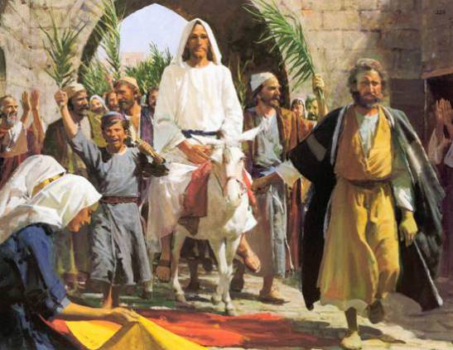
Jesus was always very kind and gentle to the donkey. He never laid His hand on the humble donkey, instead he thanked the donkey by tapping or patting gently on the right side of her neck. The donkey species is usually and wrongly underrated, downgraded, mistreated and disrespected by many of us, It is commonly observed in our cultural practices that the word ‘donkey’ (or ‘Jack Ass’ in other cultures) is negatively used to abuse or scold the character of a person who behaves stupid, idiot, ignorant, or greedy. However, Jesus blessed the donkey for her humble service and unconditional love and sincere compassion. Jesus chose to ride on the back of the donkey to Jerusalem in order to enlighten and teach us the essence of humility, kindness and simplicity by the humble and loyal service of the donkey to Him and to the human race. The donkey family in general has given unswerving service to the human race for over 5000 years in fetching water and fire woods to the farm families, carrying farm products to the market, and providing many other domestic services (as shown below). Though the donkey has provided staunched service for over 30 years to the struggle for the independence of Eritrea, she didn’t receive due respect, honor and recognition unlike her cousin Camel, whose portrait is embedded in the emblem of the state of Eritrea.
Easter is the celebration and jubilation of the restoration of our broken lives through the crucifixion and resurrection of the Lord Jesus Christ. It reflects the mystery of the Holy Spirit, the meaning of revelation, the defeat of temptation, the symbol of devotion, the triumph of dedication, the tribute of salvation, and the legacy of self-sacrificing for the very good of others. Too often we underestimate or fail to understand the power of a friendly greeting, a beautiful smile, a kind word, a listening ear, an honest compliment, or the smallest act of caring. These are some of the most sincere form of respect to a fellow human being and all have the potential to turn the life of a person around. The smallest gesture of doing good thing in our community and religious institution can bring great hope and aspiration to our younger generation. We need to uplift their spirit and raise their hope to be successful in life. We need to motivate and inspire them so that their efforts and potential can blossom like the flowers of spring. We need to bring hope to our children by teaching them to believe that no matter what storms are raging in this troubled world, under any painful tribulation, even in the darkest and tragic circumstances and horrific situations, through the glory and power of the Almighty God, love and peace can bloom and unfold in ways we never can imagine and understand. Despite the persistent turmoil and hostile environment we may encounter in our current cluttered and confused world, there is always a light shining bright at the end of the dark tunnel. Our younger generation should be taught to turn the pages of life over without any despair because page is loaded with divine gifts and blessings from God. As St. Augustine said, “God loves each of us as if there were only one of us.” Thus, your friend and brother, Dr. Tesfa G. Gebremedhin with his dear wife, Meheret Ghebremeskel and his beautiful children and grandchildren, feel great honor and privilege to wish you all to have Easter Holiday full of Joy and Happiness.


