Eritrean Association in Greater Seattle
1528 Valentine Place
Seattle, Washington
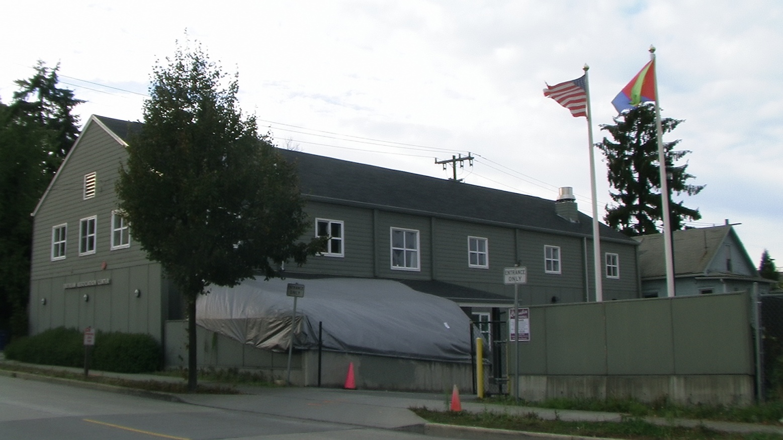
The Eritrean Association in Greater Seattle
Invites You to Our New Year’s Eve Party

Program: Cultural Show by Talented Seattle Musicians

Date/Time: Thursday, December 31 2009, starting at 6:00 PM

Place: Eritrean Association in Greater Seattle
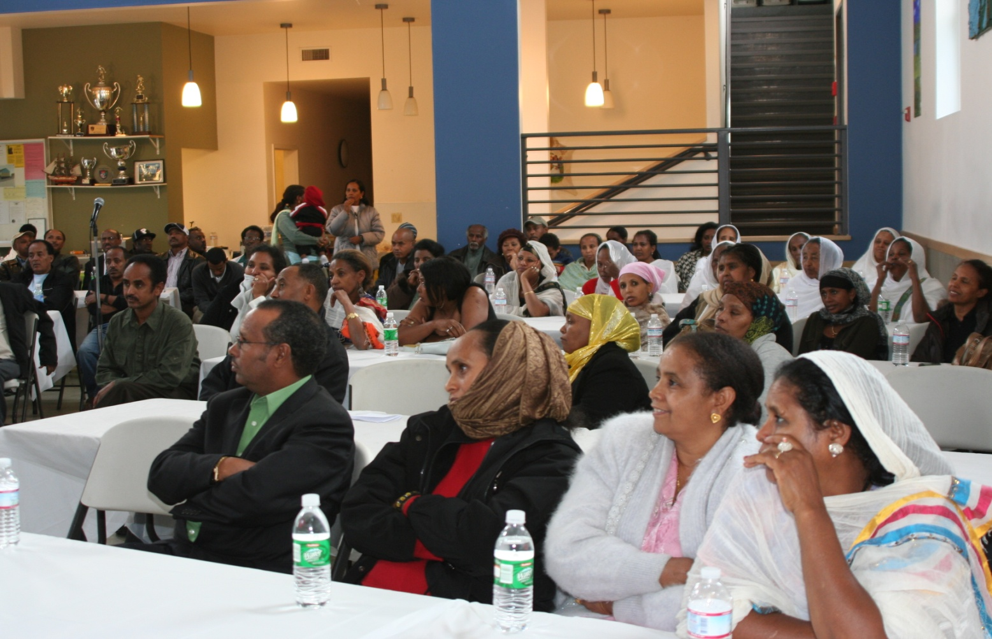
1528 Valentine Place, Seattle

ማሕበረኮም ኤርትራ ስያትልን ከባቢኣን፡
ሓዲሽ ዓመት ሓቢርና ንምብዓል፡ዓቢ ናይ ባህሊ ምሸት፡ በቶም ወናማት ደረፍትን ሙዚቀኛታትን ስያትል ዝተሰነየ ኣዳልዩ ስለ ዘሎ፡ ንኹሎም ፈተውቱን ተሓባበርቱን ብኽብሪ እዕድም.

እዚ ናይ ባህሊ ምሸትዚ ፡ ነቲ ማሕበረኮም ንምስፋሕ ተታሓሒዝናዮ ዘሎና ዕማም ሓድሽ ህንጻ ንምስራሕ ዝውዕል እዩ።

ብደሓን ምጹ
ማሕበረኮም ኤርትራ ስያትልን ከባቢኣን

