Red Sea Cargo Agency LLC

Big Discount
We have reduced the shipping price from $175 to $150 and the cost of the Plastic Barrel from $35 to $20

With Red Sea Cargo you can ship your household goods, groceries, and all other consumer products to Eritrea at the lowest price ever!

If you have a plan to visit the DC, MD or VA area, then bring all your goods. The Cargo is sailing Nov 18
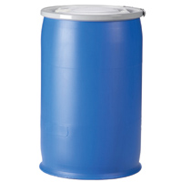

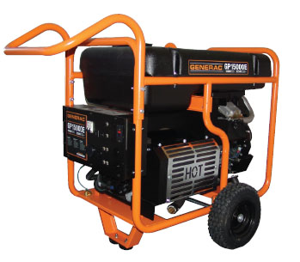
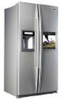
$175 $175 $200

Now $150 Now $150 Now $150

400 lb Plastic Barrel BOX 300 lbs Refrigerator $200 Power Generator $150

Bicycle $50 only, All size Mattress $125, Doors, windows $ 125, Tires $25 each, Solar panel $150, 42" TV $135
To make it cost effective and convenient for you, we are making every effort to reach our customers in various locations of the United States. If you are located in the East coast such as New York, Philadelphia, Delaware, Ohio, Pennsylvania, North Carolina, South Carolina, Tennessee, Georgia, Connecticut, and even in other states, Red Sea Cargo will make all the necessary arrangement for 30 or more Items. Red Sea will pay for pickup and delivery to Washington DC at no cost to you. You will pay only $150 from Baltimore to Asmara.

Our new service:
- You can purchase goods and products in any place and have the company or Store deliver it to our warehouse.
- For small fee, we can do shopping for you in our area if you provide us with a specific itemized listing and we will pack and ship it to Eritrea on your behalf.
- For more Information, Please call Yonas @240-381-4817 All payment must be payable to RED SEA CARGO LLC

