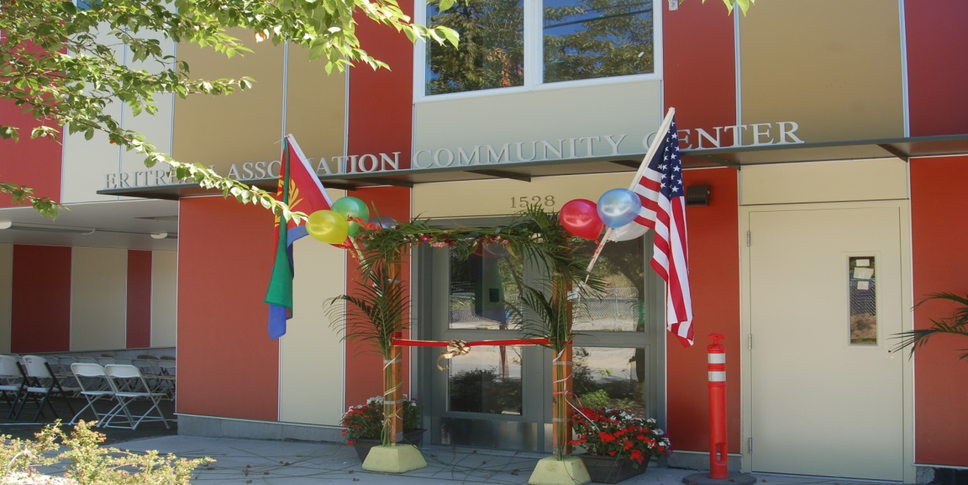
Report of Grand Opening Ceremony of the Eritrean Association Center Expansion Project: August 25, 2012

On a beautiful summer afternoon on August 25, 2012 over 400 members, friends and supporters of the Eritrean Association in Greater Seattle were gathered in the outdoor space of our newly completed expansion project. Well before the official start of the opening ceremonies the hosts were busy preparing for this special occasion. Some had taken days off from their jobs to volunteer their time to make this a successful event. And a success it was. This is a culmination of five years of hard work and tenacity of the members led by the Boards of Directors and the core group of the Steering Committee charged to lead the effort.

After confirming the arrival of the Mayor of Seattle at about 3:15 PM, the MC, Mrs. Workinesh Tianen opened the event by welcoming and thanking those who graced us with their presence. Ms. Naitinti Tesfamicael sang the National Anthem of the United States followed by a rendition of the Eritrean National Anthem by our own community youth. The same group of youngsters treated the audience with an energetic cultural dance.

Mr. Isaac Araya, the president of the Board and a member of the Steering Committee, gave a summary of the ups and downs, trials and tribulations and eventual triumph of this worthy achievement in the life of the Eritrean Association in the past long five years. He recounted the initial hopeful take off of fundraising activities in 2007 with early grants from the City of Seattle Department of Neighborhoods and the Gates Foundation, the Boeing Employees Community Fund, The US Department of Urban Development and smaller grants from private foundations. Members and friends of the Eritrean Association were also able to contribute during this early phase. Mr. Araya pointed out after this initial flurry of fundraising activity which managed to reach $1.1 million by the summer of 2008, all of a sudden everything came to a stand still. The Great Global Recession of Autumn 2008 had reached even our modest project. It was a time of desperation for us individually and collectively, he reiterated. Every promise made became undone; every door we knocked on was shuttered in our face. The US Congressional Appropriations Bill, which had included a substantial grant for our project, got pulled down for good. This was followed by a threat from the Washington State Legislature to re-purpose the already approved award from the Building Communities Fund for other State priorities. It is during this time members of the Steering Committee learned a new skill, lobbying the movers and shakers in Olympia and were able to successfully restore the grant! As well, the Block Grant from the City of Seattle Department of Human Services was on shaky ground until the Steering Committee was able to convince city officials that the Eritrean Community is committed to seeing the project through. The final leg of this complex funding package was achieved at the end of last fall and the beginning of this past winter when the Association secured a loan from the Washington Community Reinvestment Association. All along the Boards and the Steering Committee, whose members included Isaac Araya, Benyam Stephanos, Solomon Woldemicael, Tsegai Abraha, Mehari Asrat, Tony To, Paul Haas, Uche Ozekie, Workinesh Tianen and their architect Ben Pongpront kept on moving along planning and strategizing with the goal of making their dream come true. It did become a reality as we witnessed today, albeit, taking longer and consuming a lot of energy from so many. Isaac closed by congratulating the entire community and by pleading for all of us to stay focused on the challenges ahead.

Mr. Araya introduced the Mayor of the City of Seattle, Mr. Mike McGinn, who was received enthusiastically by all in attendance. The mayor expressed his admiration for this relatively new immigrant community for their achievement and determination and reminded us America is a land of immigrants, save the indigenous First People, the American Indians. His own ancestors came to the shores of America as immigrants and went through similar transition challenges and opportunities as the Eritrean Community members have been going through since their arrival in large numbers to Seattle in the mid 1980’s. He pledged to work for us and with us to support our children’s education and the safety and well being of our communities. The Mayor concluded his remarks by saying the city’s departments and his good offices are open and willing to forge relationships and partnerships through their newly created Office of Refugees and Immigrant Services.

The next speaker on the roster was State Representative from the 37th Legislative District Mr. Eric Pettigrew. Our Community Center is located within his district and along with State Senator Adam Kline, Eric had provided his support and had shepherded the approval process in the State legislature not only for the current project but also during the building of the original center in 2002-2003. He said he is proud of the track record of this community from his past experience working closely with the leadership. He further stated that he came to thank our community, not to receive a thank you tribute from them. He holds this community as an example of a good investment for Washington State in support of local initiatives. He encouraged us to stay connected with neighboring communities using the facilities as a launching pad and closed by saying he looks forward to working with the Eritrean Association and is committed to representing and fighting for the interests of the residents of the 37th District back in Olympia.

The Speaker of the House in the State Legislature and Representative of the 43rd District, Mr. Frank Chopp surprised us all by a last minute decision to be part of the event. Although our Community Center is not located within his own district, as the Speaker of the House he was delighted to join us and to see first hand how the funds appropriated at the State level benefit our communities throughout the State of Washington in direct and meaningful ways. He validated the struggle the Eritrean refugees and immigrants went through to come to the US as he himself had witnessed and is aware of the devastation wars and conflicts can wreak to entire populations. He commended us for our achievement and our desire to keep our spirit high as we look to the future.

Mr. Ryan Mace from Senator Patty Murray’s office delivered a congratulatory message from the Senator and her staff and encouraged the community to stay involved in all aspects of civic life as they achieve citizenship and the responsibilities that go with it. On behalf of our Senator, Ryan commended the members of the Eritrean Community for their hard work and their ability to see through the completion of the Expansion Project.

The next four speakers Ms. Judy DeBarros, Ms. Sylvie McGee, Mr. Tony To and Mr. Paul Haas are not new to the Eritrean Community. Judy goes back to the days of the arrival of new refugees from East Africa starting in 1984 and has mentored and supported us throughout. Tony and Sylvie worked with us in the 2002-2003 project and Tony came back in 2007 and stayed with us to this day. Paul, likewise, joined the team in 2007 and is not done with us yet from the sounds of the talks we heard today. This quartet has been dubbed the” honorary members of the Eritrean Association”. They spoke forcefully and directly and said to the elected officials, that this community has proven time and again that they can deliver on the commitment they make to build a strong community not only for this generation but generations to come and deserve full support. Paul and Tony were presented with plaques in recognition of their service and dedication not only to this project but also to the community.

Two staff members from HomeSight, who worked as Project Managers and members of the Steering Committee for the expansion, Ms. Kim Calendar and Ms. Uche Okezie were awarded Certificates of Appreciation in recognition of their tireless work in support of this undertaking. A Certificate of Recognition was also given to Mr. Keith Cowan who contributed material, financial and labor in landscaping the facility. Our able architects Ben Pongpront and Bruce Ellison from the Arai Jackson Architects were present and we had the opportunity to thank them not just for their professional services but for their lasting friendships.

From the Eritrean Community representing the elders Aboy Gebremeskel Pawlos and Mr. Gebrehiwot Gebrenugus spoke in Tigrigna and thanked the Board members and the Steering Committee members for providing strong leadership and vision and presented each with a plaque in recognition of seeing the project to fruition.

We were fortunate to be graced on this occasion with the presence of the Bishop of the Eritrean Orthodox Church of North America, Abune Shinoda, who happened to be in town for a separate church related business. He came from Washington DC and he and other Eritrean Orthodox Church priests joined us at the ceremony and Abune Shinoda shared his wisdom and gave his blessings. He pointed out having a place one can call their own is indeed not something that should be taken for granted and he praised and congratulated the Seattle Eritrean Community for coming this far in the short history of their settlement in this region.

We were also honored by the presence of a large delegation from the Seattle Sierra Leone Community. They added color and a festive mood to the occasion as they came wearing their beautiful, regal West African traditional attires. The president of their Community, Ms. Betty Sheriff congratulated the Eritrean Community and said the Sierra Leone Community and other African immigrant communities have a lot to learn from the Eritreans and look forward to collaborative networking in the near future.

One of the most eloquent remarks of the day was delivered by Mr. Yohannes Kahsai Seyum, a young attorney raised and educated in the US. He began by paying tribute to his parents’ generation who overcame the hardships of the Eritrean War of Independence, life in refugee camps in the Sudan and later settled in different parts of the world. He credited his parents’ generation for doing so much with so few resources and with seemingly insurmountable barriers. He ended his message to those of his own generation to step up to the challenge and to assume the responsibility to build on the foundation and the legacy their parents worked so hard to pass on to them. He went on to confront his generation for their lack of involvement and reminded them they should have been the ones to build the new expansion since their parents paved the way when they built the earlier project in 2003.

Representing our youngest members, Meaza Tsegai Abraha and her sister Lula sang “Lean on me” and Meaza talked about her experience growing up in the community and learning about Eritrean culture. On behalf of the young people who will benefit from the nurturing spaces that have been created, Meaza said she is thankful for the opportunity that is about to be available to the young ones to continue to learn and to thrive.

The new facility has been designed to accommodate the needs of our seniors for recreation and relaxation, for our youth to come together to engage in support groups, civic engagement and to discuss the many challenges and issues they face at their age; for our families to come together to engage in mutual support and for our youngest to do their school work, to learn their cultural heritage through music, dance and visual representation. The new facility has a computer room for all ages to take advantage of our modern technological age, an office space, a small meeting room, a large conference hall, a common area with a kitchen and other amenities. The only missing element is appropriate furnishings for these great spaces. The community is currently engaged in fundraising to buy furnishings for the new facility and welcomes and appreciates donations from friends and supporters.

Finally, after two dance shows by our youth, the guests were invited to join the president of the Board Mr. Isaac Araya, his wife Mrs. Haregu Tesfay, Board members and Association members in a ribbon cutting ceremony to officially open the new facility to the public. This was followed by a sumptuous buffet of an assortment of Eritrean dishes especially prepared for this occasion by our skillful community mothers. An all night entertainment was provided by a long time supporter, Portland based musician, Mr. Fitsum Woldu and other local musicians who joined him.

Congratulations to all but especially to Eritrean Association members as you celebrate and savor this moment.

Report prepared by: Workinesh Tianen
Member, Steering Committee

