Interdependence for Mutual Respect and Support
Dr. Tesfa G. Gebremedhin
West Virginia University
The concept of evolution describes a process from dependence toward independence, ultimately resulting in interdependence. The actual process of personality development and maturity begins with the declaration of independence. We feel independent and we advocate that dependency is death to initiative, self-reliance, and risk-taking opportunity. We declare that there is no dependence that can be as assuring as independence. However, we live in the age of interdependence. Like how human body is made up of different limbs and organs, all of us, must depend on each other to exist. Whatever affects one directly, affects all indirectly. We are tied together because of the interrelated structure of objective reality. If we are successful in life, it is because there was somebody in our life journey who showed us the way to success. As George Adams indicated, “There is no such thing as a ‘self-made person’. We are made up of thousands of other people. Everyone who has ever done a kind deed for us, or spoken one word of encouragement to us, has entered into the make-up of our character and of our thoughts, as well as our success.” Little of what we achieve is without learning from others. In all our lives, we receive helping hands. Just as shown in the picture below, we have the responsibility to nurture our children and prepare them to be ready for the challenge of life. We need to make our children understand that life is interrelated and to recognize the basic fact of interrelated structure of all reality. Equally we all have countless opportunities to provide helping hands to others.

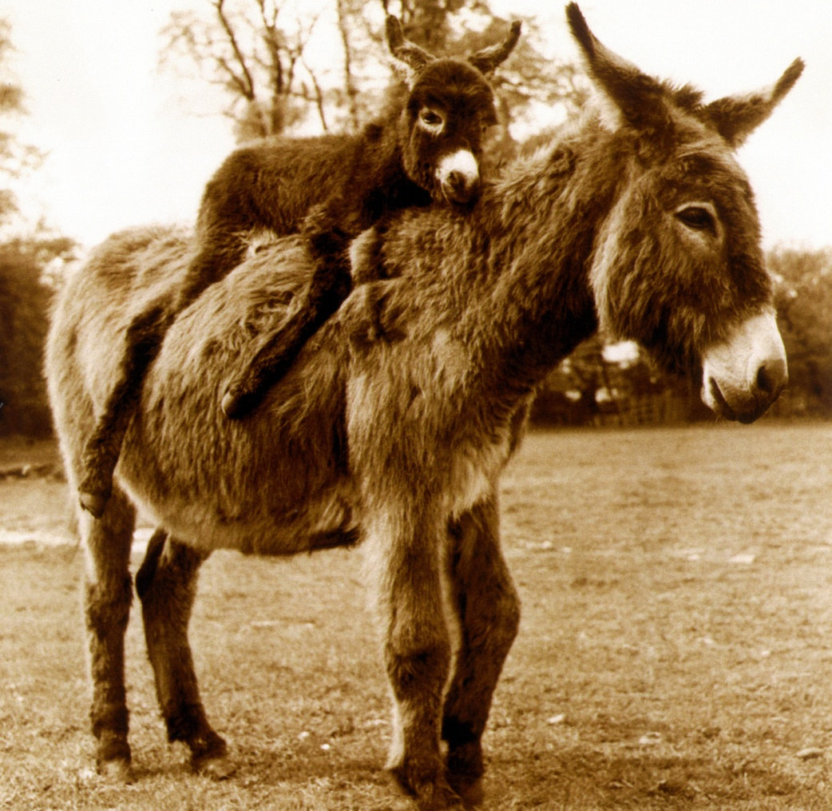
Covey writes, “Life is, by nature, highly interdependent. To try to achieve maximum effectiveness through independence is like trying to play tennis with a golf club – the tool is not suited to the reality.” Interdependence is a far more mature and advanced concept to understand. It is the conscious acknowledgment of our need for one another. If I am physically interdependent, I am self-reliant and capable, but also realize that if I work with others, I can accomplish far more than I can accomplish alone. If I am intellectually interdependent, I will need the best thinking and creativity of others to make a big difference in my career and life. I have always considered myself an independent person and always thought of my independence as a good quality. Yet, I always knew - deep down - that there is not any part of me that is absolutely alone. I have realized that the real success, the road to maximum effectiveness, is indeed through interdependence and working as a team player with others in our own community. There is an endless net of threads among ourselves. At every crossing of the threads there is one of us connected to the other As all the different parts of the human body are interconnected to each other and work together for the survival of the whole body, none of them is really independent of another. Likewise, no individual person should boast of being independent because it is a blessing that we are all interdependent on one another.
Let us take a look at interdependence from a social perspective, with particular focus on relationships. Every one of us exists only through relationships with other people. No person can no longer live entirely on absolute independence nor can exist in isolation. Interdependence requires a balance of personal needs of those whom share the same relationship. It is not so much about depending upon another person; it is more about depending mutually upon the interrelationship of those individuals sharing in the relationship. A good example of interdependence would be that of our traditional social structure, relationships and extended family system of our people designed to improve the betterment and welfare of the entire community. The need for a healthy relationship and connection among ourselves should be acknowledged and recognized. We are not going to have peace and harmony in our community until we recognize the basic fact of interdependence. Not only do we need intimate relationships with our family members and close friends, but also we need a sense of solid relationships and connectedness to members of our community and religious institutions. We need to have a feeling of belongings to our communities and country of origin. Ultimately, we need to feel that we are part of our Eritrean society and honor our culture and ethnic identity.
Relationship is what really life is all about. Whenever there is relationship, there is interdependence. We can discover our role in life through our interdependence and relationship with each other. It is obvious that wherever there is relationship, there is conflict. To resolve our conflicts, we need to have a good relationship which depends on each other to find solution to the problem. When conflict is handled correctly through good relationship and collective effort based on trust and respect, we grow closer and make progress in our lives collectively. But to establish a good relationship and to depend on each other there must be a sustainable effort from all of us to embrace the concept of interdependence. We must respect, listen, and learn from each other and seek common ground in order to solve our problems and create peace and harmony among ourselves. When we build a healthy environment in our communities, our children will have the opportunity to hold on to something real and reliable to survive in life. Their families and communities can be their mighty rock to hold onto and the fortress where they can feel safe and secured and have the highest form of living. A fundamental interdependence initially geminates in our own households when we are connected to each other and then become active participants in the creation of a mutually supportive community. The whole idea of compassion and love created in our communities and religious institutions should be based on a keen awareness and understanding of the interdependence of our own people, which are all part of one another. Only with the unity of our God given diverse gifts can we truly be all that we need to be as a solid community. We are all caught in an escapable network of interdependence in which we have the obligation as human beings to honor and cherish our mutual respect and support.

