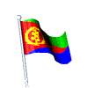The Eritreans residing in Toronto and environs are commemorating the Martyr's Day on the following date and place:

Date - Wednesday, June 20, 2012.
Place - Etienn Brule Park ( Old Mill subway station)
Old Mill Road at Catherine Street, Toronto, Ontario
Time - 5:00 PM

Wetru Awet N'Hafash!
ENHOC

