መዓልቲ ስውኣት ኣብ ሳን ሆዘ፡ ካሊፎርንያ (ሰንበት 17 ሰነ 2012)
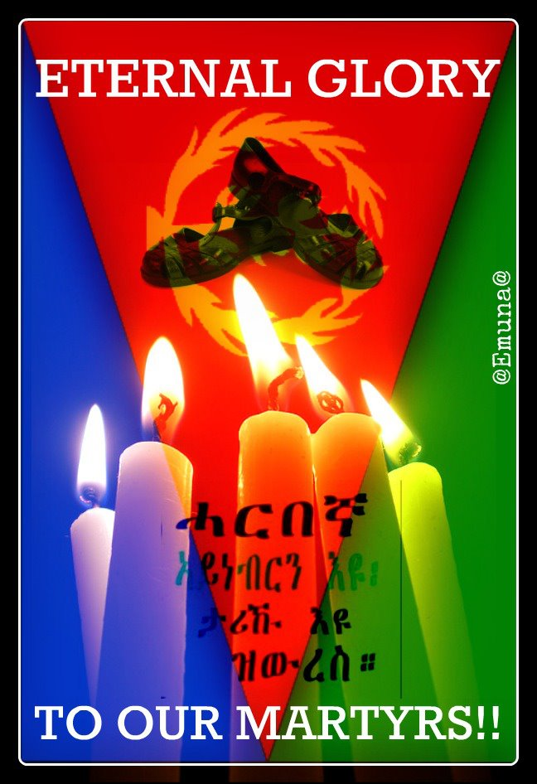
MARTYRS’ DAY IN SAN JOSE, CA ( June 17, 2012 )
Lake Cunningham Park – Cypress Pavilion
On White Rd (Between Tully Rd & Cunningham Ave)
Between Parking lots B & C - Enterance on White Rd side
( 2:00 PM to 7:00 PM )
National Holidays Coordinating Committee: San Jose and Environs

