ዝኸበርኩም ኤርትራዊያን ዜጋታት ተቐማጦ ሎስ ኣንጀለስ፡ ኦረንጅን ርቨርሳይድን ካዉንቲን፡ ሽማግለ መኸተ ሃገራዊ ሰላምትኣ ድሕሪ ምቕዳም እዚ ዝስዕብ ኣገዳሲ ሓበሬታ ተመሓላልፈልኩም ኣላ፡-
(1) ነዚ ብዓለም ለኽ ደረጃ ዝካየድ ዘሎ ሃገራዊ መደብ ኣብ ከባቢና ንምክያድን ምዕዋትን ተበጊስና ከም ዘሎና እንዳ ኣበሰርና፡ ወይ ኣብቲ ኣብ ሃዉተርን ዝርከብ ቤት ጽሕፈትና (310) 973-4555 ወይ ኣብ ቤት መግቢ መርሓባ (አናሄም) (714) 826-8859 ኣብቲ ተመዲቡ ዘሎ ሰዓታትን መዓልትታትን ብኣካል ብምምጻእ ወይ ተለፎን ብምድዋል ሓበሬታ ክትረኽቡ ከም እትኽእሉ ንሕብር። ብሕማም፡ ስራሕ፡ ወይ ካልእ ምኽንያታት ክትመጹ ዘይትኽእሉ ድማ ሓብሩና እሞ ኣብቲ ዘለኹሞ ቦታ ክንመጻኩም። መዓልትታት/ሰዓታት፡ ዓርቢ/ቀዳም/ሰንበት ካብ ሰዓት፡ 6 ድ.ቀ--9 ድ.ቀ
(2) ረቡዕ ዕለት 15 ታሕሳስ 2010 “መዓልቲ ተቓዉሞ” ምሉእ መዓልቲ ካብ ሰዓት 6 ቅ.ቀ ክሳብ 3 ድ.ቀ ኣብ ሃዉተርን ቤት ጽሕፈት ወይ ኣብ መርሓባ ካብ ሰዓት 9 ቅ.ቀ ክሳብ 3 ድ.ቀ ተረኺብና ብፋክስ፡ ኢመይልን ቴሌፎንን ድምጽና ነስምዓላን መልእኽትና እነመሓላልፈላን መዓልቲ ስለዝኾነት ኣብ ካላንደርኩም ሓዝዋ ሓደራ። 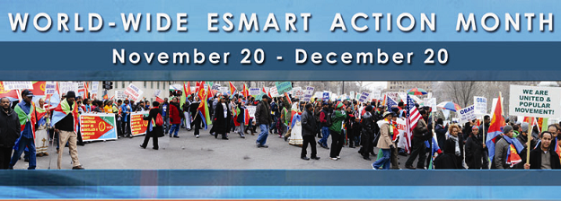
Dear fellow compatriots and friends residing in Los Angeles, Orange and Riverside counties: after extending its greetings the local Mekete committee would like to inform you that local efforts to make the month-long campaign successful are under way. During the campaign month you may visit the ECCC office in Hawthorne (310-973-4555) and Merhaba Restaurant in Anaheim (714-826-8859) on Fridays, Saturdays and Sundays between the hours of 6pm and 9pm to sign letters. If, for any reason, you are not able to come personally and you need assistance or if you decide to write, fax or email on your own then please call us at either phone number and give us your name and phone number.
Moreover, Wednesday, December 15, 2010 is designated as “ACTION DAY” and we would like you to come in to one of the sites (ECCC or Merhaba) any time on that day between the hours of 6am and 3pm for ECCC and 9am and 3pm for Merhaba and convey your message by phone, fax and/or e-mail.
ሕጂውን መኸተ፡ ዓወት ንሓፋሽ!!! ሽማግለ ህዝባዊ መኸተ።

