
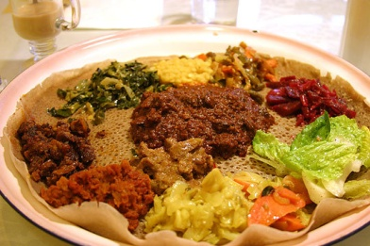

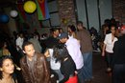
E.P.L.F. 4OTH ANNIVERSARY E.P.L.F. 4OTH ANNIVERSARY E.P.L.F. 4OTH ANNIVERSARY tttjadsad23ggggggggggggggggggggggggggggggggggg
@ e.c.a.o (Eritrean-Canadian association of Ontario)
920B BLOOR ST. (OSSINGTON)
WHEN: Saturday OCTOBER 30TH, 2010
TIME: 5:00PM- till late
Admission: FREE (a complimentary dinner will be served)

ADMISSION: ADVANCE TICKETS $10, AT DOOR $15

YPFDJ AND HIDRI TORONTO

Present

“Eri Summer 2010/Ypfdj conference reunion night”

…ALSO CELEBRATIN’ the launch of KORCHACH’S NEW cd RELEASe

Young People’s Front for Democracy and Justice: Building a Strong, Conscious, and Patriotic Youth Movement !!

Anandakdlko0w0oe0r0

