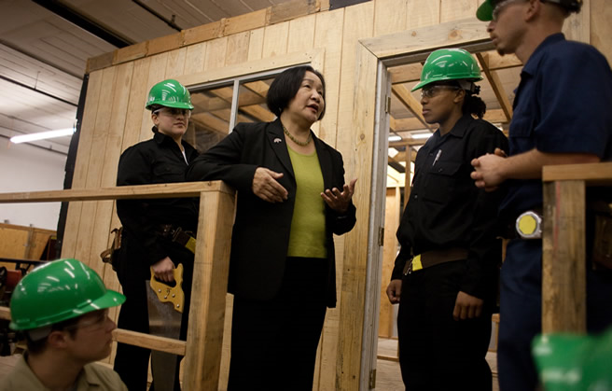
Jean Quan
Mayoral Candidate for City of Oakland
is meeting
Eritrean Community
At the Cultural Civic Center (ECCCC) Oakland.

All Eritreans and friends all welcome to attend this important
Event and share the impute the future of our city.

Mohamed and Seida are preparing dinner for the event.

Date:- Saturday, Oct. 16 - 2010
Place: 5255 Claremont Ave.
Oakland, Ca. 94518
Time: 6:00PM

