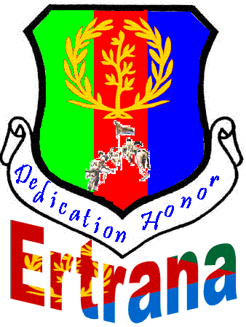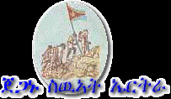
You are cordially
Invited
To attend the annual commemoration of the Eritrean’s Martyrs day
This will be a day to reflect, remember and pray for those who paid the ultimate price by sacrificing their lives for us and our country’s independence. It is also a day, to renew and fulfill our promise and obligation to them to uphold and pass it to the next generation. All ages of Eritreans in Indianapolis and the surrounding counties are invited to attend this very important day in Eritrea’s history.

Date: - June 20, 2010
Time: - 5:00 PM
Location: - 62nd and Moller Road Community Park.

For information: - Please call the following numbers

317-756-8196
317-281-2080
We hope to see you there!!

