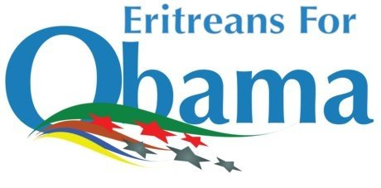

Election Night Watch Party
Eritreans for Obama Cordially invites you to come and watch the election results, state by state, and toast your candidate in this historic election.
Date: Tuesday, November 4, 2008
Time: 7:00 pm – When votes are tallied
Location: Enjera Restaurant
549 S. 23rd Street
Arlington, VA
Eritreans for Obama is a national grassroots coalition of Eritrean-American youth, students, businessmen, taxi drivers, and community leaders living in the United States who support Senator Barack Obama's 2008 Presidential bid.
For more information, please visit www.eritreansforobama.com.

