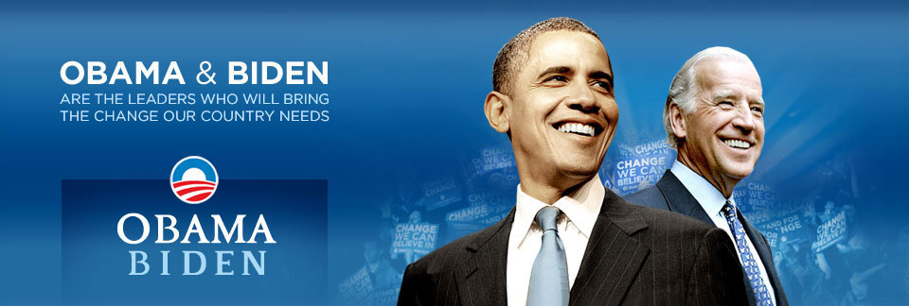

John Burris and his Associates,

Members of the Finance Committee of Northern California

to elect Senator Barack Obama will address

Eritrean-American Community in the Bay Area.

All Eritrean-Americans in the Bay Area are urged

to attend this meeting. Mr. Burris

Will address to the successful election of
Senator Barack Obama as the next
President of the United States.

All African-Americans of the Diaspora
Are also invited to attend this meeting.

We will have a question

and answer session.
----------------------------------------------o-----------------------------------------------
ህዝባዊ ኣኼባ
ምስ ወኪል ሰነተር ባራክ ኦባማ ኣብ ኦክላንድ

ጆን ቦሪስ፡ ኣባል ሽማግለ ቁጠባ ንምምራጽ ኦባማ ኣብ ደቡባዊ ካሊፎርንያ፡
ንኤርትራውያን ኣመሪካውያን ናይዚ ከባቢ መደረ ክህብ ስለ ዝኾነ፡
ኩልና ኣብዚ ብዓይነቱ ፉሉይ ዝኾነ ኣኼባ ክንርከብ ኣዝዩ ኣገዳሲ ኢዩ።
ድሕሪ መግለጺ ናይ ጆን ቦሪስን ብጾቱን፡
ናይ ሕቶን መልስን መድረኽ ክህሉ ኢዩ።

Sunday the 26th. of October. @2:00PM
410 - 14Th. Street, Oakland, Ca. 94612
Between Broadway and Franklin
Formerly known as Jeoffrey’s Inner Circle

