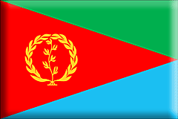

ኣህጉራዊ መዓልቲ ደቂ ኣንስትዮ
8 መጋቢት ሓቢርና ንኽንጽምብል ብኽብሪ ንዕድመኩም አለና።
ሃ.ማ.ደ.ኤ ቦስቶንን ከባቢኡን ምሸትና ብድራር ተሰኒዩ ብሙዚቃን ሳዕስዒትን ደሚቑ ንኸምሲ ናይ መዘናግዒ ምሽት አዳሊና አሎና።

ብደሓን ምጹ!

The members of the National Union of Eritrean Women
In the Boston area, cordially invites you to join us in celebration of International women’s Day, on March 3rd 2012.
Come enjoy the dinner with music and let’s dance the night away.
Place: At American Legion Post,
163 Glen St. Somerville.
Date: Saturday March 3rd, 2012
Time: 6:00 PM Prompt.
Entrance: $20.00

