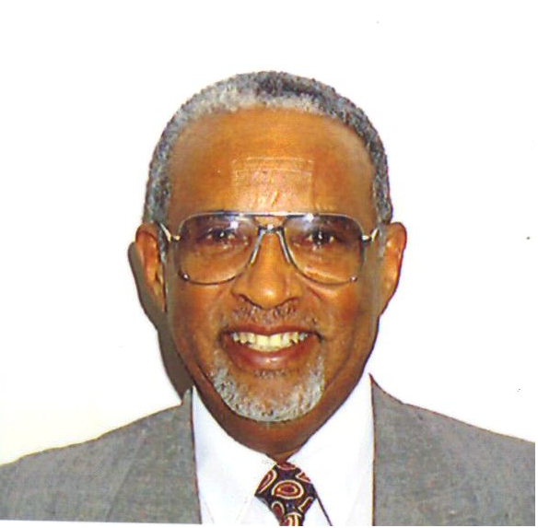
We are saddened by the passing of highly respected, a man of great moral and dignity, and a great husband, father and friend, Mr. Kesete Bariagaber Welderufael, on Wednesday, February 2, 2011 at the age of 75 in the presence of his beloved wife, children and other family members at Saint Thomas Hospital in Nashville TN, U.S.A.
Mr. Kesete was born in Adi Ugri, Eritrea in November 2, 1935. Mr. Kesete, who was married to Mrs. Alem Weldegiorgis Weldemussie, was a father of six, a grandfather of fourteen, and a great grandfather of one child.
Mr. Kesete had a passion for teaching and education. He was a great educator who taught and mentored hundreds and thousands of Eritrean students throughout his 39 years of teaching career and administrative services in various parts of Eritrea.
We like to express our gratitude to everyone for your heartfelt condolences and support during this difficult time. Your presence helped to lighten our burden and comfort our hearts. At times like these, we were grateful to hear your lovely memories.
Your expression of sympathy will always be remembered by the family of Mr. Kesete Bariagaber Welderufael.
Best regards,
Alem Weldegiorgis Weldemussie and family

