Everything you are not supposed to know about Eritrea (1/3)

INTERVIEW OF MOHAMED HASSAN
BY GREGOIRE LALIEU & MICHEL COLLON
The Horn of Africa is one of the deadliest regions on that continent, rent by incessant warfare, famine and poverty … These are images familiar to everyone. But few people know that Eritrea considers it possible to escape from this vicious circle, to resolve its conflicts through negotiation and to attain a high level of development. This would be something to celebrate. Yet, in the eyes of the international community, Eritrea is a pariah state, the subject of UN Security Council accusations! In what way does this country, which nobody speaks about, threaten western powers? Mohamed Hassan reveals everything we are not supposed to know about Eritrea.

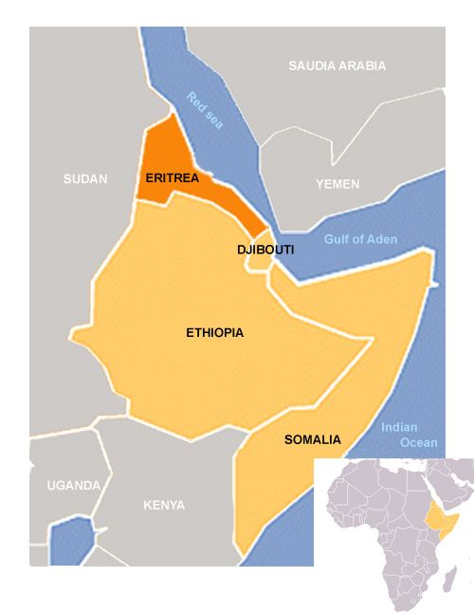
Horn of Africa
Is it true that Eritrea is the source of all the violence taking place in the Horn of Africa? This is what the UN Security Council seems to think since it has recently voted to impose sanctions on that country. Eritrea has been accused of providing arms to the Somali rebels.
These sanctions result from a campaign of lies aimed at destabilising the Eritrean government. There has been an embargo on providing arms to Somalia since 1992; international experts are in place to control the situation, and every armament today has a serial number which allows its origin to be traced. In spite of all these provisions, the Security Council has no more evidence of this alleged arms traffic that it had of the existence of weapons of mass destruction in Iraq! And once again it is Washington you find behind the campaign of lies. As a matter of fact even the US joint Secretary of State for African Affairs, Johnny Carson doesn’t believe it. The truth, he has explained, is that Somalia has been at war for 20 years and is flooded with armaments. Anybody can buy or sell them on the black market. The Somalis don’t need to go to Eritrea to obtain their supplies.
Equally Eritrea is accused of causing tension with Djibouti over the question of its frontier. On top of that there was an encounter between their two armies in 2008.
Eritrea has never had any territorial designs on Djibouti. Like most of the frontiers in Africa, the one that separates the two countries was drawn by the colonial powers. It was therefore laid down a long time ago and has never been disputed.
The 2008 ‘incident’ is a pure fabrication on the part of the Bush administration. Everything began in the month of April when the Eritrean president, Isaiah Afwerki, received a telephone call from the Emir of Qatar. The latter was relaying a complaint on the part of the president of Djibouti, Ismail Omar Guelleh, to the effect that Eritrea was massing troops on the frontier. Yet President Afwerki had never ordered his army to do anything of the kind and was very surprised by this call. Why was his counterpart from Djibouti acting through a third party? Isaiah Afwerki nevertheless proposed a meeting with Guelleh in Djibouti, Eritrea or even in Qatar if that was what he wanted. The President of Djibouti made no response to this invitation.
A few weeks later, on 11 June 2008, soldiers from the Djibouti army attacked the Eritrean troops on the frontier. A brief battle took place, causing some 30 deaths and dozens of injuries on both sides. The President of Djibouti immediately claimed that Eritrea had attacked his country. With disconcerting speed, the US issued a communiqué condemning the « military aggression of Eritrea against Djibouti ». The UN Security Council echoed this condemnation. It was only later that it proposed sending a commission of experts to analyse the situation on the ground and establish the facts. Why did the Security Council put the cart before the horse? On what were its accusations based? There are no matters of contention between Eritrea and Djibouti. The people of the two countries have always enjoyed very good relations. But yet again the US has been manipulating the international community and the Security Council in order to put pressure on Eritrea.
How is Djibouti’s attitude to be explained?
President Ismail Omar Guelleh has hardly any social base. He only remains in power thanks to the support of foreign powers. As a result, he can’t refuse them anything. It is this that explains why there are so many foreign troops in Djibouti. For example, the US only has one military base in Africa – and it’s in Djibouti. This little country also shelters contingents from other countries, including the largest French military base on the continent.
So Guelleh is entirely dependent on Washington. If the US orders him to create a new regional crisis, then that is what he does. This has become a US speciality: fomenting problems in order to propose resolving them. Here the US is seeking to present Eritrea as a bellicose country that is the cause of all problems in the Horn of Africa.
Why should the US want to marginalise Eritrea?
The Eritrean government has a vision for its country and for the region: it is possible to attain a good level of development and to resolve conflicts by dialogue provided one gets rid of interference on the part of foreign powers. Take the crisis in Somalia: Eritrea has always advocated getting all the political participants of that country round a table for the purpose of dialogue. In order to find a solution to the conflict and to rebuild Somalia, Eritrea has suggested involving civil society: women, the elderly, religious leaders, etc. Let everybody get together to overcome differences in order to rebuild a country that has not had a government for 20 years. This method would certainly be an efficient way of restoring peace in the country. The US, however, has deliberately fostered the chaos in Somalia. In 2007 it even got the Ethiopian army to attack Mogadishu at a time when peace had been restored. And on top of that it is Eritrea that gets subjected to UN sanctions!
In fact the US is afraid that the Eritrean vision will gain adherents in the Horn of Africa. This would mean an end to US interference in this strategic region. Washington is therefore seeking to put Eritrea in quarantine to prevent the « virus » of its influence spreading. It is a technique that the US has always applied and which Noam Chomsky has studied. He talks of the « rotten apple theory »: if you have a rotten apple in a basket you must remove it straight away to prevent the other apples becoming rotten as well. This is the US’s perennial reason for seeking to overthrow governments –sometimes successfully and other times not : Castro’s Cuba, Allende’s Chile, Laos during the 1960’s … Chomsky notes that Washington in those days intervened on the pretext of defending world ‘stability’. But this ‘stability’, he explains, means only the ‘security’ of multinationals and ruling classes.
As far as Washington is concerned, is Eritrea then the rotten apple in the Horn of Africa?
Absolutely. But the region’s real enemy is imperialism, especially US imperialism. Eritrea therefore desires that the Horn of Africa get rid of interference on the part of neo-colonial powers and develop a common project. The Horn of Africa has a very favourable geographic position: it is both connected to the countries of the Gulf and of the Indian Ocean, which is where the greater part of world maritime trade is effected. Besides which it has considerable natural resources: minerals, gas, oil and biodiversity. If the countries of this region were to free themselves of neo-colonialism and unify their efforts, they would be able to escape from poverty. This is what Eritrea wants for the Horn of Africa. Of course, the US doesn’t want these proposals to see the light of day because they could lay to rest its own control over this strategic region and access to its raw materials. Washington therefore is trying to put pressure on President Afwerki in order to force him to change his policies. At the end of the day, Eritrea, which had to fight so long for the independence it established in 1993, is still fighting today in defence of its national sovereignty.
Eritrea’s independence struggle is the longest in African history. The country was first colonised by the Italians in 1869. How did Italy, which was not a great colonial power, find itself in Eritrea?
It is necessary to see this in the context of 19th century Europe. At that time, the old continent was the theatre for a merciless struggle between the imperialist powers for the control of colonies and their raw materials. There had already been strong rivalry between France and Great Britain. The unification of Italy in 1863 and that of Germany in 1871 brought to new sizeable competitors on to the scene. In addition, the capitalist world suffered its first major crisis in 1873. This crisis brought about the dismemberment of the Ottoman Empire which added further to the colonial appetite of the rival European powers. Germany, for instance, wanted to take advantage of the dismemberment of the Ottoman Empire in order to acquire new colonies. For their part, the British had their eye on Istanbul so that they would be able to block German expansion.
Chancellor Bismarck therefore decided to organise the Berlin conference of 1885. This is a major event in the history of colonialism: until that very moment, the European powers had mainly been installed in African coastal areas to set up commercial trading posts, but after that conference, they undertook gradually to colonise the continent as a whole. Therefore, to avoid new conflicts and to spur the recovery of the capitalist economy, Europe agreed on the sharing of the African cake. The British strategy was to invite a less threatening colonial power, such as Italy, to install itself in the Horn of Africa in order to block the expansion of more serious competitors such as France and Germany.
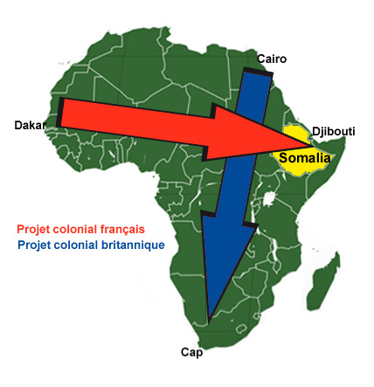
Europe carved up Africa but at the beginning of the 20th century, Ethiopia was the only independent country left on the continent. Why was that?
This anomaly arose from a compromise between the French and the British. The former intended to expand from Dakar to Djibouti, while the latter had the ambition of extending their empire from Cairo to the Cape in South Africa. If you look at a map of Africa you will unfailingly notice that these colonial projects had to collide. In order to avoid a conflict that would have caused great losses on both sides, France and Britain decided not to colonise Ethiopia. But the imperialists did not give up their claims on its territory. They supported the army of Menelik II who ruled over one of the richest regions of Ethiopia. With the support of colonial powers Menelik II seized power over the whole of Ethiopia, which allowed the French and British to have access to the natural resources of his empire.
Finally, if Ethiopia was the only country not to be colonised, you still could not say that it was independent! The man who called himself Menelik II, Negusse Negest of Ethiopia, the conqueror lion of the tribe of Judah, chosen by God, was nothing but an agent of imperialist powers, and was incapable of building a modern state. He was chosen precisely because he was an orthodox Christian and came from one of Ethiopia’s richest regions. Menelik II therefore headed a minority regime within a feudal system where most of the nationalities were deprived of all rights. Slavery was practised. All this gave rise to numerous inequalities which even today persist in Ethiopia.
On the other hand, Eritrea was colonised by Italy. Mussolini was even to say later that she would be the heart of a new Roman empire. What were the effects of the Italian colonisation of Eritrea?
When it colonised Eritrea, Italy’s population consisted of too many peasants. Many of them emigrated to Switzerland or France. But others left to set themselves up in Eritrea. With its picture postcard landscapes and agreeable climate, the new Italian colony gave more than one of them dreams. Colonists were implanted side by side with the peasants. The Italian bourgeoisie then invested heavily in Eritrea. It was particularly interested in the country’s geographic situation because the country has a long coastline along the Red Sea. It is close to the Suez Canal in the north and of the strait of Bab el Mandeb in the south. This is one of the busiest navigation routes in the world that joins the Red Sea to the Indian Ocean.
As a result the Italians invested in Eritrea and developed plantations, ports and infrastructure. To give you an idea of the level of development of this colony, when the British invaded Eritrea during the Second World War, they were to dismantle factories in order to remove them!
This seems to be a far cry from the usual ransacking and hand chopping that characterised the Belgian Congo. Was Eritrea somehow exceptional within the pitiless colonial world?
There were positive aspects but there is no point in deluding ourselves. Italian colonialism was still a discriminatory system in which black people had very few rights compared to the whites. Why? Because when Italy get hold of Eritrea and a part of what is today Somalia at the end of the 19th century, it tried to extend its expansion into Ethiopia. But the Italian soldiers were defeated by Menalik II at the battle of Adoua in 1896. In the following years, fascist ideology developed among the Italian intelligentsia who wanted to restore the honour of their country that had been defeated by blacks. Therefore Italian colonialism was very racist as regards the black people. The Eritrean population within the colonial system was as but an inferior class.
Moreover, Italian fascism (which seized power in 1922) was based above all on anti-black racism. It was not anti-semitic like German fascism. Jews worked within fascist organisations in Italy! And Mussolini had a Jewish mistress. Imagine Hitler doing that! It was only later, towards the end of the 1930’s that Italy began to persecute Jews. This was because by then Hitler had a rapprochement with Hitler and then because the Italian fascist party needed something to give it a second wind. It therefore used the Jewish community as a scapegoat to help it mobilise the Italian population.
Finally, the Italian fascists took their revenge on Italy. In 1935 Mussolini’s troops invaded the only uncolonised country of Africa.
Yes, even though the occupation of Ethiopia did not last very long. In 1941, at the height of the world war, the British army chased the Italians out of the region and the Allies took control of the Horn of Africa. Following the war, Ethiopia regained its ‘independence’. The fate of Eritrea, on the other hand, was subject to debate.
The Soviet Union wanted this colony to obtain its independence. The British on the other hand, rather as they had done almost everywhere, wanted to divide the country into two on the basis of religious affiliations: the Muslim areas should be annexed to Sudan and the orthodox Christians to Ethiopia. It is interesting to note that the Ethiopian church supported this option and pressed the Eritrean Christians to accept it. The church told them that if they refused they would not be buried and their souls would never reach paradise. In spite of everything, the Eritrean Christians did refuse: they felt themselves above all to be Eritreans! This feeling of belonging is explained above all by the fact that the Italians, unlike many other imperialist powers, had treated its colonial subjects without any distinction based on ethnicity. But in the end it was the third option which won the day, that proposed by the US, namely that Eritrea should become part of a federal Ethiopia.
Why did the US favour this option?
Its geographic situation meant that Eritrea was of great importance in Washington’s eyes both during and after the Second World War. Since the 1940s, the Pentagon and the private armaments industry set up major enterprises in the country: an assembly line for aeroplanes, repair shops, a naval force… And above all, during the 1950s, the US intelligence services established in its capital, Asmara, their most important overseas telecommunications bases. At the time, the satellite surveillance systems of today did not exist and listening posts had a limited range. But from Eritrea, you could listen in on what was happening in Africa, the Middle East, the Gulf and even certain parts of the Soviet Union.
The US therefore argued for Eritrea to be reattached to Ethiopia which was allied to Washington. John Foster Dulles, an important figure in US politics, was in charge of Foreign Affairs. He admitted in a debate of the Security Council that « From the point of view of justice, the opinions of the Eritrean people ought to be taken into account. Nevertheless, the strategic interests of the United States in the Red Sea area, and considerations of security and world peace, make it necessary for the country to be reattached to our ally, Ethiopia ». That is how the fate of Eritrea was decided – with severe consequences: Africa’s longest struggle for independence was about to begin.
In the coming weeks: the second and third parts of our interview about Eritrea. With Mohammed Hassan’s help, we will examine the 30 years of the epic struggle waged by the resistance. We will discover what was at stake in the Eritrean revolution, its similarities with Cuba. And we will also deal with the question of human rights in Eritrea, and how they were attacked by the imperialist powers. Finally we will broach the famous African paradox: so much wealth for such poor people.
Mohamed Hassan recommands those readings:
- Dan Connell, Against All Odds. A Chroincle of the Eritrean Revolution , The Red Sea Press, Inc, 1997
- Firebrace & Holland, Never Kneel Down, Spokesman, 1984

Translated from French by Ella Rule

Understanding the Muslim World with Mohamed Hassan - Previous chapters:
Somalia: How Colonial Powers drove a Country into Chaos
Yemen: USA are fighting against democracy, not against Al-Qaeda
What should Ahmadinejad do to get the Nobel Price?
Afghanistan – Pakistan: the black hole of the empire
The Darfur crisis: blood, hunger and oil
“Gaza is a normal place with normal people”
How can we explain the success of Hamas ?

