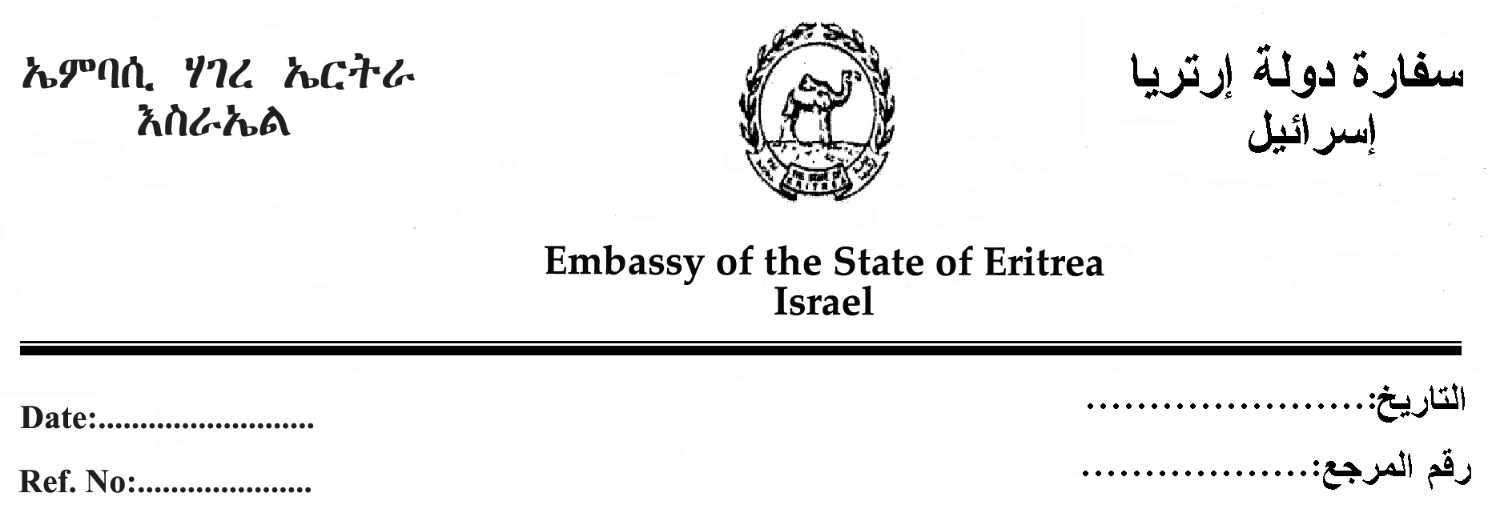

Dear Mr. David Horovitz,
I am contacting you in reference to the article that appeared on page 7 in the March 10, 2010 edition of The Jerusalem Post. The article was entitled: UNHCR: Eritreans by far largest refugee group in Israel.
As I was not asked by the writer Ben Hartman for my response, I would like to reply to some of the points raised in the article, as I found them somewhat disturbing. I would like to take this opportunity to bring your attention to the following:
- The issue of labor immigrants is very complex and problematic and your readers’ need a clear understanding of the situation vis-à-vis every nation. I want to point out that Eritrean labor migrants are invited guests. The manifestation of this is clear in the paper written today. Agencies and individuals are giving the wrong message to migrants in order to migrate.
- As the Ambassador of Eritrea I have met quite a number of "refugees" registered as Eritreans and found that they are from Ethiopia and some from The Sudan. Therefore the number that the writer received from the UNHCR office is not correct. I know that not only in Israel, but also in Europe and the USA , other nationalities are seeking asylum in the name of Eritrea because Eritrea is considered as ''Bad example of Good Example" by so many agencies which earn their living from refugees.
- I would like to say that the writer got information from UNHCR, ARDC and a report from Amnesty International. Firstly, it would have been a fair and balanced report if he would have asked for information from our Embassy in Tel Aviv. In fact, all of the information about Eritrea cited in the reports is not correct, and the individuals and institutions who prepared the reports have never even visited Eritrea. They have no idea about the core values of the people and The Government of Eritrea. Eritrea is a stable nation in the Horn of Africa, completely free from any crime and corruption. Eritrea is a very harmonious nation consisting of nine ethnic groups with Christians and Moslems living together in peace. Eritrea is a country that does not need any type of food aid from any other country. The people of Eritrea are living in harmony and work together to develop their nation this is one manifestation of democracy.
- The negative allegations in the article about Eritrea are completely unfounded and without any merit. The people and government of Eritrea are moving forward and building their nation until they achieve their goals. The goals will be certainly achieved soon.
I thank you in advance and am sure that you will find the best way to publish my clarifications and remarks in your esteemed newspaper.

Respectfully your,

Embassy of The State of Eritrea
Tel Aviv, Israel

Address: 33 JABOTINSKY St. Tel. 00-972-3-612-0039 TWIN BUILDINGS # 1 FL.11 00-972-3-612-9561
RAMAT-GAN 52511 Fax . 00-972-3-575-0133 ISRAEL

