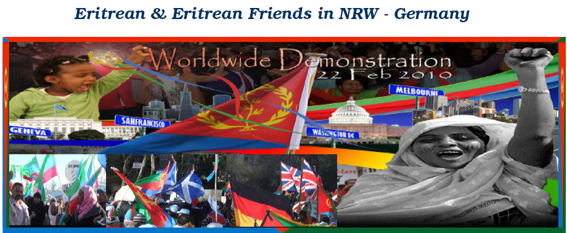 Tens of Thousands demonstrated against UNSC Resolution 1907(2009)
in Geneva , the capital city of Switzerland
On the 22nd of February 2010, tens of thousands of Eritrean and Friends of Eritrea took to the streets of Geneva, to protest against the unfair, unjust and illegal Security Council Resolution 1907 & the sanctions against Eritrea. We, the Eritrean from NRW in Germany, were very proud to be part of them.
The demonstration in Geneva is part of the world wide day of protest. The Same Rallies were conducted in San Francisco, CA, Melbourne Australia, and Washington DC.
They gathered from various European countries and marched on the streets of Geneva in a colourful show of unity and determination to bring public awareness to the latest UN injustice committed against the people of Eritrea. The peaceful march began with the youth leading all the participants for they are the leaders of tomorrow.
Eritrean, various African & European flags waved in the cool wind and young and old, men women and children marched in unison calling for the annulment and repeal of the unjust, unfair and illegal US-UN sanctions against Eritrea. The rally was broadcast live on Eritrean television.
It was no shock to see this many Eritrean people come together, that is what being Eritrean entails, defending what you believe in and fighting for what is right. The extensive preparation of the Eritrean in Geneva and participation of the Young generation was excellent.
The events of the peaceful Demonstration were concluded by handing over 116,000 signatures in petition to the Sanctions to a representative of the UN in Geneva.
The World Wide Demonstration of the loyal, proud, beloved & one heart Eritrean against the Unjust , Unfair Sanctions imposed on the People & government of Eritrea ended successfully & peacefully,
We, Eritrean never & never kneel down,
Our fight for Eritrea is never over.
Eternal Glory to our Martyrs!
Glory to the mass of the Eritrean people
the Eritrean residing in NRW – Germany

