Sports, Spain & the Eritrean connection = Success!
While Spain as a nation is going through what some observers are calling the "Golden era" in sports, Athletes of Eritrean Heritage are going through some individual success in the nation of Spain either by representing Spanish professional teams or training in Spain. If you are a sports follower it is easy to figure out that Sports in Spain in the second half of the 20Th century has been dominated by football (Soccer), however other popular sport activities include basketball, tennis, cycling, and more. With Rafael Nadal's Wimbledon victory, the Spanish national soccer team bringing home the Euro 2008 trophy and Carlos Sastre's Tour de France triumph more recently, as well as the Spanish national basketball team winning Silver at the Olympics and winning Gold in the FIBA (Federation International Basketball Association) the world governing body of basketball basketball tournament. Add to that the number of Spanish players playing in the NBA and Spanish Basketball Clubs having success internationally, the "Golden Era" is something to be proud of for the Spanish people.
So where is the Eritrean connection? That is why this blog was created in the first place to research and detail stories that may never be told about the great success stories of Eritrean athletes. What we will do is talk about Eritrean athletes that are having much success and beginning to show some signs of prowess at the international stage. Let's start of with Eritrea's greatest athlete so far and the internationally acclaimed Zersenay Tadesse in particular, then the role Spain is playing in developing Eritrean athletes in general.

With an Olympic bronze medal behind him and the benefit of sponsorship, better equipment, athletic wear and state-of-the-art training facilities in Spain, Tadesse has turned out to be one of the top long and middle distance runners in the world. He has also inspired a few more Eritrean Athletes to do well including his brother Kidane Tadesse.

Other runners having success include Eritrea’s Samuel Tsegay who provided a major upset earlier this month by taking a surprise win at the ‘55th Cross Internacional Zornotza’ held on a cloudy day and 10ºC on the thermometer. In doing so the 2006 World Junior 10,000m 4th placed overwhelmingly defeated by no less than 21 seconds Kenya’s Moses Masai, who finished fifth at last year’s Cross Country Worlds in Edinburgh. Add to that Yonas Kifle who was the first Eritrean athlete even before Zeresenay to make headlines at the international level. Most of us recall Yonas and Kidane's 2nd and 3rd place finish in Spain with less than one and two second frame of time against Kenenisa Bekele in December 2006.

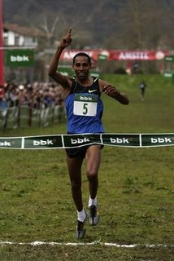
It should also be noted that a university in Spain Universidad Europea de Madrid has conducted research on Eritrean runners. Here is what they came up with "Despite their young age, limited training history, and lack of running tradition compared with other East African endurance athletes (e.g., Kenyans and Ethiopians), male endurance runners from Eritrea have recently attained important running successes." The purposes of the study was to document the main physical and physiological characteristics of Eritrean distance runners and compare them with those of their Spanish counterparts.
(Pictured above Samuel Tsegai winning in Spain)

In basketball yes may be most of you may have not been following and wondering where our Eritrean-American star Thomas Kelati has been? If you guessed Spain you got it! In what was an excellent trade from Poland to one of the top teams in Spain, Kelati has made his home in Malaga Spain. Competing in the Euroleague for an eighth consecutive season is evidence enough of Unicaja's staying power as one of the top teams in Spain. In 2007-08, Unicaja returned to the Euroleague Top 16 and the Spanish League semifinals, knocking off regular season champion Real Madrid in the process. Unicaja now faces the challenge of keeping its status as one of the best teams in Europe, but with an entire region solidly behind it, this team has only begun to fight for the continent's biggest prizes. A clear indication is Thomas Kelati's contribution to the team. He currently leads the squad as a leading scorer with an average of 12.5 points a game. During a recent game against Olympiacos of Greece Thomas went on to have an outstanding game leading all scorers with 16 points. This Eritrean basketball players should be an inspiration.
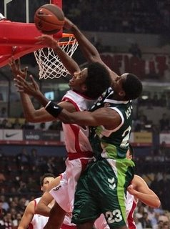
Here is the You tube link for all to see. Check it out and just witness what the Eritrean Spirit of hard work and dedication means no matter where in the world.
http://www.youtube.com/watch?v=s1ynmrxBN7U

Be sure to click on the You tube link above & See Thomas Kelati in Action.
(Pictured left is Thomas Kelati Blocking a shot in Spain for his new team Unicaja)

Again we stay in Spain and in the biggest and most popular sport and one of the most powerful soccer/football leagues "La Liga" our own Swedish-Eritrean Henok Goitom is proving why he is one of the best despite facing some minor obstacles. In 10 starts Henok has scored 5 goals currently leading his team as the top scorer. Eritreans are the top leading athletes in Spain as of this week. While Spain remains on top as a Sporting nation in the world, individually Eritreans are showing that they can be top athletes in the top sporting nation, which is a sign of big things to come. These athletes should serve as a classic model of what can happen when you are disciplined and motivated. Young Eritreans take note and aspire to be the best that you can be by using these great athletes as role models. Their combined accomplishments as athletes is a rarity and as of now just think of it this way while an Eritrean has been the last runner to win a championship in Spain, an Eritrean currently leads his basketball team one of the best in Spain as a leading scorer and an Eritrean playing in "la Liga" leads his 12th, place team in scoring. All this happening as we speak. Congratulations to all of them and may they have more success in the future. Add to that the recent successful come backs of Meb Kiflezghi from a major injury to win a meet in Houston and Simon Bairu who won the the Canadian 2008 Champion Men's Senior 10k race after a very painful Achilles heel injury, and Bolota Asmerom who has been running well indoors and took 10th place in the NYC marathon the "SKY IS THE LIMIT" as my high school coach used to say.
Update on Henok;

Picture below is Henok against Espanyol 4 months ago in Spain.
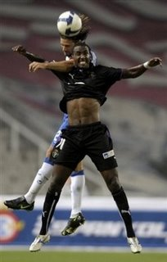

Playing for Real Valladolid in "La liga" Spain's top division, Henok has shown his brilliance over and over again. He has only started 10 games and has scored 5 goals in La Liga play while he has added another in the Spanish Copa de rey totaling his goal number to 6 goals, not bad considering he was out with injury for three games. In a game today against Espanyol Henok scored his 5th League goal and has taken the lead as the team's top scorer. Henok headed the ball into the net for Valladolid shortly before half-time but the 19 th place team Espanyol came from behind to tie the game at 1-1. Goitom missed many other opportunities and was substituted towards the end of the game. Real Valladolid is currently in 12th place and must do better as the the season is a little more than at the half way point. Hopefully Henok will be a big part of the team's success and until next time just stay tuned by continuing to monitor new developments on the Eritrean sports scene by clicking on,

http://eri-internationalsports.blogspot.com/
This is Mike Seium for

http://eri-internationalsports.blogspot.com/

