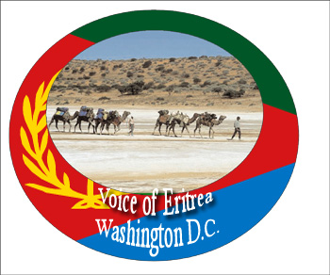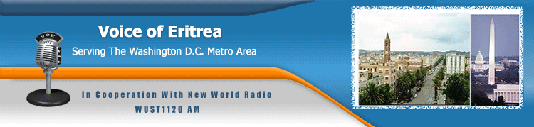

You are cordially invited to celebrate
Voice of Eritrea’s 11th Anniversary
Fundraising Event on

Saturday February 21, 2009 @ 7:00pm
at
Washington Times
3600 New York Ave NE
Washington, DC 20002

VOE Washington DC is your Voice!!!

We are counting on your support !

