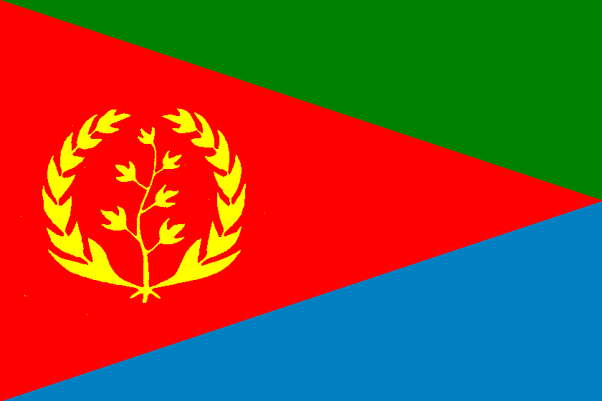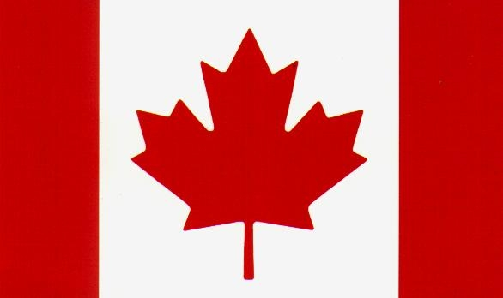

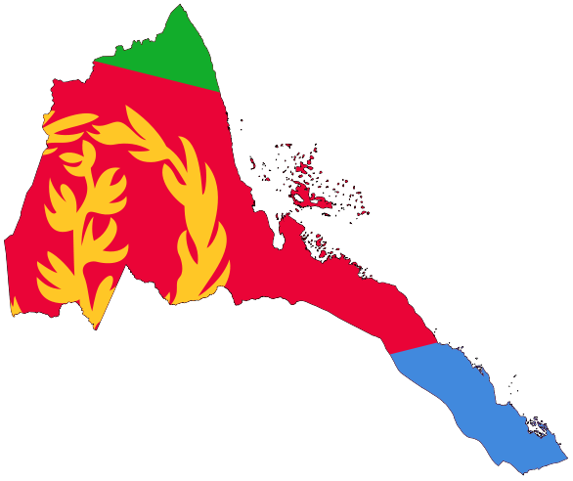
Vancouver Celebrates Independence Day

The Eritrean cultural center in Metro Vancouver is cordially inviting all Eritrean and friends of Eritrea to come and join us in celebrating 18th Independence Day on Saturday May 23, 2009.

LOCATION: UKRAINIAN ORTHODOX CHURCH
154 EAST 10TH AVENUE
VANCOUVER, B.C.

TIME: 8:00 pm to 2:00 am

Organizing Committee

