Yemen: Stemming the Rise of a Chaos State
Project: Middle East and North Africa Programme
Peter Salisbury
26 May 2016
Associate Fellow, Middle East and North Africa Programme
While Yemen may not be a Western policy priority today, the growing humanitarian crisis and the rise of jihadist groups will soon force it further up the international policy agenda.
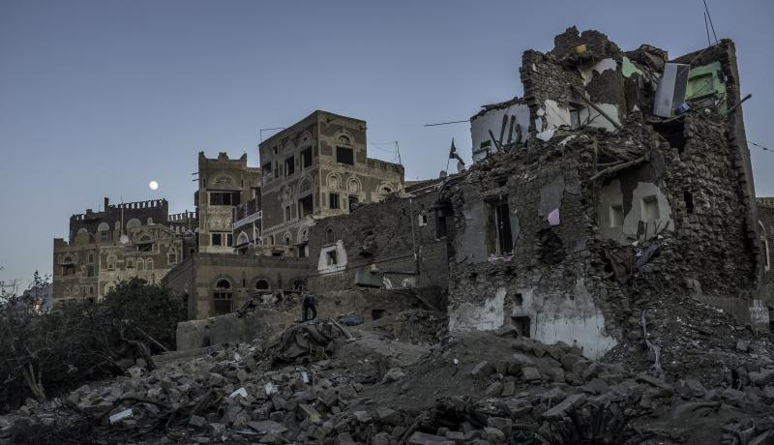The rubble of a traditional mud house pictured in the early evening, Old City, Sana'a, 26 September 2015. Photo: Peter Salisbury.

Summary
- Yemen’s civil war has reached a stalemate in which an outright military victory by any of the many parties to the conflict is highly unlikely. Although widely presented as a war between two distinct coalitions, the conflict is in fact multipolar, fuelled by regional and international support for the various parties involved in the fighting.
- There is broad consensus among international policy-makers that the only way the conflict can be brought to a sustainable end is through political mediation. Yet the current UN-led peace process has not been structured in a way that reflects the complexity of the dynamics in play, and some policy-makers currently lack the capacity to develop a deep understanding of the situation in order to consider a more inclusive structure for peacebuilding and diplomacy.
- Maintaining the illusion that either the internationally recognized president, Abd Rabbu Mansour Hadi and his allies, or the alliance between the Zaydi Shia Houthi rebels and the supporters of former president Ali Abdullah Saleh, are representative of all the warring groups in Yemen would be a mistake. Tensions are rife within both coalitions, and particularly so in the deeply divided anti-Houthi bloc.
- Because of the wide variety of local dynamics and grievances, Yemen risks seeing the ‘big war’ ended only to be consumed by a series of complex ‘small wars’ that are open to exploitation by national and regional actors.
- On the assumption that a durable ceasefire can be brokered and a political process initiated, policy-makers working on the Yemen conflict need to begin planning for a peace process that is more inclusive than were the abortive attempts during the transitional period of 2012–14, which prioritized elite-level mediation and security concerns – particularly counterterrorism initiatives – over the economic needs of the population.
- The new political process will need to give equal weight to bottom-up, grassroots local approaches to peacebuilding alongside top-down, national and elite-level interests; and ensure that the political, security and economic tracks of the transition are interlinked rather than dealt with separately.
- Failure to expand representation and to focus on local governance will almost certainly lead to renewed hostilities at a local level that could push Yemen a step closer to becoming a ‘chaos state’ – a country defined by little more than its borders, in which complex regional conflicts are deepened and prolonged by the interests and actions of external players.

Podcast - Yemen: An Embattled State
Jane Kinninmont speaks to Peter Salisbury about the ongoing civil war in Yemen and its implications for the region and the wider world.

Research Paper: Yemen: Stemming the Rise of a Chaos State
pdf | 586.19 KB

