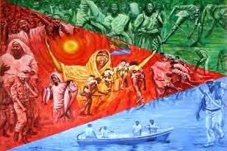
ERITREAN
INDEPENDENCE
DAY
Date: Saturday May 21, 2016
Location: Eritrean Community Center
119 Franklin St. Rochester NY 14604
Time: 12pm Cookout
6pm Traditional Eritrean Dishes

Come Celebrate Eritrea Independence Day All Are Welcome!!
*WE are having a Talent Show feel free to share your talent.

