Diversity: The Way to Go
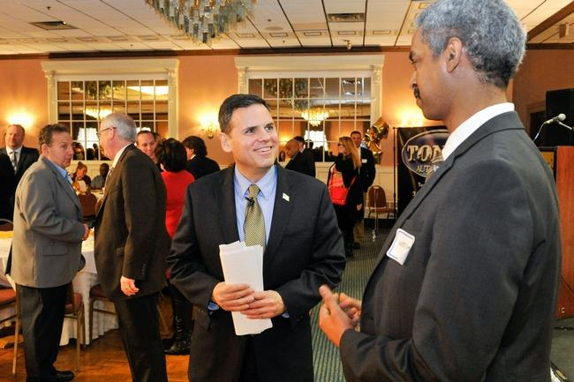
Mayor Gary Christenson speaks with Habtom Hadgu after his State of the City address at Anthony's of Malden, Thursday, Feb. 25. Wicked Local Staff Photo / David Sokol
The City of Malden Mayor, Mr. Gary Christenson gave the state of the city inaugural address on February 25, 2016 at Anthony’s Restaurant to a packed auditorium. The mayor discussed about the budget, public safety, fire safety and education. He also mentioned how Malden is dedicated in recognizing its veterans. In regard to seniors, the mayor told the crowd the improvements the city has made with newer technology at the senior center. Last but not least, Mayor Gary reiterated how he will bring the many different diverse groups which reside in Malden together. Malden is among the most diverse city in the nation.
Among the many civic associations which were present for the inaugural speech, members of Eritrean Cultural and Development Center (ECDC) of the Greater Boston had the privilege to reserve a table on behalf of ECDC. ECDC members also met the head of Malden’s Police Department, Chief Kevin Mollis. He was very happy to meet members of ECDC and have vowed to meet other Eritrean community members in the near future. On behalf of ECDC, I would like to thank our own Mrs. Alem Isack Ghile for facilitating the presence of ECDC members for the inaugural ceremony.
Post the inaugural speech there was a brief question and answer session. Our own Solomon Mehary first commended the mayor for bringing the many different diverse groups together. Secondly, Solomon advised the mayor to work closely with minor communities. The mayor appreciated Solomon’s advice and mocked Solomon by claiming that he will be at ECDC for the honey wine. Apparently, the mayor was the guest of honor at a luncheon party held on behalf of 2015 high school graduates. And he had the chance to taste ‘mes’ (honey wine) at the party.
