THE FEELING OF HOPE
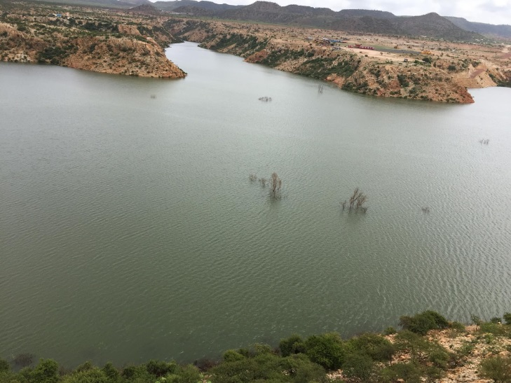
Watching over the endless vast waters collected in the Adi Halo Dam, I couldn’t not help it but remind myself of the bright future of Eritrea. As big as the water reservoir in the Adi Halo Dam is, so is Eritrea’s potential in the future. While standing on top of the huge dam that impounded the waters and looking at the breathtaking surroundings of lush green coating in the surrounding I felt a strong feeling of pride. This was also the feeling I felt abundantly during my visit to Eritrea this past summer. It is a feeling of hope and optimism. Honestly it is a feeling that gave me a strong relief. It is a feeling that has, truth be told, that has inspired me. Amidst all the negative media reports that have plagued Eritrea since its inception, amidst all the controversy and problematic relationships that have brewed ever since Eritrea became a sovereign state, and amidst all the labels that have haunted Eritrea’s international reputation, none, none at all even registered in my mind when I stood atop the concrete wall of the Adi Halo Dam. It is hope that makes me proud to happily say that “I am Eritrean!” Seeing what the future holds for this young country can only give a person so much hope and encouragement. Without a doubt Eritrea is a young country that has so much to improve on and there’s no denying that it has a long way to go in improving the living standards of its people. But one must realize only so much can be done in a 25-year-old country. When setting foot inside Eritrea every step I took reassured me that the people of Eritrea are building towards a better future, incessantly, and with unwavering resolve. Seeing the beautiful landscape across Eritrea that is being cultivated, as well as observing a proud people who are determined to build a better future is inspiring to say the least. Witnessing this any sensible person can only be filled with a hope of optimism and that how I felt. I am certain that is the hope many Eritreans have for their young country as well.
Adi Halo Dam
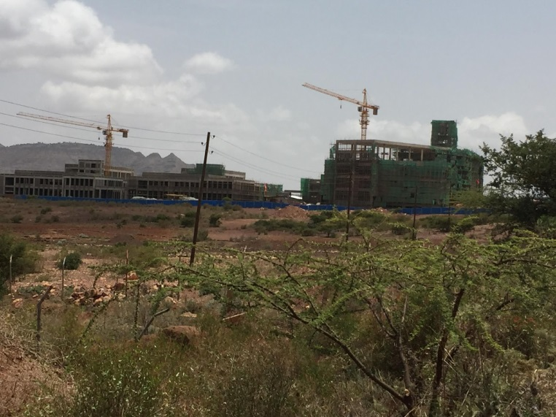
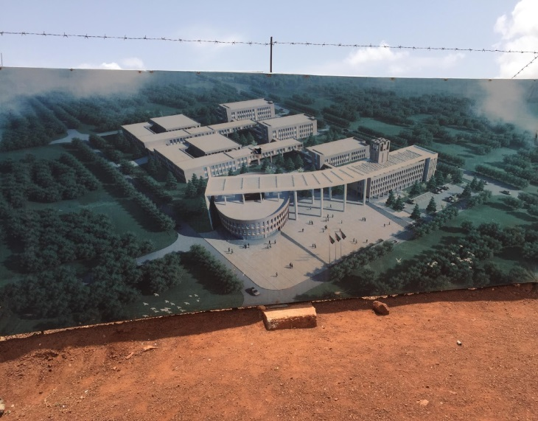
The nearly completed science building at the Eritrea Institute of Technology (EIT) at Mia Nefhi also brought an impassioned surge of emotions through my heart.
In the short time since the blueprint was put to work massive amounts of progress have been made on this complex that is going to house the labs, library, office complex and class rooms for the College of Science at the EIT. The College of Science is one of three colleges housed at the EIT; the other two being the College of Engineering and Education. Covered in scaffolding the complex was surrounded by numerous cranes moving back and forth assisting the construction workers. On the right side of the gate one can see the image of a fully complete view of the science complex in full out vivid colors. Just catching sight of the picture while standing in front of the whole construction sight gave me a surge of hope. Despite sanctions, accusations, defamation, methodologically flawed reports, and numerous political assaults Eritrea is standing tall and busy building for its future and the future of its people. EIT’s new science building together with the engineering and education as well as staff residence buildings that are in the pipeline Eritrea is building a platform for educating its youth and it really encapsulates the direction that our country is going in- investing in our youth and the future. I already heard that graduates of the EIT are building drones, controlling heavy earth moving caterpillars using mobile apps, writing software that enables Eritreans to use any operating systems in their own languages, … and with more modern facilities and equipment the sky is the limit to what they can do.
Eritrea Institute of Technology (EIT) at Mia Nefhi
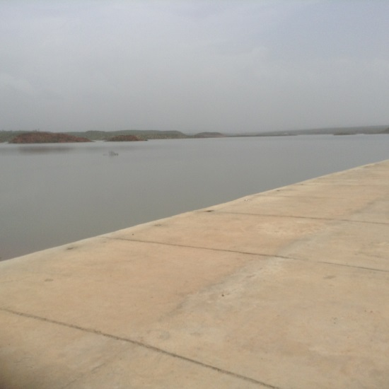
I also managed to visit the Gergera Dam which is even larger than the one I saw at Adi Halo. While driving to these place, I honestly wasn’t expecting much. Dams are simply ways of life. Ways of survival that have been a part of humankind for years. But when driving towards the dam sites and seeing civilians of the neighboring villages working around the dam sites was truly a spectacle. People of different ages and genders were taking part in helping build and fully complete the project for both of these dams. Seeing both old and young alike working in the dam in Adi Halo brought a smile to my face. The hospitable greetings they gave me as they moved aside as we drove past them also warmed my heart. But the grit and determination clearly shown as they worked was what really empowered me because once again I was getting this lingering feeling of hope. It all came together in a grand way as I stood on top of the barriers of the dams. There when I could see the whole picture in full, as I looked upon the surrounding mountains and waters with tiny dots of people all across I knew that hope and prosperity was written all over this.
Gergera Dam
I cannot stress how much hope I see in this beautiful country of ours. I see a united and unbreakable population that knows that its country’s future is also the future of the masses. That is why Eritreans young and old are investing the infrastructure, food security, water conservation, health services and educational fascilities of the country through equitable development. It is a self-fulfilling type of dedication that makes Eritrea unsullied standing tall and proud. From the youth in Sawa who beam as shining beacons ready to partake in the esteemed national service of the country to the elderly who built the roads to the Adi Halo Dam. It is no wonder why the Western Civilizations attack us and accuse us of Human Rights Violations by pointing out things like Sawa. It is because institutions like Sawa and our water conservation projects like Adi Halo, as well as the EIT that represent the hope that is in Eritrea’s future. I’m disheartened to know that I am missing out. I hope that in the future I am able to contribute to Eritrea’s future. I hope that in the future I can be closer to this lingering feeling that I felt in Eritrea. I pray that all Eritreans can be able to do so. In the future I’m determined to come closer to this beautifully humane feeling that Eritrea gave me. The feeling of hope.
Awet Nehafash
Dawit Ghebremedhin
New York
September 2016

