Eritrea: One country – two realities
Eritrea: One country – two realities | Reportage
Journalist
Martin Schibbey
Twitter: @@martinschibbey
Fotograf
Johan Persson
August 23, 2016
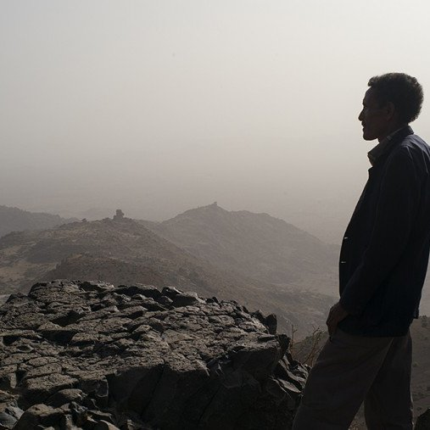Background: Eritrea is one of the world’s most secretive nations and has been closed to foreign journalists for a long time. During the past year, Blankspot’s Martin Schibbye has followed the pro-Eritrean groups and here he reports, in the first of a three part series, from the border of Eritrea and Ethiopia, not far from where he himself was imprisoned for 438 days from 2011 to 2012 during a reportage trip. An investigative report on oil transformed into a story about ink and Freedom of the Press as they fought for survival inside the notorious Kality prison in Addis Ababa. Martin Schibbye and Johan Persson were pardoned and released—after 438 days—on September 10, 2012. Now they return to the region, in search of answers…

PART 1The Border—April 2016
The four-wheel drive Toyota bumps and jerks over the rocks. In the distance, camels move along. The strong smell of gasoline burns in the nostrils, sand crunching between teeth. Amanuel Hadgu, our escort from the Eritrean Ministry of Information. He’s dressed in civilian clothes, laughs easily and appreciates leaving his office to get out in the field.
Between his legs he holds a camera to document our visit at the border. His forehead is already shiny with sweat.
We pass a sign warning of land mines.
”Over there is Ethiopia,” he says and points toward a hill over by the horizon. ”I’m sure they’ve missed you.”
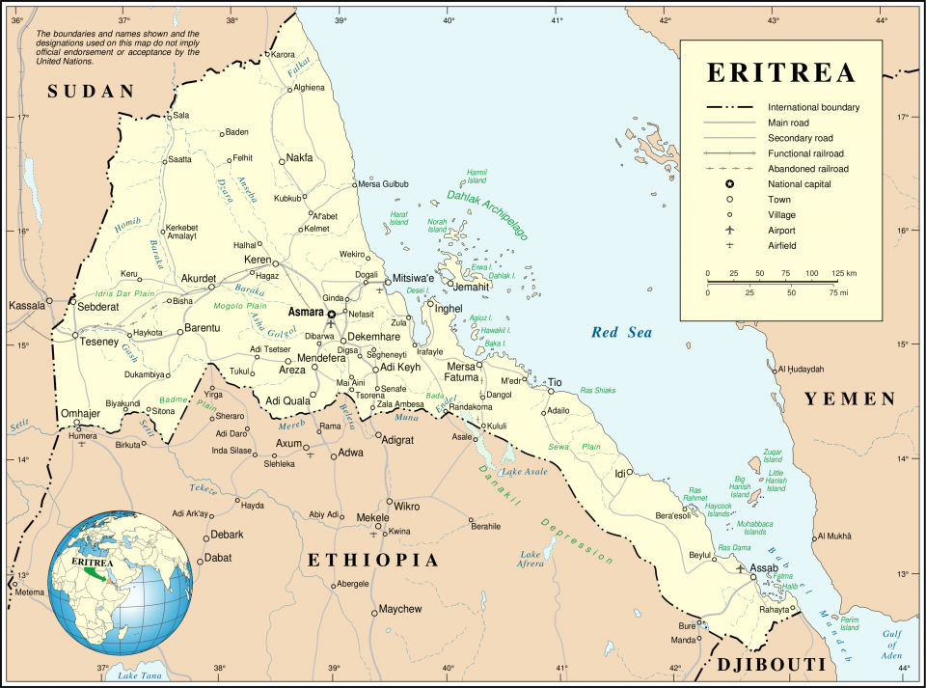
Next to me in the backseat is Johan Persson, the photographer who was jailed with me in Ethiopia for more than a year between 2011 and 2012. The landscape surrounding us is unforgiving and I recognize it all too well. My body remembers the heat, the sand, the smell of gunpowder and the taste of blood. A half-empty water bottle rolls around on the floor boards of the Toyota. The sound is familiar.
They say the desert raises you by taking.
As long as I focus on this project, this reportage trip, I’m calm. If I zoom out and see myself as a small speck traveling toward the Horn of Africa, toward a country that views me as a convicted terrorist, my mouth goes dry and I start sweating.
Of all the countries in the world, why am I back here?
My motivation is rooted in journalistic principals. The as-yet unsolved border conflict between Ethiopia and Eritrea is an important question to the future of the country celebrating 25 years as an independent nation this year.
Most of what us Swedes and Europeans read about in terms of Eritrea has to do with the imprisoned journalist Dawit Isaak, who’s been in prison for 15 years this September.
The fact that Ethiopia occupies parts of Eritrea is largely unknown.
And just like a tongue that is constantly touching, feeling the aching tooth, I want to be back here, on the border of possibilities.
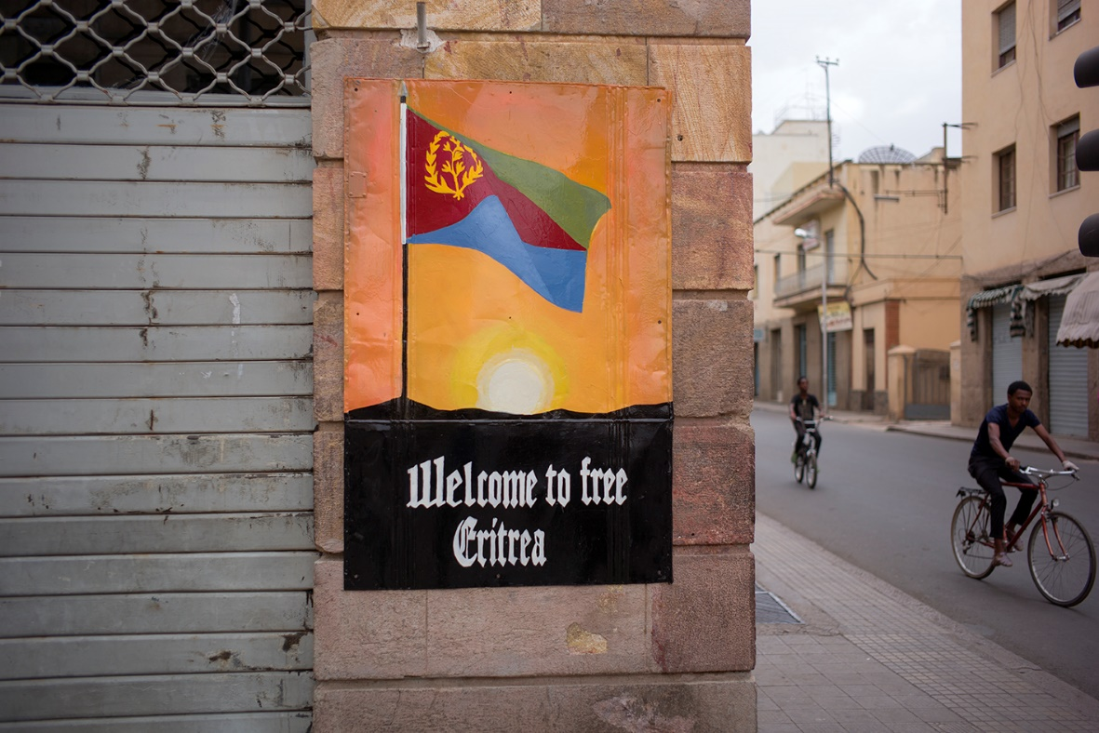
We speed past water pumps and houses of dried clay. The road ahead of us is empty with the exception of some children playing and a goat or two. The dust, which now has infiltrated my shirt, is starting to feel like sand paper in my perspiration.
I pull out a map and unfold it in the back seat. My fingers travel across names from Asmara to Mendefera and Adi Quala toward the south and I try to measure the distance with a compass as the car moves along the bumpy road.
I am guessing that we are about nine kilometers from Ethiopia. A tank’s firing range is ten.
Our fear and anxiety are good things. They keeps us alert. Stop us from getting soft and losing our edge.
”Maybe this isn’t such a great idea,” says Johan as if reading my thoughts.
This is our first reporting trip together since our time in prison. We had said that it would be fun to succeed with a project together some time, but I procrastinated for a long time before calling him about this trip. Finally I realized that if I was going to do this, it had to be with him. Our working relationship is a little rusty, but we’re starting to feel like a team again. With every moment closing in on the border, a kind of survival mode kicks in, a mode where everything inessential is left behind.
Ahead of us, the desert is spreading its vastness and we know all too well that here, there is no room for bickering.
The Toyota is moving erratically between boulders and thorny bushes. We get a visual of the mountainous border between Eritrea and Ethiopia.
The road to the border post is made for tanks or camels—not cars. Rock after rock slams against the chassis and we are jerked around in our seats. The smell of gasoline induces a headache.
I hold the map in a cramped grip. It’s gotten moist from my sweaty palms and I think I should have laminated it.
Suddenly we are close enough to discern the many trenches snaking around the mountainside. Men dressed in camouflage look at us curiously
We drive up on a mountain, around us the view of a flat desert is endless in all geographic directions.
”You’ve got 10 minutes, then we have to leave,” says Hadgu opening the door to the backseat.
The wind whips my hair and I take a deep breath. On the other side of the valley is Ethiopia. Suddenly Johan’s phone pings with an incoming text message. The Eritrean network blocks all foreign phones—it can only mean one thing. We’ve picked up the Ethiopian cellular network.
”Damn, turn it on flight mode!” I yell.
”Yeah, yeah,” Johan mutters.
In something that resembles excitement, we run toward the dugouts that are so close to the edge, they are almost hanging off the mountainside. The thought of the risk involved by us returning here, rushes like hot liquid through my veins.
”This is gutsy,” I say.
”A little too gutsy,” Johan responds, nervously.
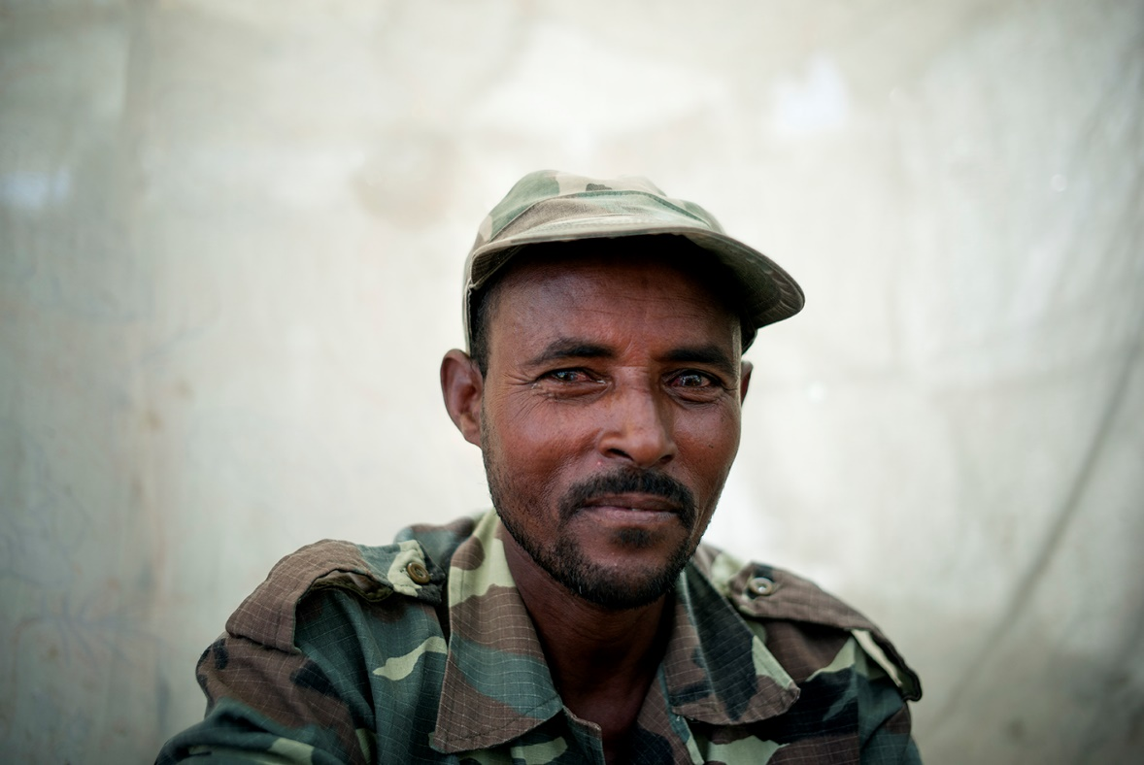
MEMORIES OF THE WAR 1998-2000
They didn’t arrive at dawn like Berhane thought.
The heat was oppressive and the sun was already high in the sky by the time he saw the first Ethiopian soldiers running, half-crouched, across the dry valley. Around him the platoon had set up helmets on sticks to give the impression they were more soldiers up there in the trenches.
Curiously, he followed the Ethiopian advance through his riflescope, the distance too big still for him to want to squeeze the trigger.
He already knew, because of the last war, the 30-year long war, that every soldier in his ranks was forced to kill 25 enemies each, in order to stand a chance of survival.
This time, like back then, the odds were not on Berhane’s side.
The confusion was great in the beginning. The order was crystal clear, while at the same time completely incomprehensible.
They had fought in the same war, rolled into Addis Abeba together in 1991, they spoke the same language and had devoted themselves to the same cause—and now, he had to shoot at his brothers and sisters.
After 30 years of war with Ethiopia, he had hoped for a lasting peace. An alliance. A common economy.
“I knew war eats people. And not just the people—it devours all of a country’s resources, all efforts that should have gone into the development will go to the war, all dreams will be postponed.”
At the same time, he was also a soldier. If someone attacks your country, he knew you have to fight back. And if someone slaps Eritrea in the face, you don’t turn the other cheek.
You head-butt the enemy.
Berhane knew that’s how his generation reasoned.
But he was scared.
“We are only human, but when they started shooting and I did the same thing, then the fear disappeared.”
The first soldiers fell, silently, to the ground and became still. He reloaded his rifle with an experienced hand.
The next attack came after only a few minutes. They were successful this time, too. Then a third wave of soldiers. And a fourth. Berhane remembers thinking that the machine-gun pipes were about to overheat. After that, his memories are fragmented.
“It was completely unrealistic. They fell like rag dolls down the mountain, bounced and tumbled among the black stones. It was like an army of zombies, and impossible to count them.”
The officers told them that if they lost the Adi Begio rock, if it fell into enemy hands—that would be the end for Eritrea as a country. Then, the road would be wide open straight to Asmara, the capitol.
“At dusk it got harder to hit target. The Ethiopian soldiers held all the way to the dugouts closest down to the valley. I could hear how my friends fought man-to-man, with fists and knives.”
In the dark, several of his own were shot, and during cease-fire, he could hear the moans of the dying.
That’s when an order came from higher ups, some say it came straight from the president, to roll the artillery up on the rock and aim the barrels downward—in violation of both the war and the law of physics.
Nobody who was there will forget the sight that met them when the sun rose the following day.
“You couldn’t put your foot down without stepping on a dead person, there were corpses everywhere,” Berhane says and points.
At the bottom of one ravine there are still skeletons with military boots on their feet. That’s how they knew who was who.
“The dead soldiers with sandals, we dragged with us and buried. The Ethiopian soldiers wore boots, so we let them lay. Nobody came to collect their corpses. They’ve laid there for 14 years now.”
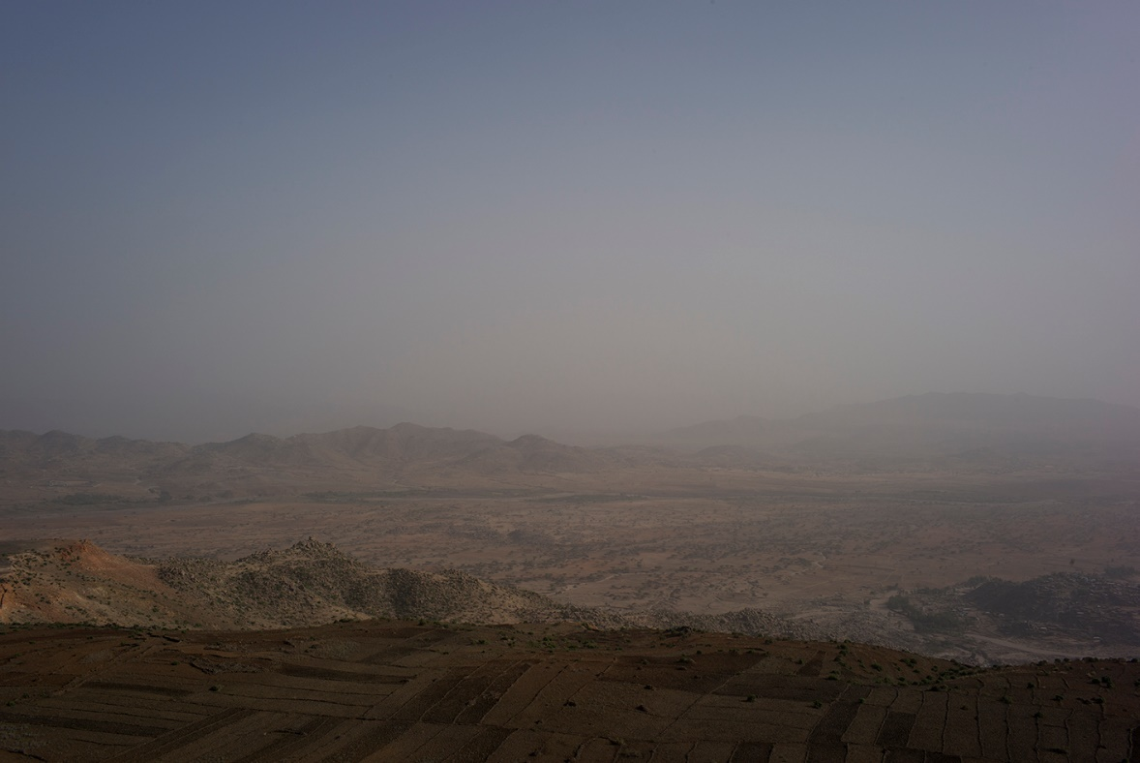
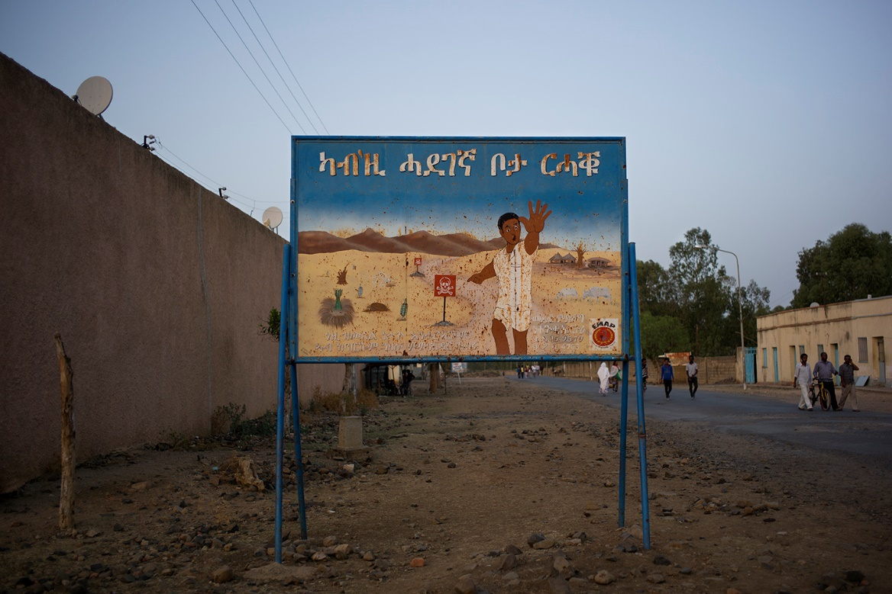
It’s hard to say when everything went wrong. The difference of opinion had been there during the whole independence campaign. Some point to the fact that relations between Eritrea and Ethiopia had been strained ever since independence in 1993. Ethiopia claimed parts of Eritrean territory and there was dissatisfaction over the terms of the use of the strategically important ports of Eritrea.
Others say that the Ethiopian Tigrayan People’s Liberation Front, the TPLF guerillas, have always strived for a “larger Tigray” which includes Eritrea. And yet another opinion is that Eritrea’s decision to replace the Ethiopian currency with its own was a declaration of war.
The only thing all parties seem to agree on is that the conflict is about everything but the dry land.
There are also a number of versions as to what was the real reason for the actual outbreak of war. According to Ethiopia, on May 12, 1998, an Eritrean troop entered a disputed area behind the poorly-marked border.
According to Eritrea, Ethiopian militia torched one of their villages north of the city Badme. When Eritrean soldiers went there to mediate, they were shot and killed.
The following day, May 13, 1998, the Ethiopian Parliament declared war on Eritrea and in June the airport in Asmara was bombed with napalm.
Eritrea countered with an aerial bombing of Mekelle, the closest large city in Ethiopia. The cluster bombs destroyed military complexes, but also a school, where twelve children died.
Within a few months, what was first considered a border conflict had escalated into a full-fledged war.
Embassies in Asmara were evacuated. Eritrea was the accused aggressor and the country entered a familiar state of war. At the height of the war, armies of half a million men stood on opposing sides of the border, which makes it the largest battle in African history.
After two years of combat, the non-profit International Crisis Group estimates the number of deaths to be between 70,000—100,000 on both sides. 250,000 people of the region have become refugees.
The two countries finally entered a peace agreement in Alger in June 2000 and accepted that an independent border commission would determine the outcome of the war.
Both parties committed to accept the conclusion of the commission, but when presented with their findings in 2002, which were said to be final and binding, Ethiopia refused to accept that the city of Badme would belong to Eritrea.
NO WAR, NO PEACE?
The Eritrean flag slowly moves in the wind above an abandoned lookout made of stone and dirt walls.
A few soldiers sit underneath a sheath of fabric below a string of dugouts, abandoned themselves. They do not believe a new war will happen.
“We won the war,” one of the soldiers says confidently. “Ethiopia wanted to switch our government to one that was loyal to them, and they weren’t successful. It was an obvious victory for us.”
If Ethiopia would just follow the decision in the International Court of Justice (ICJ) and cease their occupation, the conflict would be over, according to the soldiers.
Today, 14 years after the end of the war, the soldiers believe the biggest threat to the peace rests beyond the rocky field, where the enemy is.
“Ethiopia isn’t the problem, it’s the outside world and the United Nations. They allow Ethiopia get away with their aggressions and by ignoring the ICJ’s decision for Ethiopia to retreat. The outside world wants us to bend, crawl and bow for them [Ethiopia], but that will never happen.”

GENEVA SWITZERLANDJune 2015
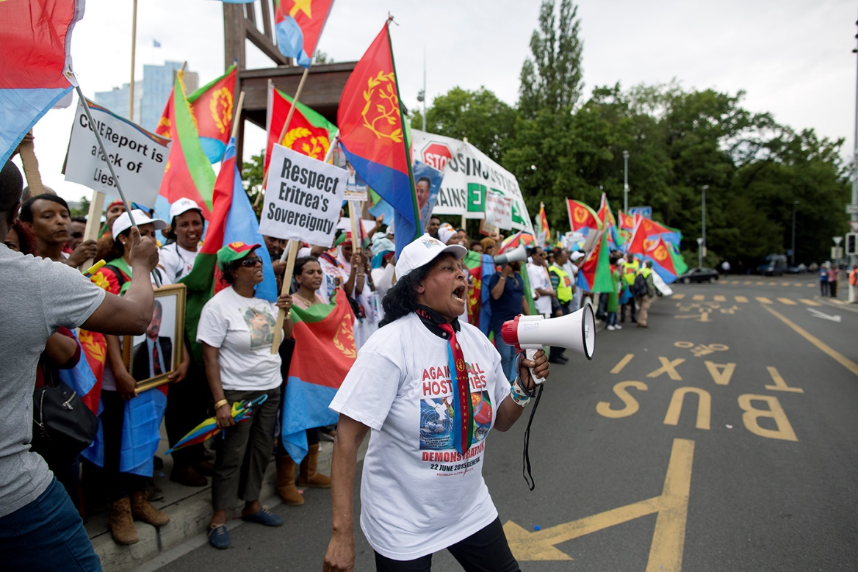
In June 2015, there was feverish activity at the small square outside the United Nations’ Commission on Human Rights (UNCHR) in Geneva. Young and old from all over Europe flooded the square with the famous three-legged chair, carrying drums, megaphones and banners. Many of the participants had wrapped themselves in the Eritrean flag. One of them carried an umbrella with the text: “I love Eritrea.”
Inside the UNCHR building, an investigation by the UN Commission of Inquiry on Human Rights in Eritrea, based on more than 500 interviews and witness accounts by survivors in eight countries, would soon be official.
”Stop targeting Eritrea under pretext of human rights,” said one of the banners.
Near the loudspeaker equipment, and under whipping flags and banners, Eritrean-Swede Fthawi Mehari chitchatted with the other demonstrators.
“Twenty-two hours in a hot bus is nothing compared to the sacrifices people have done during the 30 years of struggle for independence,” he said. “We want to show that there are Eritreans who are against the report.”
As one of the activists in the Swedish division of YPFDJ, Young People’s Front for Democracy and Justice, an organization described as the youth branch of the ruling party, Fthawi Mehari, who is 30, asked for vacation to travel from Stockholm to participate in the demonstration.
The YPFDJ arranges concerts, parties and seminars to gather young Eritreans in exile. Under the hashtag #HandsOffEritrea they had mobilized thousands of people in just a few days.
One can easily believe that Eritreans in exile would be an oppositional force, but the diaspora is divided and the rhetoric between the different groups is hostile.
Fthawi Mehari told me that he and thousands of others had wanted to contribute their testimony to the UN investigation—but were never interviewed. A fate they shared with companies that invested in Eritrea as well as foreign embassies.
The Commission of Inquiry on Human Rights in Eritrea has also received criticism in diplomatic circles and from scholars because of their one-sided use of testimony by refugees in Ethiopia. On the question of whether it was a little peculiar to demonstrate against the UN, an organization with a fairly high degree of credibility, Fthawi Mehari shook his head.
“I am not against investigations and reports where they find areas for improvement, about Eritrea, but this delegation hasn’t put their feet in there,” he explained.
“But isn’t that because they weren’t allowed entry?”
“They started at the wrong end,” Fthawi Mehari explained. “If you begin by traveling to a refugee camp in Ethiopia to speak with refugees, you have to expect the interviewees to exaggerate so they can get asylum. Then you speak with the opposition, and the last thing they do is to speak with our government, well no, then you won’t be welcome.”
“Because?”
“Because they then already have their opinion of what the state of the nation is,” Fthawi Mehari said, then turned around to welcome yet another busload of people. “Now the people from Stockholm are here!”
Suddenly his irritation is replaced with laughs, tears and the sounds of joy ful reuniting.
In the report that the demonstrators are gathered to protest, Eritrea was described as a totalitarian state with torture and forced labor from which 5,000 people are fleeing every month. Young people testified that they had fled the country to avoid indefinite, compulsory military service.
The report also described a widespread surveillance society, where neighbors and family members were forced to tell on each other, or were held prisoners without knowing what they were accused of. The UN experts concluded that they had “rarely witnessed” such grave and extensive human rights violations in a country.
One of the interviewees stated that he’d been hung upside down while electrodes were attached to his arms, so his whole body was shaking. A journalist described how he was whipped and strung up “like Jesus, but without them spreading my arms.”
According to the report, Eritrea was no longer ruled by law, but by fear.
After reading the 478 pages of reported violations against fellow humankind, it was hard to understand the anger amongst the demonstrators on the square. Would all of these testimonials, hundreds of them, be fabricated?
“Nobody denies that Eritrea faces challenges, but if you interview people in refugee camps who are anonymous, you won’t get the truth. [The report] also claims that women in the army were used as sex slaves and there’s no truth in that. All of us have relatives who’ve been in the army,” Fthawi Mehari said.
He and the other demonstrators felt that the report was part of a campaign by the outside world to weaken and destroy the current regime. In their opinion, Eritrea had proven it could rebuild a nation without foreign aid.
“And that’s why Eritrea poses an ideological threat in terms of how the West relates to Africa,” Fthawi Mehari explained.
He also admitted that it was true that some young people did flee to avoid the military duty, but that media should explain why Eritrea has compulsory military service.
“Nobody writes that we have Ethiopian soldiers on Eritrean land, that we are occupied. If the outside world had supported international law and made Ethiopia withdraw from the regions where they have remained after the war, we wouldn’t need mandatory military service,” Fthawi Mehari said loudly enough to be heard over the drums.
In the background, the music got louder and the rhythmic sound against the drums made it hard to continue the interview. When the music stopped for a short moment, Fthawi Mehari continued:
“I have friends who have left the country. It’s tough in Eritrea, but they flee the circumstances, not from the regime. And even those who come to Sweden, quickly become part of the community, they sign a document at the embassy, in which they apologize, and then they can return for vacation.”
Despite the demanding questions, Fthawi Mehari seemed to appreciate our discussion. He says that when Eritrea was discussed in media, nobody ever called him.
Having grown up in Sweden, he considers himself a strong supporter of free elections and democracy and meant that was the plan, long term, for Eritrea too. To stand up for Eritrea in Sweden, a country where most of the reporting of his home country is about an imprisoned journalist was strange, he admitted.
“I always invite my co-workers over for cake on Eritrea’s Independence Day, so they get a chance to ask all the questions they may have. Most Swedes only know of Dawit Isaak, and I take it as my responsibility to tell them about all the other things that are Eritrea.”
“The fresh UNCHR report also brings up the capture and imprisonment of members of the opposition and journalists, are you saying what’s stated in there isn’t true?”
“I have not read the full report, but when it comes to Dawit Isaak, the regime says that it’s about national security, I who believe in and support my government, have to assume that what they say is true. But it is a disgrace that he hasn’t been tried in court. He should have been given a trial.”
Fthawi Mehari believes that if they just work to solve the “overall issues” of the nation, the case of Dawit Isaak will be solved too.
“When the regime says it’s a risk against national security, then it can be solved,” he said before his voice was absorbed by the noise again.
Fthawi Mehari’s frustration was also rooted in a perceived double standard. He felt it unfair that Ethiopia didn’t fall under the same looking glass and criticized by the outside world when, for example, the ruling party got 100 percent of the seats in parliament.
“So highlighting the double standards, justifies lack of democracy in Eritrea?”
“No, but if it’s democracy the outside world cares about, they can’t just attack one country this hard. It’s obvious how Ethiopia, on the other side of the border, can do how they please. They seem to be held under different rules or expectations.”
A short distance away, closer to the street that separates the demonstrators from the UNCHR building, stood a young woman, wrapped in the Eritrean flag, like a shawl. She summarized the report as “500 pages of paper.” She asked to remain anonymous but said: “When our children were bombed with napalm, the outside world didn’t say one word, they looked the other way, but now when we’ve eradicated Polio, malaria, and when my cousins are giving birth to children without dying, that’s when we are attacked by The United Nations.”
She disagrees with the report’s conclusion about the lack of democratic freedom and rights.
“If there’s one place in the world where there’s democracy, it’s in Eritrea,” she says. “We don’t elect a president, but we vote for what we want done. Okay, we don’t have newspapers in Eritrea, but in every street corner there is a bulletin board where people can post what they think and feel about things.”
She shared Fthawi Mehari’s frustration about not being heard.
“Sweden is a country where there is no freedom of speech,” she said. “We have tried to give our version of what’s going on in Eritrea, but we always get ignored. When we demonstrate, nobody writes about it. We are a majority, whom with pride, pay two percent of our earnings to Eritrea in tax. Why are we not invited to debates?”
“But aren’t there any cases in Eritrea where people are imprisoned for political reasons?”
“Are there any such cases in the US?”
“We are talking about Eritrea now.”
“Yes, but why just point finger at Eritrea? Why is Dawit Isaak worth more and the 70,000 Eritreans who were expelled from Ethiopia and cannot return to their lands? Is a person with a Swedish passport worth more than one without? Now that we again are attacked, and our existence is at stake, when the UN threatens to eradicate our country, then you have to look at whose life is worth more. Those who have sacrificed everything for their nation, or his [Dawit’s] life?”
Next to the woman I spoke with, stands an older man, looking to be in his 50s, and listens curiously. To him, this is nothing new. He had fought 35 years for the ruling party, of which he’d been a member since 1998. A resume like his is not unusual among the demonstrators in the square in Geneva. What makes him stand out is that his brother was one of those imprisoned.
Tedros Isaak introduced himself, then said, “You know this whole thing with journalists and such, the UN has brought that up several times. It will get solved sooner or later. Even my brother, Dawit Isaak, will one day be free.”
He swayed back and forth when he was talking and his eyes were searching.
“Don’t judge five million people because of Dawit, look instead to all the new railroads and hospitals. Of course there is room for improvement, I’ve asked the regime many questions too, but before those questions are addressed, Eritrea needs to get out of its belligerency.”
“What types of questions do you have for the regime?”
“Right now, in a state of war, we shouldn’t pressure our regime. Now is the time to support them with all means we have. I don’t want my country to end up like Libya—but many in the West want to see an Eritrea in chaos, conflict between Christians and Muslims, and I don’t want that. I know that my brother is fine, and sooner or later, it’ll be all right.”
“But why is your brother in prison?”
“There is nobody in this world who knows more about my brother than I, and I know that he is doing just fine. I also know that he will be released, so I am not stressing over it.”
“Why was he arrested?”
“No outsider should interfere with my brother’s business. Nobody has a right to do that, aside from my family. It just gets worse. To walk around in a town square doesn’t help, the only thing that helps is my support. That’s why I am here with my people.”
“Do you really believe he’ll be freed?”
“He’ll be freed, I am not worried. I know, that’s why I’m not worrying like my other siblings. They know nothing. If I know 100 percent, they may know five,” said Tedros, then he disappeared into the crowd.
The more I listened to them who were defending the regime, the more intrigued I became. I really wanted to try and understand this country.
How did they end up here? How could the picture of Eritrea be different? How can critical reports incite the demonstrators to go out and defend a nation under attack’?”
In all my conversations I also detected that there appeared to be confusion over Eritrea as an idea and the current state-building.
To be a patriot was synonymous with being loyal to the sitting president. The alienation drew people closer, gave meaning and an identity in a rapidly changing Europe.
The following day, thousands of demonstrators from Eritrea gathered again, and accused Eritreas long-standing president Isaias Afewerki of being a dictator and urged the UN to take strong measures.
We didn’t stay. The answers to our questions were not in Geneva.
To get closer to this mystery, I had to go to Eritrea. I had to succeed with what the UNCHR commission had failed to do. I decided to apply for a VISA to the closed country.
Perhaps 438 days in an Ethiopian prison could be viewed as an extended VISA application?
I wrote a long letter to the Eritrean Ambassador in Stockholm and told him that I wanted to experience Eritrea. Neither write positively nor negatively, just doing my job.
The decision would take a long time.
I wasn’t denied, but I also didn’t get a VISA and I had started to give up hope of ever being able to go on a reportage trip to Eritrea, when an email suddenly appeared in my inbox.
It was from the Eritrean Embassy, inviting me as one of the keynote speakers during an Eritrean festival for the loyalists.

THE BATTLE OF JÄRVA FIELD—SWEDENAugust 2015
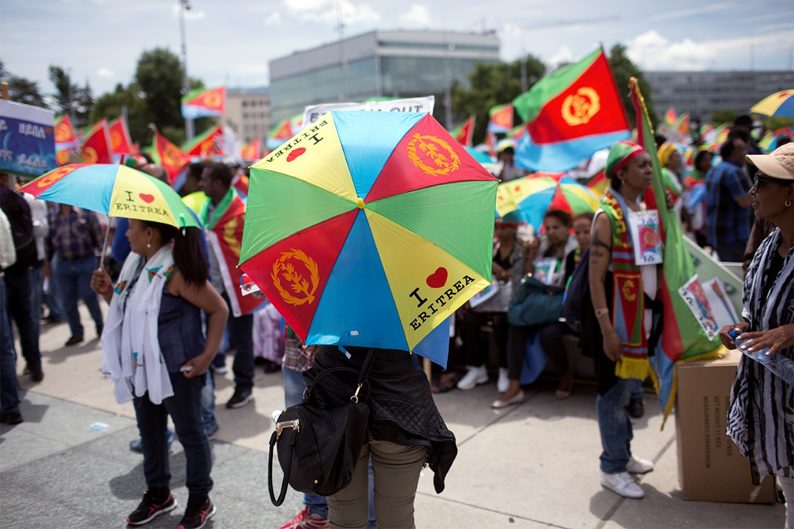
Late summer, the grass was wet and the dandelions had long since bloomed. Already in the distance I could hear the buzzwords.
“Dictatorship, dictatorship, dictatorship!”
The mud in Järva Field in northwestern Stockholm stuck to my shoes. It had been a rainy summer.
As I rounded some bushes, I saw about 100 people who had gathered to protest at the annual festival, arranged by organizations with close sympathies with the Eritrean state.
“Innocent people are in prison, it’s torture. Do you people know what it’s like to die in a container?” a man yelled toward some festivalgoers passing by just a few meters away.
Eritrean flags and banners fluttered in the wind. During the summer, the UN Refugee Agency had reported that more than 400,000 Eritreans, or nine percent of the total population, had fled. And, according to the UNHCR, 5,000 Eritreans left the country every month in the summer of 2015.
While I made my way across the muddy field, I thought that they probably wanted to test me, see if I dared to speak at this event. Behind a kilometer-long fence, on the actual festival grounds, a few thousand people had gathered. On the other side of the fence stood about 100 demonstrators.
It kind of looked like a medieval battlefield.
Men in yellow vests and two-way radios guarded the festival entrance.
In front of them stood a paddy wagon. Tumult had erupted as some of the demonstrators tried to storm the festival and had clashed with the festivalgoers and the police had to interfere.
It didn’t take long before people recognized me.
“Is it true that you will speak at the regime-festival?” an older man, asked me politely. “We got very disappointed when we heard that. We demonstrated for your release from prison, and now you do this?”
Before I had a chance to respond, a young woman added: “Yes, is this really true? Are you really going to talk for them? This festival is political in every way. Arranged by the only political party in Eritrea. They are using you. If the purpose of your participation is to promote journalistic freedom in Eritrea, you’ve chosen the wrong platform. I also believe dialogue is important, but to what price? Not at the expense of my people.”
A third person began talking about the festival’s importance for the country’s economy.
“All young people, and many adults, are forced to work for the regime, the rest escapes. Their two main incomes are the two-percent tax, and these kinds of festivals!”
According to the demonstrators, the People’s Front for Democracy and Justice (PFDJ) and the organizer of the festival controlled and supervised the event via the Eritrean Embassy, in order to collect taxes and “voluntary” contributions in exchange for services such as identity documents, passports and other documents a refugee would be dependent upon.
I began formulating a response, but didn’t have time to finish before I heard the chants now addressing me.
“Schibbye, don’t speak! Schibbye, don’t speak!”
The announcer for the demonstrators saw me and I gesticulated to him that I wanted to say something.
“Give him the mic!” many of the demonstrators yelled now.
For a second I hesitated.
A part of me understood them, and sure I get that it’s problematic for me to speak at the festival and not just interview participants. But sometimes you have to take advantage of an open door. My plan was to hold an uncompromising talk about the importance of journalism and freedom of speech. After all, it’s these people who have the keys to Dawit Isaak’s cell. But I also believed they held the answers as to why Eritrea is the way it is.
And if this was naïve of me, and that I’d just be used for an appearance in their state-owned television, I planned on cancelling it myself.
They were testing me, but I was also testing them.
I walked over to a tent, where the sound system was, grabbed the microphone in a tight grip and looked out over all the people. Behind them, the fence and a towering a circus inside the festival area. I remember thinking: “the Battle of the Järva Field” as the buzzing and chanting stopped and the demonstrators gathered around me.
“Hello everyone! I work as a journalist and then you have to speak with both sides, even if it’s difficult,” I began, a little carefully.
I recognized several of the faces in my audience from freedom of press events for Dawit Isaak. Many of them wore scars on their bodies from torture and imprisonment. I wanted to tell them that I had applied for a VISA to visit Eritrea, and gotten an invitation to speak at the festival in response.
But it was too soon. I was in the middle of the Eritrean Embassy’s litmus test, and it wasn’t an easy position I’d put myself in.
“I once promised, when I left prison after serving in 438 days as a prisoner of conscience, to tell the world what I have seen and it is a promise to the other jailed colleagues around the world that I plan to keep. Over the past year, I’ve spent a lot of time traveling around and speaking about the freedom of press: about that it should be a war crime to imprison journalists, and that’s what I intend to do inside that festival today—”
I didn’t get any farther before I was interrupted by applause. The aggressive mood had vanished.
“Thank you so much, it is great that you are honest with us, and it is important to speak about the importance of journalism. There are many imprisoned journalists in in Eritrea. Go in there, and tell them,” one protester outside yelled.
I returned the mic and when I turned toward the festival entrance, I heard the words “Dictatorship, dictatorship, dictatorship!” echoing across the Järva Field again.
Just when I was about to duck underneath the police tape, I saw Meron Estefanos, who stood, stone-faced, staring at the Eritrean flags.
“I get so upset to see all these people attending this festival, just this year 1,000 Eritreans have been beheaded by ISIS, or drowned on the Mediterranean. It feels as if they don’t care about their countrymen,” she said.
From an apartment in a Stockholm suburb, she works fulltime, reporting on Eritrea for the opposition radio station, Radio Erena. After the tragedy outside Lampedusa in October 2013, Meron Estefanos caught the attention of the world, and she has been a link between the desperate refugees on the Mediterranean and the Italian Coast Guard for several years now.
“I don’t understand how they can dance at a festival, financed by the regime. I am here to show that it shouldn’t be allowed. If these people think it’s so great in Eritrea, what are they doing here then?” she said, sounding tired.
Here Eritrean-Swedes had gathered from around the country. All of them wondered why Swedish authorities hadn’t stopped the festival. They had worked for several years, trying to outlaw the festival, by reminding the landowners that they are renting their property to a dictator, but so far nobody has responded to them.
“People have traveled here from all over Sweden to protest against this festival, and also against Sweden. They are collecting money for the Eritrean military openly here, it should be illegal, but Sweden doesn’t care. I honestly don’t know what the Swedish government is doing I am getting tired of them. They say nothing about this, because they want to free Dawit Isaak, but at the same time I am also an Eritrean-Swede and I think it’s about time to take a harder stance. We’ve been waiting for 14 years now,” Meron Estefanos said.
I ducked underneath the tape and headed toward the entrance, slicing through the no-man’s-land of the two groups. The grass was tall and still moist after the night’s rain.
The guard at the entrance had a firm handshake and wore a brassard of the Eritrean flag tightly tied to his upper arm. Next to him stood Fthawi Mehari from Geneva and of the political party’s youth branch, YPFDJ.
“Welcome to Eritrea,” he said and followed me into the festival area.
The rain had held off since last night and the muddy ground was slowly drying up.
Once inside, a more festival-like mood took over; it was family-oriented, festive and sold-out. According to Fthawi Mehari, 5,000 people visit the festival every one of its four days. There was a large tent for big lectures and meetings, a barn for the smaller ones and small tents for business meetings or for use by different Eritrean organizations were sprinkled throughout. In the middle of it all stood a clown, flown in from Eritrea, to entertain the little ones.
“We flew in a comedian from Eritrea also, as well as some of the country’s most popular artists,” Fthawi Mehari said.
Despite the loud and festive alarum, the demonstrators on the outside could be heard.
“Dictatorship lovers! Go home!”
I asked Fthawi Mehari what he thought about the accusations and the yelling.
“I’m fine with it. They have a right to stand there and protest, making life miserable for people who are entering the festival. Actually, later in the evening when they are finished, some of them even come inside to join the festival, so it’s a bit ambiguous. Today though, about 30 of them tried to storm the fences and exercised violence, but that’s where we draw the line and our guards had to stop them,” he said.
“But if they are yelling ‘If it’s so good in Eritrea, go home then!’ how does that feel?”
“The rhetoric they use is very hostile. You only hear what they yell in Swedish, but what they say in Tigrinya is even uglier, meaner. They target women who walk by and say things that make people sick. But it is okay, everyone is entitled to his or her opinion.”
His explanation of polarization was the Eritrean regime’s thoughts on social justice.
“That everyone in the nation shall live under equal conditions and everyone working together. I’m not sure everyone shares that reasoning, perhaps those who personally aren’t benefitting from the cause.”
“Everyone I’ve told about this festival and that I am going, have reacted in surprise and say things like “what kind of dictatorship lovers are they, living in Sweden and supporting that regime?” Why do you think they react that way?
“It is media that portrays things that way. As you can see, there are a lot of them here. But none of the journalists will mention the festival mood, they will stay over there by the fence. Those who are there [anti-regime] will get all the attention. Why it’s that way, I don’t know, but it feels like media have a preference for those who do not support the Eritrean regime,” Fthawi Mehari said, grimly.
It was already packed inside the large tent, and people of all ages sat tightly squeezed, shoulder-to-shoulder, on the wooden benches. The sun was bright and I was wondering if my pictures would be visible on the screen. Behind it was an enormous Eritrean flag.
“Oh, so you are here, we never thought you’d dare. I was expecting a text from you saying that you’d gotten sick or something,” Sirak Bahlbi of the Eritrean Embassy said and laughed loudly.
He told me about politicians who’d participated and been raked over the coals by the press afterward as “dictatorship lovers” and never dared to return.
“They say they’d like to come but don’t dare because of Swedish media, but isn’t it the job of a politician to do just that, meet people who think differently and discuss different points of view?” Sirak Bahlbi said.
I had met him once before when I submitted my visa application. His family lived in London and he was quite new at the job in Stockholm. The first shock for him was that each workday began with clearing out his inbox of emails from people demanding the freeing of the Eritrean-Swedish journalist, Dawit Isaak.
While we were talking, more and more people poured into the tent.
“We had to move your lecture here, to the largest tent, because the interest is enormous,” Sirak Bahlbi said and wondered if I wanted to dine with the Ambassador and guests after my talk.
I declined on the spot. It would probably have been a great material for my story, but it felt like getting too close.
I saw how the incumbent presidential adviser, Yemane Gebreab, sat down close to the podium. He has a substantial influence over politics in Eritrea.
I swallowed hard. I had passed the point of no return.
Beforehand I had asked Johan to film my lecture so nothing could be edited out or changed. But I couldn’t find him anywhere in the audience. It was so quiet in the tent, you could have heard a pin drop. Both the organizers and I were nervous.
I had held the same lecture for the EU Parliament, at American press conferences, in Bangkok, Vienna, Capetown and all over Sweden. But this time everything felt different. I saw how several people in the audience fished out their phones and began filming as I began speaking.
This morning 17 colleagues in the Kality Prison [outside Addis Ababa] woke out to the shrill voices of the guards, “Kotera, kotera, kotera!” mixed with the sound of nightsticks banging against corrugated sheet metal.
They stood then two by two “Hulet, hulet!” in the mud outside of the metal barns. When all the prisoners, hundreds of them, had been accounted for, the metal doors closed behind them again.
Even if I’ve been released from the prison, I’ll never be free from the noises. The first screams were always the worst, that scream before the first hit, and then toward the end, the prisoner had gone quiet.
I told them about the realpolitik, about the Horn of Africa, about the situation in Ogaden. Then I showed a picture of Reeyot Alemu, a journalist who sat in the next cell over, and how she during many times in her 30-year-old life had been faced with a choice. She could have chosen a simple life.
But her love for the truth, for Ethiopia, for her fellow humans and for journalism, inspired her to become one.
She stayed and wrote. She showed what journalism should be, but all too often is not. She paid the price for coming generations, a high price. She paid with her freedom.
I saw how many in the audience nodded and took pictures with their phones.
Representatives for governments will always say that the freedom of press has to be balanced against other values such as stability, economic growth and regional power balance. But in countries where journalists are imprisoned, nobody is free.
Then I explained what it means to get the attention as a prisoner of conscience.
After Johan and I were released, we have often been asked if attention helps those who are imprisoned. I would like to think that it is more important than bread and water.
The support from the outside is what gives you the strength to sustain, and the guards think twice because they know that “the world is watching.”
So I took a deep breath and added:
That’s why I write letters to Dawit Isaak, to let him know that he’s not forgotten because that’s your biggest fear as a prisoner of conscience. Even if he doesn’t receive the letters, the mere knowledge that someone is writing, is what makes you keep on going. To know that you are deprived of your freedom for a good cause.
It turned completely silent in the tent again.
I continued:
To target a journalist should be like barbecuing a panda. It should be a crime against humanity. It may sound bold and grandiose, and I am really not neutral in this question. To me it’s personal. Freedom of the press is the freedom upon which all other freedoms rest. Without the freedom for journalists to do their job, the world will turn mute.
As soon as I stopped, I looked at a forest of hands. Some people were so enthusiastic that they stood up. The first question came from the politicians in the first row.
The questioner thanked me for my lecture, summarized what I had said and then wondered: “But what do we do with journalists who commit crimes? Should one be allowed to do whatever one sees fit, just because you have a journalist’s badge?
“No, if a journalist commits a crime, that person needs to be arrested and then put on trial. If that doesn’t happen, people need to prepare for a political shit-storm from the International Federation of Journalists,” I responded.
Someone else asked why Swedish media and media in the rest of the world had such a skewed picture of Eritrea when Ethiopia got away with everything.
“It’s partially due to the fact that Ethiopia is allied with the West. They have tested to cross all the red lines there are to cross, arresting and convicting international journalists, jail bloggers and nothing results in any diplomatic, political or economical consequences whatsoever,” I said.
The exchange at times got heated, but was straightforward. During a full 30 minutes we discussed the war against terrorism, the change in Swedish foreign policy, Olof Palme and Dawit Isaak. All who asked questions were polite, well-informed, intellectual and reasonable.
We agreed that we didn’t agree on everything.
After the lecture, a man appeared out of the masses. I recognized him immediately.
Dawit Isaak’s brother, Tedros Isaak, took my hand, thanked me for coming and said everything was going to be all right.
He told me not to stress.

SCANDIC HOTELL LIDINGÖAugust 2, 2015

A stone’s throw away from the Eritrean Embassy in Lidingö, just outside of Stockholm, sits the Scandic Hotel. With bare walls, and an echo, the small conference room wasn’t the best meeting location, but there was no time to find a better option.
Just an hour earlier, I had received word about the interview. The Embassy didn’t want to reveal where the Presidential Advisor, Yemame Gebreab, was staying, for fear of protestors.
We weren’t quite confident in each other.
As the only Swedish journalist, I’d been granted an interview before he returned to Eritrea.
The night before, I had stayed up late and watched him getting fiercely attacked in interviews with the BBC, Chanel 4 and France 24.
“I’m not very good at this,” he said and looked pained while unbuttoning his blazer and sat down on the hard wooden chair across from me.
I thought it must be a weird feeling to constantly be attacked. To every morning feel that world is against you.
“Will you show pictures and ask him to comment on them?” Sirak Bahlbi, the embassy clerk, asked.
“No, I don’t do TV,” I responded and for a second, Yemame Gebreab looked relieved.
Johan slapped his palms together to synch the sound and recorded interview began rolling.
When I asked him to tell me how one becomes a politician, he looked at me for a long time, suspiciously, through his glasses—as if he was calmly trying to figure out what cunning trap I had set for him.
“I was born into politics,” he said. “During a time when my generation was coming of age, was also a coming of age for the armed independence struggle for Eritrea.”
The only times his answers were abrupt during the whole interview was when I asked personal questions.
It was as if he thought the questions strange. Why would he as a person be interesting—when I was reporting about his nation? And when I asked if he’d lost a loved one in the wars, he almost looked offended.
“There is no one in Eritrea who hasn’t lost someone dear,” he said. “We have all sacrificed our lives for our nations’ freedom, and it has been a rewarding experience.”
And then he slowly began talking about the dream, a dream that kept him alive during those 30 years in the trenches. A dream that contained so much more than just freedom from Ethiopia.
“I fought for a country that was going to meet the needs of its people, a country that would improve quality of life, establish social justice, and that struggle is far from over.”
The time after independence had been by far more complicated and conflict-ridden than he had ever imagined during the war.
The improvements the country has managed and been recognized for, according to the UN, are regarding reduced maternal and infant mortality. “But that’s not enough,” said Yemame Gebreab.
“They are modest improvements. It’s far from what we want to achieve, our biggest bragging point is that we have the highest life expectancy in Africa today with 67 years old. In 1994 it was 38.”
Yemame Gebreab had visited Sweden several times to meet with Swedish politicians. This time the sole purpose was to visit the festival and now he was on his way home.
“We would welcome an extensive collaboration, but so far we haven’t heard anything positive from Sweden when it comes to our ideas.”
According to him, he was there to show “support for their own.”
“I am here with a message to my people that we are going through a very tough time, and we need all of our people’s help to move forward.”
According to Yemame Gebreab, the shift in government in Sweden (which has a multi-party system) has not made a difference in the relations between the two nations.
“I don’t see any bigger differences between the new and old, but I believe that there are possibilities to maintain and foster dialogue around both the questions on which we agree and disagree.”
On the direct question if Margot Wallström, the Deputy Minister of Sweden and Minister of Foreign Affairs, who has been a strong critic of the sitting regime in Eritrea would be welcome in Asmara, he said respectful relations across the board were more important than high-profile state visits.
“We all live in the past. Many African countries have not calibrated their attitude toward the West, while Europe views Africa as a problem area. I think all that needs to change.”
Yemame Gebreab highlighted that Sweden was an important actor in the Afro-political scene back in the 1960s and 1970s, but has since then withdrawn, something that he feels is very unfortunate.
“I would welcome a more active role by Sweden. Africa changes, it’s not the renaissance people are calling it, but there are possibilities. Also Europe isn’t as strong or rich as it once was and through this a good partnership could be born.”
The beginning of all interviews is usually calm and collected but you always get to the point when the question has to be asked.
“One of the hindrances for good relations between our nations is the imprisoned journalist, Dawit Isaak. After more than 5,000 days in prison—do you have any news about him?”
“I do not have any news about his situation, but it is a question that has dominated our relations and has for Sweden and the Swedish government been the only question. There are other issues, the 30,000 Eritreans living in Sweden, for example, and they aren’t in prison. So far, I have not seen any efforts from the Swedish to discuss this. That’s the lay of the land, and in regards to [Dawit Isaak] and his case, it has been discussed meticulously with Sweden but we have not been able to get anywhere.”
“If we use my case as an example… I was jailed in Ethiopia, accused of terrorism. Both Sweden and Ethiopia wanted to find a solution, and that’s what finally happened. Would it be possible for a humanitarian solution in his case? That you’d reunite a family that has suffered for 14 years?”
“First of all I don’t believe these cases are comparable at all! In the case of Dawit the judicial is solid, but regardless of the solution, it is a solution the Eritrean government will come up with. This is not an appropriate matter for diplomatic bargaining. Dawit Isaak is an Eritrean citizen and the Eritrean government has the mandate to find a solution to that problem.”
Q: “Would it be possible to get an interview with him, as a sign that he’s alive?”
“The regime has a ‘track record’ when it comes to that type of event.”
Q: “What exactly do you mean by ‘track record’?”
“Not only Eritrean, but also prisoners of war are well cared for, that’s how us Eritreans treat people we have deprived of their freedom.”
Q: “So he’s alive?”
“I can’t discuss a particular case, just the government’s stance on the issue.”
Q: “But is it worth it? His imprisonment has been the main issue between our two nations for decades now. The international critique is harsh since he hasn’t had a trial, which he has a right to. Don’t you just want to wipe your desk clean of this issue?”
“Once again, this case concerns a particular time in our history. When the war was the most intense between Eritrea and Ethiopia, he was a part of the movement. This is not a question of diplomacy or something that’s up for debate, it’s an internal affair for Eritrea, and it is also Eritrea that will find a way forward.”
Thousands of thoughts fly through my head. On the one hand, it was clear that they saw Dawit as part of the G-15 group that called for reform of the country in the spring of 2001. On the other hand, both journalists and politicians have long sought for signs that he was alive—and what he just said was that he was treated well.
So Dawit must be alive. Or, did I read too much into his response?
When I moved on and asked about Yemame Gebreab’s views on the concept “freedom of the press,” he said: “Freedom of expression is a fundamental right, but the term ‘Freedom of the Press’ can be argued.”
“I don’t believe representatives of the world press can look themselves in the eye and say: ‘We are free.’ At least that’s my read of it. Look at [Silvio] Berlusconi’s private media empire— that, I do not call a free press. But the development of Eritrea, it is important that young people don’t turn into parrots that only repeat what the elders say.”
When I asked about the UNCHR report that was published in Geneva earlier in the summer, Yemame Gebreab immediately questioned the investigators’ bias and methodology.
Offense. Always offense.
The central parts of the report on torture, he rejected categorically.
“That’s not true. They are imaginative portraits, copies of drawings rom a report made by Amnesty International in 2004. It wasn’t correct then either. Pictures are an expression of people’s vivid imaginations,” Yemame Gebreab said.
He denied the allegations about torture in the Army and compulsory military duty, too.
“All these allegations that people are forced into the Army and tortured, it’s not true. But when it comes to military service, it used to be 18 months, but after the war broke out in 1998 and we had to defend ourselves against a strong military power, so many stayed in the army longer than they were supposed to.”
The war. Always the war. The background to the restrictions of freedom of the press, the difficult situation in the country and military service, all according Yemame Gebreab, were connected to the war that broke out in 1998, and the still-unresolved border conflict with Ethiopia.
“Ethiopian troops continue to occupy Eritrean territory. It would be foolish to rule out the break out of another war, but the best way to avoid war is focusing on development. Ethiopia wants us to focus on war.”
When I asked how having the Army mobilized at the border was effecting the country, he didn’t take fully take the chance to use the border conflict as an excuse.
“We try to not be held hostage by this conflict. Ninety percent of the Army resources are used to develop the country. Our soldiers aren’t sitting in the trenches by the border.”
The view that everyone who flees Eritrea does so due to the state of the nation was, according to Yemame Gebreab, exactly what image the media is reproducing.
When I said that the Eritreans aren’t just fleeing, they are also risking their lives in doing so, he shook his head.
“Look at those who have managed to get to Calais, they are in France in safety, and then they want to go to England. Why do they want to move on if they are fleeing for their lives and have already crossed the Sahara Desert and the Mediterranean?”
To get him to discuss “push” not just “pull” factors seemed impossible, but after a while he did admit there were shortcomings.
“Can the situation in Eritrea be better? Yes, and that’s what we are trying to accomplish. We are trying to foster a social environment and quality of life to make the youth want to stay in Eritrea.”
I felt how the interview was about to slip into a numbers game, a trap I’ve seen all too many journalists get stuck in.
The fact that Sweden gave political asylum to all Eritreans applying, he cited as the main reason for the many refugees.
Hadn’t half a million Swedes left the old country and immigrated to the United States, once?
Wasn’t migration a “global trend sweeping the world?”
One of my questions had to do with what had been described in the UN-report as a “shoot to kill policy” at the border. I hesitated. The mood was worsening already.
On the other hand, I didn’t want to get a VISA because of questions I never asked. But I had hardly finished the sentence before I was challenged.
“That’s a direct insult against my country, it’s an insult of the culture, an insult to the people in Eritrea. We don’t do such things, it’s not part of who we are. It is not true,” Yemame Gebreab said, upset, and turned in his chair.
For the first time during our interview, he was visibly irritated.
There went my VISA, I thought, trying to calm things down by asking open-ended questions about the future, which was described as bright.
My plan was to ask him about my VISA application on tape and I wondered if I interpreted the government right in seeing a pattern in which more and more foreign journalists were allowed into Eritrea.
”We have a very complicated relationship with the press, but we’ve decided to give it a try. Let people come here and report what they want. We recently let a team from BBC in and that experience was an enormous disappointment. They were dishonest. But we said we would give them the chance, and we did. It’s up to them that they threw it away. What we want is for people to come here, have a look and draw their own conclusions.”
”I’ve applied for a VISA to observe the border conflict. Can an application like that be granted?”
”You are welcome.”
”Then we’ll continue the interview in Asmara.”
”Sure,” Yemame Gebreab said, stood up and unclipped the microphone from his lapel with a practiced hand that had done this many, many times before.
This is the first part story in a series of three in Martin Schibbye’s and Johan Persson’s reportage from Eritrea.
***************************************************

Eritrean Voices from the other side
SSON
Journalist
Martin Schibbey
Twitter: @@martinschibbey
Fotograf
Johan Persson

PART 2
Eritrea is one of the world’s most secretive countries. Every year thousands of people flee to Europe. Now that the nation has begun allowing foreign journalists entry for the first time in many, many years, Martin Schibbye and Johan Persson traveled there to find out how the Eritrean ministers are looking at the future.
Nine months later, the plane is taxiing out from Hamad International Airport in Doha, Quatar, where we have a layover on our way to Eritrea. The seconds feel like an eternity and I’m tapping my fingers on my legs while the noise fills the cabin, we accelerate and—thunder off up in the sky. I close my eyes and don’t open them again until I hear the familiar sound of wheels folding up.
“It feels like flying to the moon,” Johan says.
I look down at the light that’s spreading out underneath us. We were both at the gate well before takeoff. Johan doesn’t go nuts if he has to wait for an airplane for more than 30 minutes anymore. We all get older.
There is $5,000 in the tightly packed carryon. Eritrea doesn’t have cash withdrawal machines.
The other passengers, many in traditional garb, are excited; there’s a festival vibe on the plane. I feel more like we’re on the way to our execution.
Just before we left, news by various opposition media reported that military in the capital city, Asmara, had shot ten draftees trying to escape the compulsory military service. Demonstrations in Eritrea are announced the same day we are to land.
The information I’ve heard, that about 20 people have been killed, flickers through my brain. Several of them were civilians, relatives trying to help their sons avoid being drafted by the army. But it is hard to find trustworthy sources to confirm this.
Shortly before our departure, I received a call from the Eritrean Embassy in Stockholm. An embassy clerk wanted to know if I’d heard the news of the fatal shootings.
I give him an “uh-hum” for an answer.
“People die in Africa all the time, but it always turn into front-page news when someone dies in Eritrea,” the embassy clerk says, irritated.
He called to tell me not to worry.
“Asmara is the safest capital city on the continent. You never have to be scared of anything there. You can move about freely and speak to whomever you please. We won’t send anyone with you, because then you’ll just write that. You are on your own. Good luck.”
While I’ve taken care of all the practicalities for this trip, it feels like an impossible journey. Is it really possible to fly to Asmara? I stare at the flight map in the seat-back in front of me and read out loud. It really shows Asmara as a destination. One moment it feels like a “walk-in-the-park” and the next, unattainable. Even though we’ve done our homework and have many reportage-trips like this under our belts, where we are headed is still one of the toughest places in the world to work, for journalists.
But my real worry is that we aren’t worried. This is far from a “normal” or an easy story—the last time we were here, we ended up prisoners and sentenced to 11 years.
I doze off and suddenly I wake up and a bright light stings my eyes. I look out the window, trying to get oriented. Medina? No, it has to be Mecca! I manage to take a picture with my phone before we leave Saudi Arabia behind us and the dark sea spreads out below.
Then a light shows on the black surface, another one and another one. It takes a moment before I realize they are position lights of the ships on The Red Sea. Thousands of tankers and cargo vessels as they move through the aorta of the world economy with oil, electronics, and weapons.
Below us is a canvas of starry positioning lights.
I see on the flight map that the plane has rounded the war-ridden Yemen, before we are in a straight line toward Asmara. Recently, Eritrea entered a new strategic union with Saudi Arabia and the United Arab Emirates, which gave The Arabic League permission to use Eritrean territory, airspace and waters in their military campaign in Yemen. In exchange, Eritrea got fuel and foreign currency.
Ten thousand meters up in the air, Eritrea’s strategic geographic location manifests itself. Aside from the advantage of a long coastline on The Red Sea, the country is also cutting off Ethiopia.
The Captain speaks about the weather in Asmara over the intercom, while the plane is losing altitude and I feel a flutter in my stomach. How crazy are the Eritreans? Could they have had the idea of using us as pawns in some bizarre prisoner exchange? If not, and even if we are able to leave this place: Is it even possible to do any type of journalism from this country?
I know what I think about colleagues who only wrote about Ethiopians eating ice-cream in Addis Abeba or economic growth or an African renaissance while I was in prison. I didn’t like journalists who did not write about those who are imprisoned.
The sound of the unfolding landing gear sends uneasiness through my body. I feel that it’s a very bad idea to return to the Horn of Africa—again. The first feeling on the ground is that something isn’t quite right at the Asmara Airport passport control. Nobody wears a uniform. There are no portraits of the president on the walls and no Kalashnikov-toting soldiers milling about. Our fellow passengers line up in a long queue in front of the sleepy plainclothes men and women who are working the immigration windows.
It feels like buying a ticket to a concert at a youth club.
Nobody checks our luggage and we get our camera equipment and satellite phone through, without problems.
“Are you here to work in the mine?” A well-dressed man asks us in the arrival hall. I shake my head, but he offers us a ride anyway, since we are going to stay at the same hotel as the international engineers arriving to work at the copper mine in Bisha, who were also on the flight.
Outside the terminal a Canadian man is smoking a cigarette in the cool summer night. He carries a 24-pack of Heineken under one arm.
“I travel light,” he says and laughs.
Then there’s a power outage and everything turns pitch black. The moon, a hammock-looking sliver, and bright stars are the only illumination.
There are familiar scents.
When the power returns, the Canadian man explains his luggage.
“The local beer tastes like shit,” he says, smiling mischievously and stepping aboard the minibus which will bring us to the hotel.
His mining company, Nevsun, have been here for eight years. It was the first international mining company that was allowed. During the first test drills, they found gold and then copper. He’s a man of few words, but says the profits the mining industry has yielded have been substantial, both for Eritrea and his company.
“The mine was able to export copper to China when the prices were on the very top,” he says.
The car rolls through a blacked out Asmara and it’s hard to get geographical bearings. There are some streetlights, but no traffic signals seem to work.
Once in my hotel room, I pass out, exhausted from stress.

THE TANK CEMETERYApril 2016
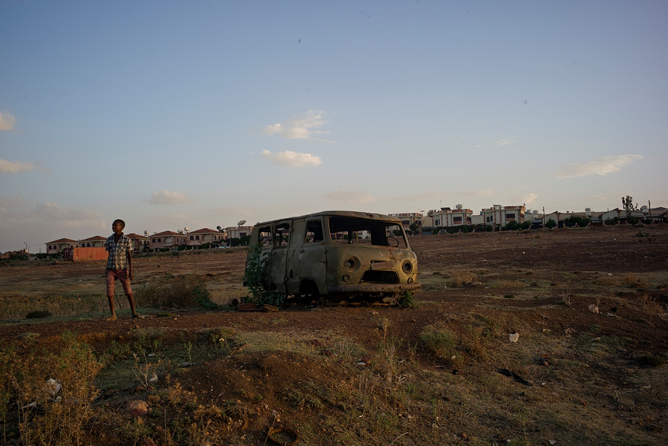
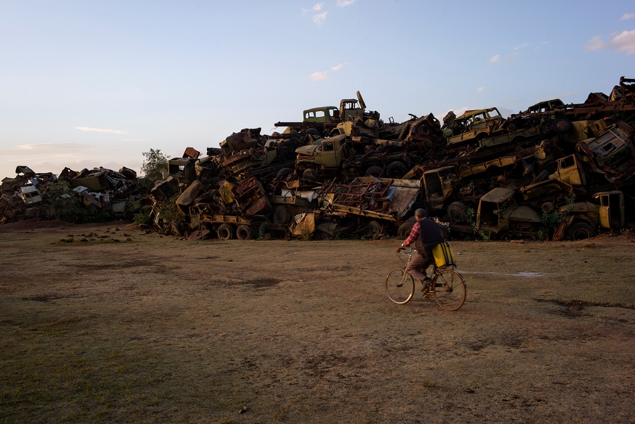
—
Rust-infected and bullet-riddled tanks defy gravity by towering against the cloudless sky. Below them, compressed steel beams, tangled power lines, trashed tank threads, sprawling pieces of metal and burned engine parts are pressed down into the earth like tombstones without names.
“It was this one they used to give orders to the other tanks,” says the 57-year-old former tank soldier, Solomon Berhe, pulling up the grooved handle of the old tank’s communication system.
With knowing gestures, his old and scarred hands move over the piping hot metal of the mutilated tanks; he touches rusty levers, tachometers, diesel tanks and engines, all of which have been flattened to a sea of debris.
“We started out with simple weaponry, then we captured these [tanks] from the enemy. They were easy to repair and then it was just to learn how to operate them, load and aim. Slowly, slowly we got the upper hand,” he recalls.
Most engines are adorned with Cyrillic characters and were donated by the Soviet Union to the Ethiopian dictator Mengisty Haile Mariam during the thirty-year war. If Solomon Berhe closes his eyes, he remembers the sound of roaring engines, the plunking of bullets against metal, the smell of burnt rubber, and, the taste of blood and sand in his mouth.
“It’s a cemetery for tanks,” he says and sweeps his arm in all directions.
It’s an apocalyptic place of kilometer after kilometer of panzer. An unintentional Army museum of debris, showing off the destructiveness of the 1900s, in concentrated form.
These objects symbolize the material costs of the war, which lasted from 1961 to 1991. They reveal nothing about the cost of human lives. If this were a painting, it could be named ”The Guernica of Eritrea.” But it’s not a painting; it’s reality.
“It was a long, horrible and bloody war. Just a few of my friends survived,” Solomon Berhe says and walks off among the remains of a history that have characterized his whole life.
He came of age during the first years of the war and the bombs of Ethiopian air raids convinced him to become a soldier by the time he was 15 years old. But he had to wait until 18 to get his military training.
He rattles off stories of about 50 different tank battles.
“What makes our independence struggle different is that it only partially was carried out as a guerilla war. For a long time it was a regular battle between two professional armies.”
Names of battlefields are forever carved into the world history like Verdun, the Somme, Kursk and Stalingrad. Some of the largest land battles after World War II were carried out in Eritrea, but that’s largely unknown outside for the country’s borders. During that time, all attention was on the sundering of Yugoslavia.
“Worst was the battle in Afabet. After three days we’d manage to capture 50 tanks. It was our Dien Bien Phu, our turning point. Until then we’d been fighting on the defense, but then we could come out of the dugouts,” says Solomon Berhe.
The rest of his response drowns in the wind blowing into the microphone. The wind screen has blown off the small and sensitive mic and Johan, who’s filming the veteran, fixes it while Salomon Berhe continues to poke around among the debris.
It’s our first day in Asmara. The sun is scorching and just like the beginning of every trip, it’s hard to know where the reportage will lead. Having seen pictures of The Tank Cemetery we got the idea to use it for images, let a veteran or two guide us around—if there’s anything there’s a lot of in Eritrea, it’s veterans.
Some journalists who’ve been allowed entry to Eritrea have simply put up a camera and then tried to interview people who refuse. It works great dramaturgically, but how would we get close to some of the veterans and learn their stories?
When we’ve fixed the mic and put it back on, Solomon Berhe tells us how his mechanic brigade, during the last years of the war, fought their way southward toward Adis Ababa joined by the Ethiopian rebel group, The Tigrayan People’s Liberation Front (TPLF).
Memories of battles, cities and names of lost friends flow. He rolled into the Ethiopian capital in his tank in 1991.
But the sense of victory was short-lived.
“The last 25 years have been very, very hard with renewed Ethiopian aggression and the never-ending conflict over the border. I hear the battle drums. I had hoped we’d gotten farther by now. But I guess it’s a price my generation had to pay. Not until now could we begin to develop this country.”
We sit down in the shade of a container, to move on to the more formal part of our interview. Solomon Berhe tells us that his children now are old enough to ask questions about the war.
“After I told them, it’s like they went mute. The new generation is not like us. They’ll never understand why we did what we did. We sacrificed ourselves, we sacrificed everything for our children,” he says.
We take a walk and pass an old bus, tipped over on its side. Solomon Berhe describes his generation as one that was driven by ideals. He and his peers were first to jump out of the dugouts into combat. The Eritrean youth of today have different ambitions.
“They want other things for themselves than spending 30 years in a trench. They want a better life, and they have a right to demand that,” he says in a determined voice.
Solomon Berhe has a brother who lives in Sweden and several other relatives who live in other countries and he understands their choices.
“The situation is difficult, war is bloody, and a normal teenager would think about other things. We need a stable peace, we need to become a country like Sweden,” he says.
With peace he believes the economical development will get a boost.
“The way it is now, there are many who want to go to Europe, but if the situation here, at home, changes for the better, I think young people who have left will return,” Salomon Berhe says, climbing up on a rusty engine and looking out over the park of old tanks.
He slowly walks toward the exit, his hands pressed together hard.
“What’s the most important lesson you took with you from the war?” I ask.
“Never turn your back against the enemy—offense is the best defense. In a tank you have 30 centimeters of steel and a canon in the front, its back has a few measly centimeters of metal sheet. Always show your face, never your weaknesses, because then you’re lost,” he says.
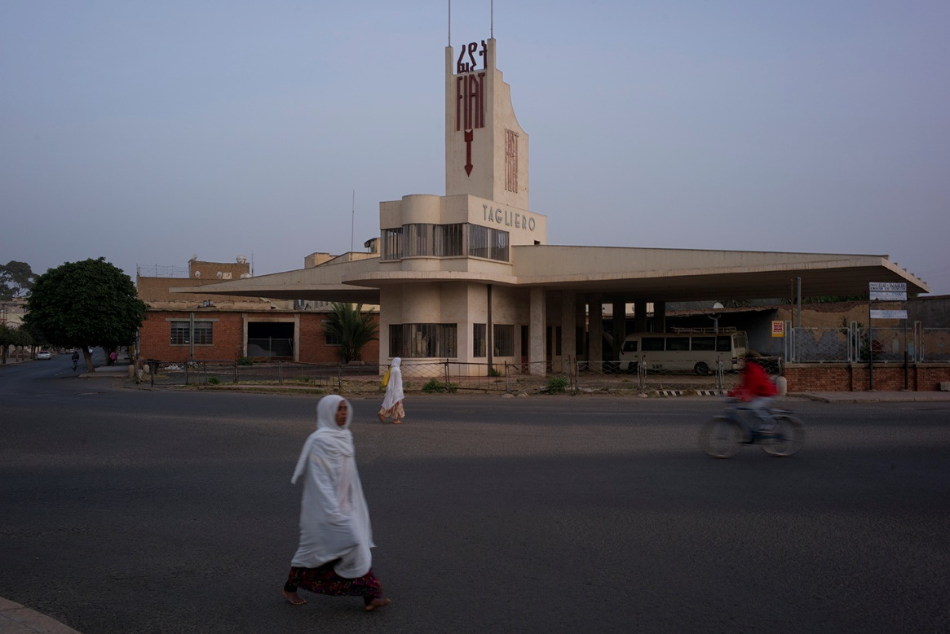
That night we turned off the air conditioner and left the windows open. I turned on the TV and flipped around between the world’s news outlets: Al-Jazeera, BBC and CNN, even the Ethiopian state-owned news channel.
According to the Ambassador, this trip would be a ”myth-busting experience.” But I know how many mine fields there are out there.
Such a small detail in reportage runs the risk of becoming a rhetorical punch line. And yet again, it’s the truth.
I have a moment of regret again, wondering if this trip is right. I’m thinking of an Italian TV-team I’ve heard about that decided upon return not to air any of their filmed material because it would have been perceived as “fluff,” too positive.
The difficulty is in the method. As a journalist you can only report what you see and hear. To be invited on a journalist’s visa is both a blessing and a curse. You are not incognito.
* * *
In preparation for the meetings of the day, I do some research. I read an interview with one of the Eritreans who fled across the Mediterranean to Lampedusa, the Italian island south of Malta.
I read about how people, in a panic, pulled each other down below the surface. How those who could not cope, didn’t have the strength to tread water any longer in the darkness and gave up, shouted out their names so that the survivors could tell how they died, and that they loved their children.
I read about how this fugitive saw the sun rise, and how she was too tired to keep hold of the lifebuoy when she was pulled out of the water, covered in oil. That night, 366 people drowned. In Italy, all victims were accepted as nationals and given a proper burial. Those who survived were not given Italian citizenship. She was one of them.
I jot down in my notebook that people don’t put their children in rickety boats unless their current living situation is scarier than death.
* * *
Outside of an enormous communal breakfast room, two housekeepers are dusting a balustrade. One night in this hotel cost a month’s pay for the employees. The room is empty aside from a Finish mineworker who was turned around because he didn’t have the right paperwork to enter the copper mine.
From here there’s a view of two turquoise pools. Nobody is swimming. This is Asmara’s most expensive hotel. This is also the hotel where a group of Eritreans held a conference about the need to democratize their country in 2001. Dawit Isaak was one of them. Several of the participants in that conference, members of the G-15 group, are either dead or still in prison.
At one of the tables, an Eritrean businessman is enjoying his espresso. When he hears that we are Swedish journalists, he gets slightly irritated.
“Are you going to write this is like North Korea, now?” he says more than asks and puts down his phone on the table.
“I am here to find out what is true and not,” I say, hearing how pretentious it sounds.
“OK, we have no elections where people vote, so I guess we are a dictatorship then, fine write that,” he says, continuing to gush.
“But in the border conflict, we are right. Why can’t the outside world recognize that? Why does everyone keep bullying us? Why do they never criticize Quatar and Saudi Arabia, when they beat down demonstrations? All we are trying to do here is to create a little social justice. Of course we could use reforms, but look at the Arabic spring, it was kidnapped by extremists. And change, what is that really? Should we all change clothes? Should I switch shirts?”
Johan asks if he can take a photo, but the man declines by gesticulating with his hands. I turn on the recorder on my phone, I definitely don’t want to miss anything from this “quote-machine.”
“It was war. We fought. To the last man. All the while, there were 15 people sitting at this very hotel, sipping wine and eating cookies. They stabbed us in the back when we were the most vulnerable. They had plans for who was going to take over the power. Dawit Isaak wasn’t one of them, but he published their list. They should all be in prison, all of them!”
I order an espresso, too, and lean back while our newfound friend keeps on talking.
“The so-called ‘opposition,’ I don’t even want to call them that. They sit in comfortable chairs in front of their computers and complain. Who are they? I know every single one of them from the war. I know who they are, and they are nothing. They complain about our president, he who wears cheap shoes, he doesn’t drink whiskey, or wine, only water in small, small glasses,” he says, showing us on a glass on the table.
I nod and say that we are hoping to interview President Isaias Afwerki.
“What do you do if you don’t have water? Well, you roll up your sleeves and get to work to find some. What do you do if you don’t have electricity? Well, you get to work, draw power lines and build energy plants so we can get some. What does the opposition do? Instead of working they are sitting on their behinds, talking about free elections. I know what types they are—“
I recognize his reasoning from the Järva Field back home in Stockholm and the demonstration in Geneva. The alienation, the suspicion, and, a burning passion for nation-building.
“We are the vulnerable ones, why is everyone attacking us? Look at Abraham Lincoln—he jailed thousands of people—but is still a hero. You have to put yourself in the president’s shoes. What would you have done when Ethiopia attacked? Given up?”
I respond something diplomatic along the lines that it surely isn’t easy to be a president.
That’s when the phone goes off. Johan picks it up after the first ring. We have been granted an interview with the Minister of Information, Yemane Gebremeskel.
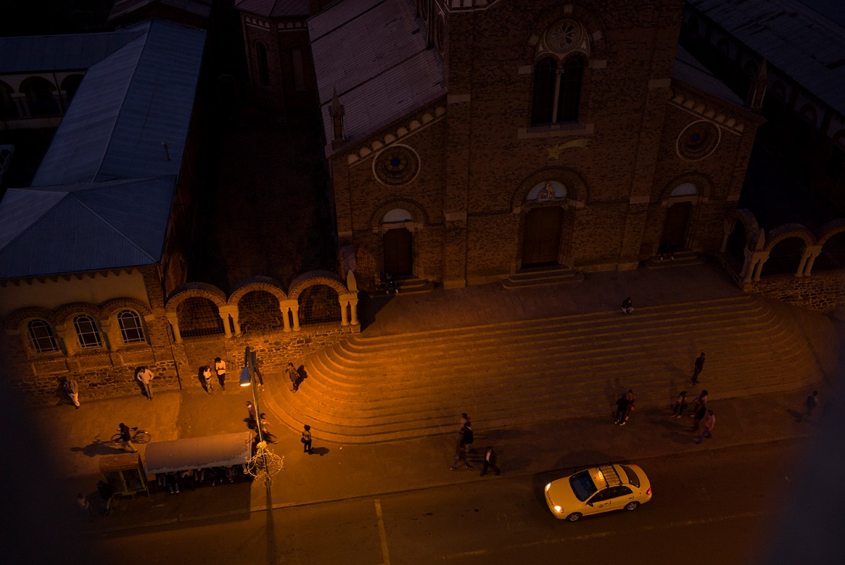
The journey through Asmara goes fast. The cafés lining the streets are full of people and palms stand tall in straight lines along the wide boulevards. All traffic signals are turned off, but the streets are very clean. It looks like few other African capital cities. Everywhere: a hard-to-explain feeling of normalcy.
“Gasoline is expensive, 45 naqfa (3.8 Euro) per liter, but the currency reform [of 2015] has brought down the prices of tomatoes and staple foods,” the driver says.
According to him, the black currency market has vanished after the reform and for all foreigners who travel with dollars the prices have gotten three times as high.
Some of the buildings swishing by I recognize as the futuristic-styled gas station Fiat Tagliero, the brutal art deco-styled movie theater Roma, and the enormous Catholic Cathedral of Asmara, which towers over the heart of the city. The Italian influence carried over from colonial days is evident. But it has been a long time since anyone called Asmara Africa’s “Little Rome.”
When the car stops in an intersection, I look around. I see facades with clocks that have stopped, the paint is chipping and the shutters are hanging askew.
”Frozen in time,” I write in my notebook. It’s a cliché that most people who visit Asmara end up using. Still, it feels true.
A few minutes later, the driver stops outside of the Ministry of Information building. It’s located on a cliff, symbolically hovering over the city. I step outside and see that the security post is empty. There’s a mattress inside of it and it looks like someone has slept on it recently. In front of the security building an older man sits on a broken white plastic chair. Next to him are a crutch and a Kalashnikov. It’s the first weapon we see in Eritrea.
He smiles and points us toward one of the bigger buildings on the property and we walk inside without showing ID, or telling him our errand. On the glass door at the entrance is a note that reads: “I am a proud Eritrean” and inside the entrance a banner for the state-owned station ERI-TVI hangs with the motto: “Serving the Truth.” One floor up, we find Eritrea’s Minister of Information, Yemane Gebremeskel, seemingly completely without security.
The English translation of our book, “438 Days” lays on his wooden and glass desk.
“So what do you want to do in Eritrea?” he asks, opening his arms and sinking down into the sofa.
I explain that most of them who are allowed entry can only report about how people are drinking espressos and eating pastries at cafés, all the while there are also reports of people fleeing the country. If they hope to get other views of Eritrea, they have to allow us to travel around in the country. Freely.
I pull out my map and say that we’d love to visit their Ethiopian border in order to write about the border conflict, that we want to go to the sea, interview the President, meet Dawit Isaak, and visit the military school, Sawa.
It feels like a wish list to Santa Clause.
The minister writes down our wishes on a note and tells us to go over the details with his staff. To speak with military personnel, however, is not going to happen. Visiting Dawit Isaak isn’t, either. And visiting a military school is also out of the question. But the border and the sea, we are free to visit.
“How do we get there?” we wonder.
“How about renting a car? This is a free country,” Yemane Gebremeskel says. “You can speak to whomever you want. You can watch the Ethiopian TV and you can surf freely on the Internet. We don’t exercise censorship on anyone. We don’t block web sites, because the people have a right to information and we are not afraid to give it to them.”
He is a new type of Eritrean politician.
Well aware that his country has a poor reputation around the world, he’s become an online detective, keeping track of all that goes viral about Eritrea.
Recently he struck down a news fib spreading like wildfire about Eritreans being forced to take two wives. And to his 3,698 Twitter followers, he commented on BBC’s newscast about two fatal shootings in Asmara, explaining that it was two draftees who “fell off a truck.”
As in all conversations with ministers, also this starts with the war.
Yemane Gebremeskel speaks of the torch that will be carried around the country in 2016 and during the 25th anniversary year of independence, an act to honor the memory of the 60,000 people who died for it.
“In the second war, 1998 to 2000, another 20,000 soldiers died. If you add in the civilian losses, we are up in the 100 thousands,” he says in a grave voice.
He compares it with the 9-11 attacks on the United States and how that affected a country of about 300 million citizens and its foreign policy.
“I don’t really want to compare in numbers, every life is important, but what kind of effect does the kinds of losses we’ve had have on a country with 3 million people?
Yemane Gebremeskel is convinced that things would have been very different for his country, if another war hadn’t hit them. He was himself one of the negotiators during the “border conflict” and to him it’s still an open aggression, and a bleeding wound, and “everything but a border conflict.”
“The war with Ethiopia was unnecessary, it was fueled by other issues, but presented as a border conflict.”
Commenting on the fact that Ethiopia still occupies parts of Eritrea, he blames the rest of the world for not taking responsibility.
“We can’t have double-edge swords in world politics. International law isn’t something you can choose to follow or not,” the Minister of Information says.
He speaks faster and faster and steers the conversation toward the fact that the Eritrean military draft is a direct consequence of the “Ethiopian war drums,” which is also a reason why the young leave the country.
“The mandatory military service is of course a ‘push-factor.” If you are young in Eritrea today, you have to serve for a long time in one place without being able to travel freely, so obviously that’s not an attractive thing. Even if they are patriots and even if they love their country, few of them will shoulder the honorable responsibility,” Yemane Gebremeskel says.
I am surprised. It is the first time I hear a minister admit the mandatory military service as a reason for why people are fleeing Eritrea. But despite this realization, he’s deeply critical of Swedish asylum policy, which he thinks makes the situation worse and makes more people flee.
“You can’t just automatically give refugee status to anybody-anybody. Political asylum should be given to those who need protection and are persecuted,” he says.
“Yes, but deserting from the Army is a crime, a crime that will send you to prison, and then you’re eligible for asylum if you come to Sweden.”
“Yes, deserting from the army is a crime, but that may result in some form of rehabilitation for a couple of months if you are arrested, it’s not particularly harsh. We can’t crack down hard on it, since we know that the conditions in the Army aren’t easy,” the Minister of Information says.
According to Yemane Gebremeskel, the “refugee issue” isn’t his responsibility, but the media image interests him and he is of the opinion that asylum is there to undermine Eritrea’s military and lure away the cream of the country’s youth. He also refers to a statement by an Austrian minister, who claims that 40 percent of those who claim to be Eritreans are really Somalis and Ethiopians.
“It is the European ‘red-carpet policy’ that has caused this refugee wave. In Sudan, there are 2 million refugees, when they start migrating this summer, how many of them do you believe will say they are from Eritrea?”
I avoid the numbers game and switch topics and ask him if it isn’t difficult to be a Minister of Information in a nation without Freedom of the Press.
“It is true that we don’t have any privately-owned press. But there are newspapers and even if they are government run, people do express their opinions in media without fear of repercussion,” he says.
When I tell him that I’ve read the newspaper “Profile” which publishes in English and I’ve not found one single critical article, he smiles.
“Can the reporters at that publication challenge the reforms of our regime? Theoretically yes. It is not illegal by law, but in practicality it doesn’t happen. It’s because there aren’t that many negative things to report about Eritrea and then our journalists feel that they don’t want to add more fuel to the smear campaign.”
“But isn’t it the role of journalism to be a watchdog that keeps an eye on power structures?”
“That’s how it’s supposed to work, on paper, but is that how it’s done in reality? I have my doubts, I have my doubts,” the Minister of Information says, pondering.
It’s a big difference interviewing an Eritrean politician at a hotel in Stockholm compared to here in Asmara. I can feel how the sharpness of my questions are slipping. How I am holding back, in hopes of getting an interview with the President himself.
I start a long explanation about the big delegation from Eritrea that came to our murdered prime minister, Olof Palme’s funeral in 1986. About the Swedish missionaries and about the times long ago when the relations between our countries were good. And while I’m talking, I think that I am starting to sound more like a politician than a journalist. It’s a little bit like when you have two great friends whom you think should become a couple and you tell them that the other person said something really great about them, and vice versa. I’m not feeling too hot about it.
“Swedish politicians constantly highlight the issue about a certain journalist who’s been involved in a number of domestic political entanglements and they have tried to tie all bilateral collaborations and contacts to this one particular issue,” Yemane Gebremeskel says in response to the loaded question about the relations between our countries.
The fact that “everything” involves Dawit Isaak makes Sweden’s role and intentions “questionable,” according to him. This while he also notes that even if Eritrea and Sweden have different opinions, he’s hoping for closer relations.
“People are allowed to have differing opinions, a relationship is based on more than one thing. The big problem with our relationship with Sweden is America’s strong position in the region and that Sweden has not wanted to approach the Eritrean position because that would mean that they have to go against the Americans.”
“And Sweden is not prepared to do that?”
“In theory, Sweden backs the border commission’s conclusion that Ethiopia is occupying parts of Eritrean territory, but they don’t do anything to help implement these conclusions since Sweden’s ties to Ethiopia are so strong. They talk the talk but they don’t walk the walk,” the Minister of Information says.
The border, always the border.
I look down into my green notebook, even though I already know what my next question is.
“You are celebrating 25 years as an independent nation. During 15 of these 25 years, Dawit Isaak has been imprisoned. Isn’t it possible to think that whatever it may be you are accusing him of, it’s about time for a pardon?
The Minister of Information tries to interrupt me several times, while I’m formulating the question.
“These are complex questions way beyond my mandate. I can’t begin answering questions that are outside of the frames of this interview,” he says.
“So you don’t have any news about his case?”
“I do not want to comment things that weren’t part of the conditions for this interview.”
“Is it possible to meet him?”
“I don’t believe so.”
“Who can answer questions about him?”
“This particular issue has been handled in a specific way and you can’t just come here and talk about one individual as if it was an isolated question. I don’t want to answer any more questions about his case, or discuss it whatsoever,” says Yemane Gebremeskel, looking down.
Outspokenness has reached its limit and now I know exactly where the limit regarding national security is drawn. We leave the Ministry of Information with a certificate that allows us to travel outside the capital city. We are now allowed to photograph and interview and we have a piece of paper stating that we have the right to buy a local SIM-card for our phone. When we step out into the fresh air, all tension and discomfort I felt when we landed in Eritrea is gone.
We have now tested the waters and tread carefully into a new reality. Slowly but surely we are lulled into a different type of normalcy. We fumble for something solid to grab onto, but every doorknob we get our hands on leads us to another door and another door. Even if we aren’t getting the answers we are hoping for, none of the doors are closed and this is a very good sign. Doing solid journalistic work suddenly feels possible.
Outside the Ministry of Information, the old man still sits on his plastic chair. He smiles and waves with his crutch in the air. His Kalashnikov has slipped down on the ground. I put a hand over my heart.
The sun is still high in the sky. It feels like one of those stories where you’ll be lucky if you manage to get one piece of the puzzle per day. The question for us is how many pieces this puzzle consists of. And, what is its motif?

THE RED SEAApril 2016
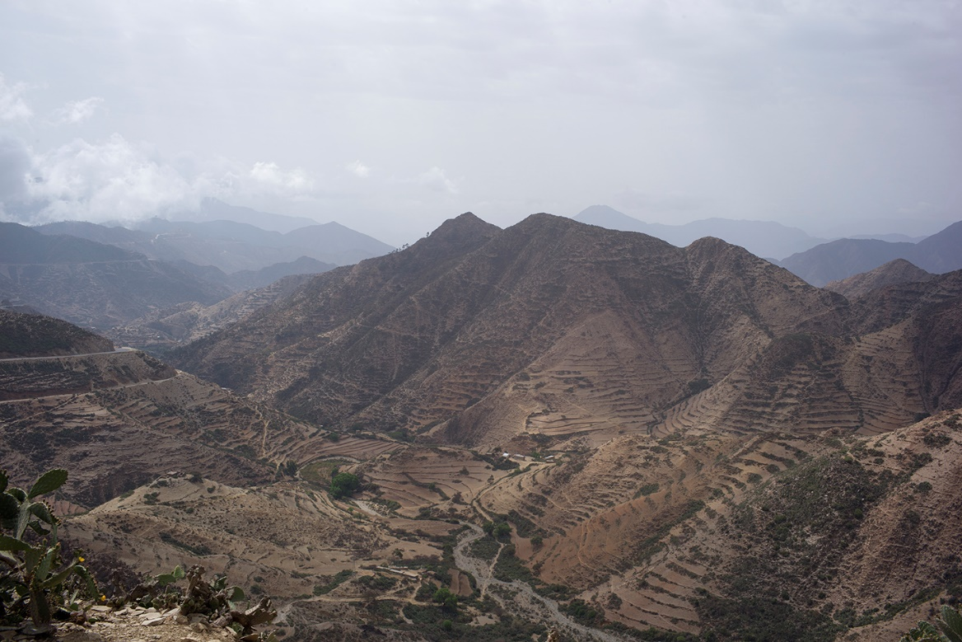
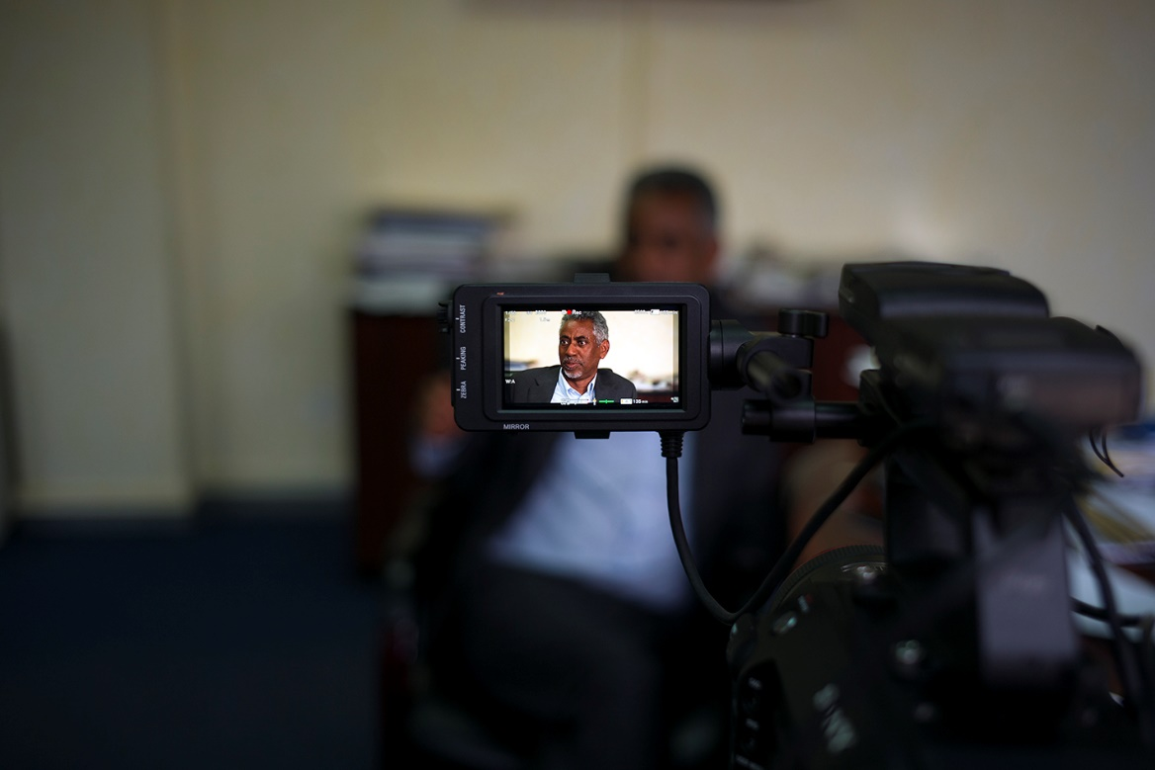
High above the valley—above the fog underneath the clouds—it’s like Eritrea’s intense history has taken a deep breath and holds it in. Not all slogans of the Eritrean Tourist Ministry hold up, but that a trip from Asmara to the port city, Massawa, is a journey of “two hours and three seasons” turns out to be true.
The road is snaking from the top of the mountains, clearing an elevation of 2,500 meters down to the sea. It’s a cinematic landscape. The thermometer on the dashboard of the car quickly increases from +25 degrees Celsius to 35. The light shifts to steel blue and after another hour of driving, all we see is a thick white wall of fog. It feels like being somewhere in the mountain slopes of the Himalayas and the altitude change makes my ears pop. When the fog lifts, an explosion of chlorophyll green hits us. I immediately understand the foreign correspondents who fell in love with Eritrea during the war. This nature and guerilla soldiers reading philosophy and discussing Italian architecture—it must have been irresistible.
We stop and buy a watermelon. The salesman swears it weighs exactly 1.3 kilos and is “sweeter than sugar.” Our driver doesn’t bother to demand it being weighed, and explains that it’s the unique trust that keeps the country together.
“If it’s not sweet you can come back here and smash it to the ground in front of me, and I’ll give you your money back,” the salesman insists.
We keep on driving East toward The Red Sea. We booked the rental car with a driver ourselves, and we see no roadblocks or checkpoints. The asphalt is new and smooth. This road was built by the Italians during the colonial era, and since then has been an important connection between Asmara and The Red Sea. The parallel railroad, built in the late 1800s, is an impressive display of engineering. Along the road we sporadically see soldiers carrying rocks or planting trees. I remember the minister’s words about how most soldiers doing their military service were not stuck in the trenches, and it seems to be true.
During the two-hour drive we don’t meet one single car. Maybe it’s because of the high gasoline prices, maybe it’s the UN sanctions put on Eritrea for allegedly supporting Al-Shabaab and Asmara’s dispute with Djibouti. But every now and then we see one of the yellow trucks on the road below us carrying copper from the Bisha Mine, moving like ants with their valuable cargo to the coast. We are traveling along Eritrea’s financial artery.
Behind us, the mountains are towering like a fort, and the heat hits me full force. This is one of the warmest cities in the world with a high humidity and an average temp of +30 Celsius. Suddenly my nostrils recognize the familiar smell of seaweed and saltwater.
* * *
A dark gray container filled with copper is swaying silently in the air as it’s lifted by an enormous crane up in the air,and loaded onto “African Swan,” a cargo freighter destined for China. It’s surprisingly silent, almost spooky. As goods worth millions fill the bulk of the carrier, the only sound is that of a forklift.
On top of a tall wooden structure, way out on the pier, the port superintendent stands, keeping an eye on the work.
“We have expanded enormously the past few years, thanks to the copper mine. We have new cranes, new trucks and now we’re operating on double-shifts in order to manage the volume,” he says passionately.
He doesn’t want to be interviewed.
“The instructions from my superiors is to only give you factual information,” he says, but the pride over his port and the work they are doing is so big that he agrees to letting me take notes.
“All gasoline, imported food and electronics in Eritrea have passed through this port. Out in the water-way, three more container vessels are waiting to come in,” he explains.
To say that the port in Massawa is at a strategic location would be an understatement. Placed in the middle of Eritrea’s 1,000 kilometer long coastline, the port is a place for projection of dreams for the nation, kind of like a Singapore in Africa. This is the entrance to Eritrea’s isolation.
“The development is going even faster now that investors are beginning to notice Eritrea,” the port superintendent says, adding that he’s hoping for a bigger yard, where there’s room for more containers and fixed cranes.
The port area looks like one large Lego project with yellow, red and blue containers moving silently over the pier and through the eye of the needle.
Even if the copper prices are lower today than a few years back when the Chinese industry was spinning at a top rate, business is still good for Eritrea.
“The only limitation we have is that we have to use mobile cranes, or the ones on the vessels at loading and unloading. With fixed cranes we’d be more competitive,” says the port superintendent, stepping aside as a forklift branded “Kalmar” comes swishing by.
“Part of this port is specially constructed for the unloading of gasoline and diesel, and another part has been expanded and fitted as a container terminal,” he says. “We’ve had Belgians from the port of Antwerp here training us, but know we know how to run everything ourselves, so we’ve sent them on vacation. We like to partner up with foreign expertise. They educate us and then leave so we can run our own port,” he says. He is also the only person in Eritrea whom I hear saying that he’s gotten a raise recently.
Down by the water, the waves are crashing in over the miles upon miles of long sandy beach visible from the pier. While the import and export business is enjoying an upswing, the beach chairs remain empty. This weekend local tourists will come to the beach resort, they say, but right now nobody is there.
Outside of the Eritrean archipelago lays an additional 300 nearly untouched islands with long, sandy beaches.
Grand Dahlak, the hotel at the tourist resort in the city of Massawa, seems deserted. The enormous pool is like glass; nobody is swimming.
In anticipation of potential tourists, the owner keeps all the rooms spotless and the floors polished; he’s ready for the time that may come.
It would be easy to call Massawa a ghost town, but also a little unfair. Traces of war are still visible on the facades in the city. After the Ethiopians were chased out of the city, they responded by bombing Massawa relentlessly for six whole days in February of 1990. Almost all buildings were destroyed or damaged.
One of those buildings that has been restored is home to The Northern Red Sea Museum. It was founded in 2000 to mark the city’s liberation. In front of the museum are captured Ethiopian military boats, and Eritrean flags flapping in the wind at every light post, while inside, the first visible object is a 14-meter-long whale. Photography is prohibited.
“Many museums keep replicas of artifacts, that’s why it’s not allowed to photograph here,” our guide explains.
I jot down the number of native Etriean turtles, fish and corals. In glass jars, mollusks rest half-dissolved in alcohol. The museum displays a mix of ethnographic, military memorabilia and natural history.
The guide shows us emperor Haile Selassie’s bed that stood in his summer palace and tells us that the Italians occupied Massawa by 1885 and that it was the colonial capital of Eritrea in 1900. Then the Italians moved it to Asmara, because the climate there was more comfortable.
We see grim-faced Askari, Eritreans who fought for fascist leader Benito Mussolini during World War II. In 1941, the British drove the Italians out and took over the administration of Eritrea.
“According to the British, we have two things: our love of freedom and our love for education. The Italians just saw us as soldiers or farmers,” the guide explains.
After World War II, many hoped for Eritrea’s independence, but the UN decided that the country should be a part of a federation with Ethiopia.
Portraits on the museum walls show the leaders of the resistance movement that began in 1958. About a year later, the armed struggle for independence began. The guide takes us into the next area of the museum, which, according to posters, shows the “bitterness of the struggle, the creativity of the freedom fighters and the malice of the enemy.”
In one photo the president’s advisor, Yememe Gebreab, interviews a Russian prisoner of war. The photo doesn’t display a year “due to national security” but I recognize the advisor.
I’ve heard about these photos before I arrived in Eritrea. The Eritrean war photographer, Seyoum Tsehaye, who was arrested at the same time as Dawit Isaak and has also been in prison for 15 years, supposedly took them. In a glass cabinet next to the black and white photos are the world famous plastic sandals the Eritrean Army wore, where the soles were put on backwards to confuse pursuers.
Other displays show how the camels carried water to the soldiers, homemade gasmasks and short-shorts made of burlap. The explanation behind the short shorts of the Eritrean Army was that the tailor tried to get as many pairs made with what material he had. In another room, the Battle of Afabet and the tanks are on display.
“The revenge by the Ethiopian Army after the loss was horrific, they charged into a village and massacred everyone,” the guide says.
On the floor are gypsum mannequins of an Ethiopian soldier who has killed a child and stands with his foot on its back, ready to shoot the mother. Thirty years and 100,000 dead people later, the war ends and independence is a fact.
It seems as if the time is frozen in 1991. The clocks have stopped, the display cases are locked and the texts are laminated. The state of war and state of emergency becomes eternal. The Ethiopian soldier’s foot on the child’s back is cast solid.
But then I see an artifact from March 7, 2007. On a wall is a mounted seagull that was captured on The Red Sea. On the seagull’s left leg they found a ring from the Swedish Museum of Natural History in Stockholm. After a flight of 5,435 kilometers the seagull was captured, and the museum guide tells us that it was immediately dissected to make sure it didn’t have the bird flu. It didn’t.
The Minister of Defense—April 2016
He wears a suit, leather shoes and a white shirt. His handshake is firm and he invites me to sit down.
“You have to understand what type of nation Eritrea is. We are children of war, we have a mentality rooted in war based on survival,” says Eritrea’s former Minister of Defense,” Sebhat Efrem, making himself comfortable in his chair.
His office is spacious and filled with maps, books, photographs, souvenirs from a life in the trenches and the inner circle of national politics. He is now Eritrea’s Minister of Energy and Mines.
The sofas are worn and unpretentious. And again, to enter his office, there are no metal detectors or guards. We are back in Asmara. Outside, the weaverbirds are singing.
“If you look at buildings and the infrastructure, you could say we’re stuck in time. In the 1930s we were like South Africa, now the difference is enormous. What happened to us?” he asks rhetorically, and puts down his coffee cup on the table before answering his own question.
“War with Ethiopia, war with Sudan, war with Djibouti, and war with Ethiopia again,” he says and knocks with his knuckle on the table.
In Eritrea, Sebhat Efrem is known to be a tough rhetorician. This is how he summarized his philosophy after the war: “If there is a crack in the boat it will sink. Eritrea is like a boat and the enemies’ main goal is to create a crack and we must ensure that the Eritrean boat will not crack.”
According to him it’s the nations “soft values” that will shape Eritrea’s future.
“National security is comprised of several things. Weaponry is one thing, but a country’s psychosocial aspects, the soft values, is where things really are decided and if you fail with this, you fail with everything.”
As a Minister of Defense it was his responsibility to disarm the army after independence. The demobilization began in 1994 and the nowadays infamous compulsory military service was instituted to “build dams and roads.”
Four years later, Sebhat Efrem had his hands full with a new war.
In his mind, the cause of the war didn’t have anything to do with a border dispute or even the city Badme, but about “Ethiopian domestic policy.”
“Our country is small and completely lacks strategic depth, we had no other choice but to stay and fight. There was nowhere to retreat,” he says.
During the three attacks by Ethiopia, the only order he could give was for them to buckle down and fight to the last man. He draws parallels to Sparta and Battle of Thermopylae. He describes Ethiopia’s actions during the war as “madness.”
“Einstein’s definition of madness is to repeat the same mistake over and over and that’s exactly what Ethiopia did.”
The former Minister of Defense describes the neighboring country’s regime as petrified of losing power, constantly paranoid.
The current situation with a “no-war-no-peace” scenario is, according to Sebhat Efrem, a hard nut to crack, one that only time can resolve.
“What happened was a tragedy, and still, nobody has learned anything. In the situation we are now, time is the best teacher both for our country and Ethiopia, but also for the international community,” he says and pours himself more coffee.
I’ve requested a meeting with Sebhat Efrem to talk about Ethiopia and what he thinks of the risk of another war. First he wants to know if I’ve been in Fisksätra, a small town on the outskirts of Stockholm. I nod.
“I have a sister who lives there,” he says, excuses himself and walks over to his desk to grab his laptop.
He tells me about the Swedish missionaries who laid the foundation for the educational system in Eritrea, but says it’s been a long time since he had any visitors from Sweden.
“I wish more Swedes were interested in Eritrea so we could begin new partnerships,” he says, sitting down again.
I sit down next to him and wait the moment it takes for his old laptop to start up. The screen turns blue and he clicks on a PowerPoint presentation with the name “National Security Strategy.”
“On paper Ethiopia is a major power, supported by the legend of an empire, but there’s been a paradigm shift in the country, something that the outside world has not noticed,” the former Minister of Defense says, and clicks up more slides of the presentation while explaining how the country is overconfident in its military force.
I move closer to the former minister to be able to see the screen better, while he describes a paranoia in Ethiopia that he believes will lead to a collapse of the state.
“A minority is trying to rule a majority and to succeed, they chose war. That’s their only chance to keep the nation together and divert attention from the real problems.”
Sebhat Efrem’s analysis also leads him to believe that there’s a big risk of future wars, and that he’s troubled by what he hears from the other side of the border.
“The Ethiopian state is tearing at the seams and we know how a state like that collapses; In the hands of those where the final decision rests, isn’t the rebellious strength but the weakness of those in power. Insurgents used to be a figment of imagination they frightened the citizens with, but now they are a reality. They have created a Frankenstein’s monster.”
I take notes and ask how he can be so sure about this looming collapse.
“Their ethno political culture is a time bomb, which will explode and then Ethiopia will vanish in its wake. Their entire huge army will fall apart without us having to fire a single gun,” he says confidentially.
He says that during the last war he already warned the Ethiopian regime about the risks of building a state where a minority of six percent, those from the Tigray region, would hold all the power positions . Eritrea chose a different path and disbanded the ethnically divided units already before their independence. He shows me a slide over Ethiopia with red arrows pointing away from the Amhara-, Afar-, Ogaden- and Oromo regions, and toward the capitol city.
“This is the map of the state collapse, how armed rebel groups are sweeping in toward the epicenter from all geographic directions. It will be a catastrophe of biblical proportions.”
The most pressing issue is the protests by the Oromo people. During this year alone, Ethiopian security forces have shot 120 civilian protesters to death.
“They are looking for revenge because they’ve been treated like secondary citizens for too long. They make up a majority of the population and is a power that could eradicate everything,” Sebhat Efrem says.
Unless the constitution is changed, he believes the state apparatus will lose its legitimacy within a few years.
“The army consists to 60 percent of people from the Oromo region, so when the politicians play the ethnicity card, it’ll be like pouring gasoline on the fire.”
When I ask the former Minister of Defense to show me some facts to support his doomsday scenario, he says it’s “hard to quantify the decline.”
“But you can already now anticipate the massive flow of refugees, epidemics, lawlessness and how the Ethiopian Security Service increasingly becomes a state within a state?”
He presents his theories, not with malice but with sadness. Ethiopia faces a choice, he says. The violence will either continue to escalate, turn into ethnic cleansing and a state collapse, or, if they change their constitution and retreat from Badme, there is a chance they can avoid disaster.
“Ethiopia is pressed up against the wall, and their options are running low. If they don’t retreat, their regime will collapse under its own power.”
His summary of Ethiopia is “a poor nation that has never won a war.” But despite his description of a galloping crisis, the former Minister of Defense thinks the process will be slow.
“Ethiopia is like a dinosaur, you won’t kill it quickly. It will take time. But they are afraid, wounded and surrounded now.”
In order to save Ethiopia, Sebhat Efrem believes nations like Sweden can play a role. But it demands quick action.
“The international community has ignored the warning signs, because they’ve had a romance with the country. But politics needs to be established in reality, not emotions,” he says, closes his laptop and calls for more coffee.
“What will you do to make sure Eritrea doesn’t walk down the same path?”
To that question is only one answer, he says—develop the Eritrean culture.
“Some politicians want to exaggerate their roles. Take the Cold War, for example, it ended by itself. Suddenly the people destroyed the Berlin Wall. Nobody saw it coming. Politics is full of surprises and I don’t think we should underestimate the spontaneity of human kind,” he says.
He also believes that right now, Eritrea’s “soft powers” are strong.
“Culturally and psycho-socially we are in great shape, especially in comparison with our neighbors, and if we only have the moral strength, the development will come by itself.”
Another advantage for Eritrea is time, he says.
“The road to economic growth and stability is more of a steady trickle, than a quick economic miracle. The best teacher is time.”
The fact that Eritrea is celebrating 25 years of independence, he says, is mostly a numbers game.
“That’s like counting the feathers of a flying bird. What does that say about anything more than that time has passed?” he asks.
But if he was to give one example of time as a good teacher, it is that the new generation is inheriting a nation in relative peace.
“The children of this country don’t follow in the footsteps of their fathers. The daughter of a farmer can become an engineer.”
The only worrisome detail, says the former Minister of Defense, is that potential investors can be scared off by all the “noise.”
In a month or two, the UN Commission of Inquiry will present its findings about whether Eritrea is guilty of human rights crimes or not.
On the walls of the former Minister of Defense/current Minister of Energy and Mines hangs a photograph of the circumscribed copper mine, Bisha. A huge open-cast mine, located 150 kilometers west of Asmara and on the border to Sudan, which so far has replenished the Eritrean Treasury with $800 million. On the question of whether he’s read Amnesty International’s report, accusing the Bisha-mine’s management of slave labor, he nods.
“I read all of Amnesty’s reports, all of us in government do. But what do you do with a report like that if you’ve thrown blood and fire? If your country is threatened by war? I wish we didn’t have to have mandatory military service. If they would have tried to come here in person, they would have seen that we are doing great.”
In a Canadian lawsuit, lawyers demand that the mine be closed because “all cooperation with the Eritrean government supports the abuse.” Several witnesses in the report describe a torture method called “the helicopter” where the victim is undressed and has their arms and legs hogtied on their back.
Mining and Energy Minister Sebhat Efrem would rather highlight the unique aspects of the Bisha mine’s operation.
“In many African nations we’ve seen how all that’s left after a few years of foreign mining is a contaminated hole in the ground. We wanted to see if it could be done a different way. We were curious if it would work to collaborate with a foreign mining in extracting minerals.”
The result was an Eritrean-Canadian project where the goal was for the foreign mineworkers to educate the Eritreans, so that eventually, the Canadians would no longer be needed. The Mining Minister also wants to downplay the enormous expectations what income a single mine could yield.
“So far we only have one mine. The money from it will not go far. Today we don’t pay the soldiers or the veterans well.”
The plan is, now that they have experiences from the Bisha mine, to invite more mining companies, as well as open up the market for oil, natural gas and tourism.
“Wars are ravaging around us, but here, in the eye of the storm, is where the stability and possibilities exist. We are open for investments, but we have to keep the control of our cultural identity. If we lose that, we have no use for the new income,” he says.
The sun slowly sets outside Sebhat Efrem’s office.
If Eritrea’s economy continues to grow, the former Minister of Defense has one single wish.
“The money would immediately be invested in our national healthcare.

THE CHILDREN’S HOSPITAL
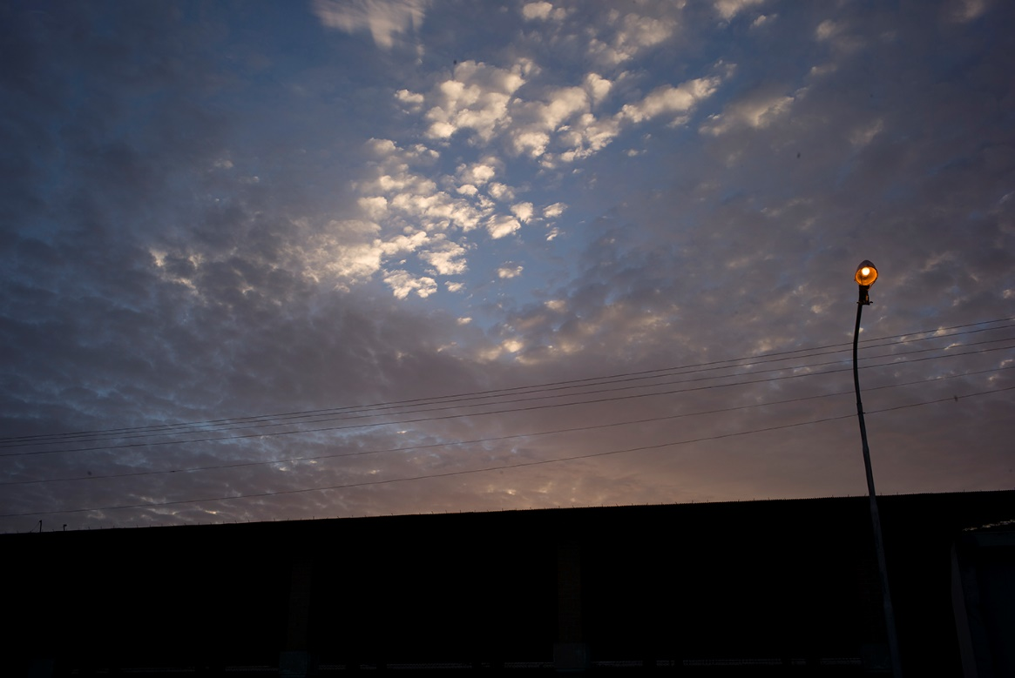
***
Just before midnight, pediatrician Samson Abay is woken up by his colleagues at the Mendefera Referral Hospital. He half walks, half runs the short distance between the house he rents and the ward for premature babies.
The oxygen saturation alarm has gone off in one of the incubators and he quickly washes his hands, puts on a pair of gloves and begins to correct the oxygen line that goes into the baby’s nose.
After a few minutes, the level is almost back at 100 percent again, and everyone around him can relax. Samson Abay gives instructions to the night shift personnel and walks with tired steps back to his house. In four hours, he needs to be up again.
When I meet Samson Abay, he’s had a few hours of sleep. The sun is high in the sky and it’s warm in the hospital rooms. In the background heart rate monitors are beeping.
Most reports from Eritrea are about refugees, repression and the lack of free press. There are other stories also, stories that rarely make it outside of the small nation’s borders.
In the waiting room families are waiting to visit a patient in all the different departments of the hospital. Around them is a lush courtyard with fruit trees that are harvested by personnel and patients.
“Most of those who seek medical attention come in with different infections in the respiratory tract, pneumonia, and some with dental problems. But we are starting to get cases of high blood pressure, hypertension and diabetes, so-called Western diseases,” says Samson Abay.
For a long time, Eritrea was the country with the highest maternal mortality rates in the world. Today, that’s been reduced by 75 percent. The mortality rate for children under five years old has decreased by two-thirds and even the malaria cases have gone down, dramatically.
“Today 93 percent of all pregnant women in the region come to the hospital for a check up, but about half of them still choose to deliver their babies at home,” Samson Abay says.
I thought for a while before I said yes to the invitation of a tour of the hospital. On one hand, this is exactly the type of story that the government wants written. On the other hand, a visit is necessary in order to understand what the regime-friendlies are defending.
“We have managed to reduce infant mortality, but the prenatal-mortality remains the same. It’s the same today as it was 25 years ago,” Samson Abay continues, and I notice that he walks with a slight limp.
When he was four years old he fell down a staircase and the doctor who treated him kept him in a cast so long that the muscles in his legs were paralyzed.
He opens the doors to the pediatric ward, where there are about 10 empty beds in a row.
“Five years ago this room was filled with babies, but after the new way we organize our work now, we catch people out in the villages in an earlier stage,” he says.
Even if the infant mortality is going down, it’s a big challenge to save the premature babies born out in the villages. This hospital covers a region with 800,000 people and 2,300 children are born here every year.
“It’s in the villages where we need to put in more resources. To get these rates down, we need to be out in the villages where they are born, and assist. Once they come to the hospital, it can be too late,” Samson Abay says.
To spread the knowledge of how to rescue premature babies, he has written an educational textbook.
“The basics are food, warmth and breastfeeding. In educating on these issues, we can save a majority of babies who aren’t in need of high tech care.”
The explanation for the improved statistics is that they have managed to do a lot with the resources on hand.
“We cannot afford to spend millions on technology, so we are trying to work with informative care. A majority of people dying in Eritrea, do not die from cancer or car accidents, they die from simple and treatable diseases. That’s best solved by developing our society. Ensuring the access of clean water and building schools,” Samson Abay says.
In the nearby villages, he educates volunteers who can handle diarrhea, pneumonia and dehydration. The last case of malaria was discovered three years ago.
“We have worked with these ‘killer diseases.’”
At the same time, he is also up against prejudice for modern medicine.
“In parts of Eritrea people believe that it’s the ‘evil eye’ that has fallen upon sick children. And some people believe they have to cut off the cleft palate in children who vomit a lot.”
Sometimes the hospital receives children who have had their teeth pulled because relatives believed that’s what caused the diarrhea.
“But it gets more and more rare as awareness increases. And here, women’s organizations play a larger role than that of the hospital,” he says.
Samson Abay studied medicine in Ethiopia when the war broke out in 1998. Shortly thereafter he, just like 70,000 other Eritreans, received an order that he was to be deported back to his home country. Colleagues of his were literally pulled away in the middle of ongoing surgeries and sent to the border, in busload after busload.
“I hid so I could finish my education, my small frame made people think I was younger than I was and that was my advantage,” he says.
A lesson in math is being taught in a classroom at the hospital area. In addition to care, those who are hospitalized longer also get education during their time there.
“When I came here I knew nothing about nothing, but now I’ve learned how to write and do math. I have my own cellphone and can call whomever I want,” says 28-year-old Fatima, who is being treated for a fistula.
Suddenly I notice that Johan stopped taking photos.
“Why are you not taking pictures?” I ask.
“We can’t include a scene like this? It’s straight propaganda!” Johan says.
“There’s a story here, how it will fit into the reportage, we’ll see,” I say.
After the tour of the hospital’s different wards, we sit down under the comfortable shade of a tree at the hospital cafeteria.
Sweet tea is carried up to us and Samson Abay takes out his iPad to show pictures of children he has treated. When a team from BBC, recently visited Eritrea, he was the one showing them around at the hospital.
“After the tour the reporter walked around a corner and whispered into the camera that everything felt ‘choreographed’.”
He finds the video clip on his iPad and plays it for us.
“I am very disappointed, it was my patients she met,” he says and shakes his head and turns off the clip. “My patients are real and this hospital is real.”
His distrust of foreign journalists looms large.
“When I meet a mother and her child that I’ve cared for, and they know that I’ve made a difference, then BBC can say whatever they want about my work here,” he says and puts down his tea cup.
Before he goes back to his hospital ward, he looks through his iPad again.
“I work for my country, not for the money,” he says. “If it was about money, I would have moved abroad, why doesn’t the BBC understand that?”
Samson Abay explains that he has decided to live at the hospital compound in order to check in on the children he’s treating once at 8 pm, then at 10 pm and one last time before he goes to bed at midnight.
“We are a poor nation, who have been at war for decades but have to do what we can with the resources we have. Good luck in your hunt for the truth,” Samson Abay says to me as we part.
Martin Schibbye
**************************************************
ERITREAEN-The Dictatorship That
Came in from the Cold
JournalistMARTIN SCHIBBYE FotografJOHAN PERSSON
Journalist
Martin Schibbye
Twitter: @MartinSchibbye
Fotograf
Johan Persson

Despite harsh criticism by the United Nations and human rights organizations, Eritrea’s ministers in Asmara feel more and more positive. Several nations have begun to make contact with Eritrea for different reasons. Eritrea doesn’t want to lose their young generation while Europe doesn’t want them knocking at their door.

PART 3

The taxi driver looks confused when I tell him to drive to the “party headquarters.” The confusion is not over what party—there is only one—it is over which one of its headquarters. After a moment of back and forth, the taxi stops in front of a large and impressive building marked “Red Sea Corporation,” which is the corporation the Eritrean state has formed to handle collaborations with foreign investors.
After new instructions, the taxi driver takes us to another, equally impressive building, adorned with Eritrean flags and the slogan: “Victory to the Masses!” above its entrance.
On the first floor, the president’s advisor, Yememe Gebreab, receives us. He looks sharper than he did six months ago in Stockholm, after he had gone nine rounds against all of Europe’s media.
We sit down around a small group of sofas. We noisily move the furniture to give space for a camera. Yememe Gebreab looks at us with curiosity.
He appears to be in a great mood, and it’s not just the advantage of being interviewed at home that factors in. The winds have changed for Eritrea thanks to a new agreement with the EU that will give the country €200 million from the union’s development fund, despite loud protests by the European Parliament.
The EU has, in lieu of the massive refugee wave, an interest in a stabilized Eritrea. Eritrea doesn’t want to lose their young generation, and Europe don’t want them knocking at their door, either. On top of that, the war in Yemen has brought Eritrea into a regional coalition with Saudi Arabia, and European politicians have changed their stance on the refugee issue.
“Many European countries are starting to understand the situation in Eritrea and they are contemplating whether it’s so smart to give everyone claiming to be Eritrean political asylum,” says Yememe Gebreab, stressing the fact that he’s been following the change closely.
“More and more politicians, journalists and investors are visiting Eritrea and getting a more balanced picture. They see that we are at peace and in harmony, that people are living their lives and that the government isn’t corrupt,” he continues.
According to Yememe Gebreab, several countries are discussing whether it’s safe to send back Eritreans whose asylum applications have been denied. “But we are still ways away from the situation when Europe sees Eritrea as a place of opportunity, not just as a problem that has to be solved.”
Just a week ago, Swedish Cabinet Secretary, Annika Söder, visited him. He can’t remember the last time a Swedish politician of that caliber visited Asmara.
“We discussed everything, the human rights situation, our relationship to the ongoing investigation by the UN system, the migration to Europe. Everything was on the table.”
Yememe Gebreab hopes that Sweden will be one of the first nations to start a new chapter.
“There are long term relations between our nations to fall back on. Sweden is a part of Eritrea’s history because of the contribution of the education system by missionaries,” Yememe Gebreab says.
He also highlights Sweden’s proactive role on the African continent during the 1960s and 1970s and the large number of Eritreans currently living in Sweden, as two important factors to build a future upon.
He believes the existing differences can be handled through transparent discussions.
“To have an antagonistic relationship hasn’t been productive so we are now trying to find our way back to each other, but we still have some ways to go,” he says.
The interview gets interrupted by Johan, who wants to change camera lenses in order to get the President’s face in focus, instead of my back.
The advisor looks on with interest. During the 30-year war, he was himself a reporter in the trenches. We chitchat about how all media wants more and more visual content and multimedia these days. During our last interview, we spoke a lot about Dawit Isaak and when the lens is replaced, I go straight to the point.
“Yemame Gebreab,” I say. “Do you have any news about Dawit Isaak?”
The President’s advisor leans back and inhales. I stare at his nose. What if I get a scoop now? I think.
“I’m not qualified to discuss his case during this interview,” he says to my surprise.
I’m startled. The President’s advisor, who just six months ago, spoke freely about Dawit Isaak and the Freedom of the Press, now is not qualified to discuss the case at all?
I try a different angle and ask about possible amnesty.
“Isn’t it time to move on, now that Eritrea is celebrating it’s 25thanniversary as independent nation?”
“In regards to amnesty, the regime can decide and give it, but I am not qualified to speak about this issue during this interview,” he repeats.
Unprepared for the curt response, I swallow and say that I have to respect his unwillingness to discuss the issue.
Perhaps the fact that I’m still hoping for an interview with the President makes me back off.
I study his face and think that a man like him must have had dreams and hopes during the decades in the trenches. He and his party didn’t just fight for independence, but also for “democracy and justice.”
“After 25 years of independence, there are no privately owned newspapers, no elections have been held, just to name two things I associate with democracy. Is the Eritrea of today the nation you dreamed of?”
Yemame Gebreab moves in his chair.
“Most elections held in the world today are over rated and I do not believe all those elections represent the desire of the people. We can disagree on this, but look at the election in Ethiopia where the ruling faction won 100 percent of the seats in parliament. Is that democratic?”
He believes in a “unique electoral system,” which they are experimenting with themselves. Nobody from the outside should believe that they can influence Eritrea with their reprimands and ‘good advice.’”
“We are not against elections, ideologically, but we’re also not trying to do what appears to be the most popular way of doing things in the world this particular month,” Yemame Gebreab says.
But he rejects that the reason being for why no elections are held would be fear of losing power.
“We don’t have an interest in keeping power, none of us have become rich from our positions. We all would have made more money if we had done something else instead of being politicians. We want our people to get their freedom and are open for a discussion as to what works and what doesn’t.”
The fact that their goal has not been reached, he explains is due to the war and border conflict.
“It wasn’t as easy to build this country as we thought, and that’s why we ended up in a new war and have had to do the building during a turbulent period.”
To offer context, he urges those who judge Eritrea to also look at all that could have happened in the country, and what’s been avoided— the facts that Eritrea isn’t hit with violent ethnic conflicts and that members of the ruling party have not made themselves a ruling class.
“We haven’t made ourselves rich and we do not travel around in large convoys with bodyguards. We have remained true to the people who fought in the war. We live in the same neighborhoods and our children attend the same schools.
Despite the heated rhetoric between Eritrea and Ethiopia, Yemame Gebreab, believes another war is unlikely, but at the same time wars sometimes come as complete surprise.
According to Yemame Gebreab, “The refusal of Ethiopia to stop occupying our land, based on their hopes that we will collapse, [the idea] that we are a weak nation and that they feel they have the support of the US and the EU” all represent outdated values.
“Our economy is growing and the outside world has begun to doubt Ethiopia as an ally. Those who put money on the collapse of Eritrea will be deeply disappointed,” he says.
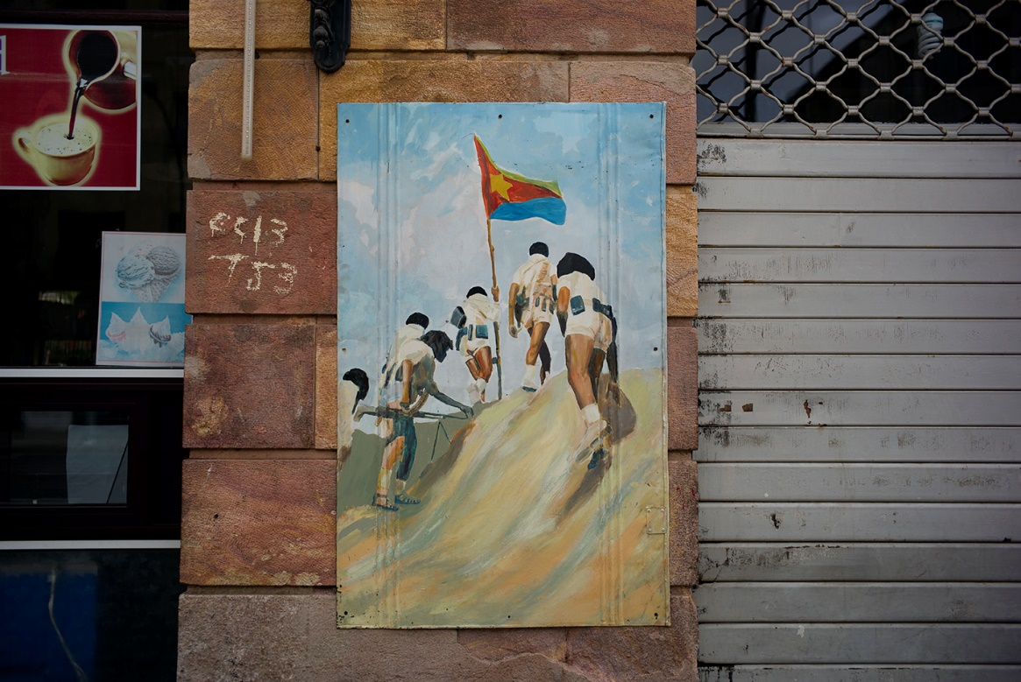
The following day, I rig the tape recorder on a rickety coffee table. Johan fiddles, restless, with his new camera and fires off a couple of shots.
Both of us are starting to get frustrated over the number of interviews we’ve done so far without getting the voices we are looking for. And now it’s time for another one. It’s clear that we’ll have to make another trip, that this reportage is an ongoing journey.
The Facebook logo is painted on one of the walls of the Internet café. One hour’s worth of surfing costs $10. Nobody checks your passport upon signing in, and no websites are censored. A hand written note urges the users not to watch porn. Around us are youngsters, chatting with relatives around the world. Still, getting online feels like breathing through a straw due to the extremely slow connection.
We talk about Eritrea as a vacation destination. About whether there may be a type of nationalism in third world countries that are foreign to the so-called first. It feels like the current “state of emergency” slowly but surely becomes the norm— even for us. We’ve gotten used to it and the realization is unnerving.
We are now part of a number of journalistic teams who can say that we were “allowed entry.” You are free, at the same time you are not. No matter how many questions you ask, or what angle you take, you still can’t reach all the way in, and we realize that after this trip, we have to also get to the refugee camps in Sudan.
While we are discussing our dilemma, Meala Tesfamichael walks up to the silver coffee table and sits down. She pushes her sunglasses up on her head and orders tea.
“I am so tired of the question: ‘Why did you return to Eritrea when so many others flee from here?’” she says and laughs.
Three years ago, Meala Tesfamichael decided to move from Switzerland to Asmara and work, for free, at the Ministry of Information.
“Life in Switzerland was different. I had everything: a car, an apartment, a job, I instagrammed my breakfast and paid my bills, but was I happy? Here in Asmara I feel alive, that life is real, serious.
In Switzerland she also felt like a secondary citizen and as soon as she was in touch with the government, she was constantly lectured on “how it works here in Switzerland.”
Meala Tesfamichael also wanted to break Eritrea’s isolationism and give Eritreans a voice.
“I know I am swimming upstream, but I feel like my country is constantly bullied, in social media and in world politics. I wanted to defend Eritrea on location and not just support my country from behind a desk.”
Eritreans who live only part time in their native country, the vacation diaspora, are called “beles,” after a cactus that only blooms in the summer time.
“Many arrive with lots of money, living the high life at the luxury hotels and then go back home again. They think us who really live here don’t know anything about anything, but in all honesty, it’s them who couldn’t hack it here.”
I recognize Meala Tesfamichael from reportages on BBC and France 24. She’s the one who the Ministry of Information sends out to “guide” foreign journalists in Eritrea. With her background in strategic communications, she often offers her services when her government asks for her help.
“I don’t get paid. I am here by my own will. The politicians asked me to revitalize the English speaking newspapers and improve the quality of Eritrean media.”
As a volunteer, she educates others in journalism.
“When people hear about our mandatory military service, they oftentimes believe that it’s just about carrying weapons at the border. But at the Ministry of Information, we have many who are doing their service as journalists. They learn a profession and serve their country.”
She defends the system because it gives the state cheap labor.
“Without the military service, we would never be able to afford to hire journalists at real salaries. This way we also keep youth unemployment to a minimum,” she says.
Currently, she feels that too much of the reporting on Eritrea is done by “patronizing Europeans” in a “Human Rights language” and that it’s always about Freedom of the Press and not about the UN proclamations concerning the right to have food and a place to live.
“I guess the right to not go hungry isn’t sexy enough for you journalists. You want to find stories that tickle and provoke.
Meala Tesfamichael is one of the architects behind the new media strategy, allowing foreign journalists into Eritrea.
“This past year the country has opened up and we want for people to come here and try to understand us.”
They are tired of the countless headlines about “the North Korea of Africa.”
“It’s always the same story— the Eritrean refugees, the two-percent tax, oppression. I can feel that in terms of PR, we are far from what we could be. We aren’t strong enough.”
According to Meala Tesfamichael, the new strategy is most of all to show the outside world that there are people living “normal” lives in Asmara.
“I think too many people believe that my country is a war zone. If they come here, they’ll see first hand that people are enjoying themselves, drinking coffee, they get a feel for the tourism potential. But we also want to show off Eritrea for potential investors.”
She agrees with the fact that journalism isn’t just about producing “good news.”
“Of course a journalist’s job is to highlight problems and challenges, everything isn’t perfect, but a lot of what’s reported about Eritrea is too cheap. It’s oftentimes ‘cut-and-paste-journalism.’ The same quotes are used over and over again, you’ll see them at both BBC and Al-Jazeera.
The only way to change this is to simply open the country up, allowing more journalists entry, she says.
“Even if you write a negative story about Eritrea when you get home too, at least you’ve been here and talked to real people. And even journalists who have reported with a negative slant are welcome back.”
When I tell Meala Tesfamichael how hard it’s been to get regular people to agree to filmed interviews, she believes that there are cultural aspects factoring in.
“Here in Eritrea, we don’t even talk to our neighbors about our problems, we say ‘everything is great.’ In addition to that, few people want to discuss solutions for problems with foreigners, since it could be considered a criticism of the country. But with my generation, this will change.”
A new generation and social media will affect the nation a lot, she believes.
“But I don’t think we’ll get an ‘Arabic Spring’ like they did in Egypt, turning it into a revolution. That mentality doesn’t exist here. People are too tired of conflicts. They want a simple life: work and get paid. Look at the hashtag #eritrea on Twitter—there you’ll get some action,” she laughs.
Meala Tesfamichael believes that a “constructively”-used social media can be a great platform for debates.
“The Internet is free, there aren’t any blocked websites, everyone can listen to radio stations where there’s a call to replace the regime. Everyone can watch Ethiopian TV, or documentaries at Al-Jazeera about the ‘oppression.’ You can download reports from Human Rights Watch and Amnesty [International].
As a journalist in Eritrea, she feels free to write about what she wants. But the word “constructive” is recurrent in her answers to my questions.
“If I write an article where I urge Eritreans to overthrow the government, well then it’s not going to be published since it would be a threat against national security. But if I want to foster a debate, let us say I think there should be elections with multiple parties, for example, well then I can write an editorial about that.”
An editorial that has to be in context, she says.
“We could hold an election with a ton of ‘pretend political parties’ like they do in other African countries, but what kind of democracy is that? We became independent in 1991 and can learn from the mistakes of other nations, build our democracy from scratch.
Meala Tesfamichael is one of the few of her generation who have returned to Eritrea. A substantial number of young people flee in the opposite direction.
“I am of the same generation as many of the refugees. I know how they are thinking. They have ambitions, they want to see the world, they are hungry for life. If they’ve decided to do it, they will do it, regardless of the risks.
And then, the exchange of an argument I now think I could repeat in my sleep.
“Many say they’ve fled the compulsory military service but have never laced on an Army boot in their lives. Some of those who flee are 14 years old— they aren’t even old enough to be drafted yet. Others are women over 25, which is the age when women here become demobilized.
The real reason behind the mass flight is the poverty, not oppression, Meala Tesfamichael says.
“Those who flee don’t make enough money in Eritrea and when they hear that there’s free education for their children and money every month, of course they leave.”
“But they risk their lives out there on the Mediterranean. They drown and disappear in the desert.”
“Yes, it’s sad, but that has a lot to do with the fact that the European embassies in Asmara refuse to give them visas,” she says confidently and finishes her tea.
According to Meala Tesfamichael, the refugees’ strategy is to flee and then sort things out at the embassies in Europe so they can travel back on vacation.
“If they were so persecuted, why would they come back here on vacation, flashing their money? They don’t seem too persecuted, if you ask me,” she says.
I can tell that Meala Tesfamichael gets irritated over the constant discussion about the refugees.
“I’m not trying to say that everything is perfect, but it seems to be a trend to escape from the army and claim that one has been transported in a container. A few years ago, everyone belonged to some religious group, and before then they were all homosexual. I’m telling you, there are trends amongst these refugees.”
Lately she has, happily, not only received TV-teams but also foreign delegations and noticed first hand that more European governments are getting closer to Eritrea.
“It’s politics. They don’t get a friendlier attitude toward Eritrea because they think it’s a good country, but Eritrea is very strategically located and that’s valuable for them, but to say that they would respect us, I’m not so sure.”
If the outside world really respected Eritrea, there is one simple and diplomatic thing to do.
“If that was the case, they would stand with international law and prove that it pertains to all countries, Eritrea too. The occupation is an assault and by keeping their silence on that issue, it means that those nations are accepting it.”
Meala Tesfamichael can understand that people who aren’t from Eritrea wonder why there’s so much emphasis on the border. She says the reason is both political and emotional.
“During 30 years of war, our citizens fought alone without any help from the outside world. The border conflict is an open wound, a wound that hurts and constantly stops us from relaxing.”
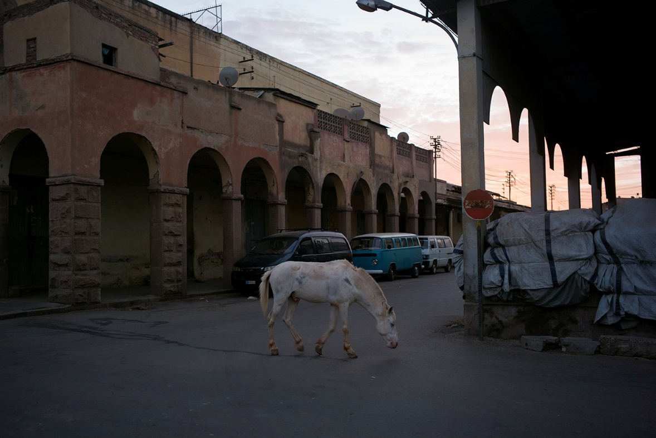
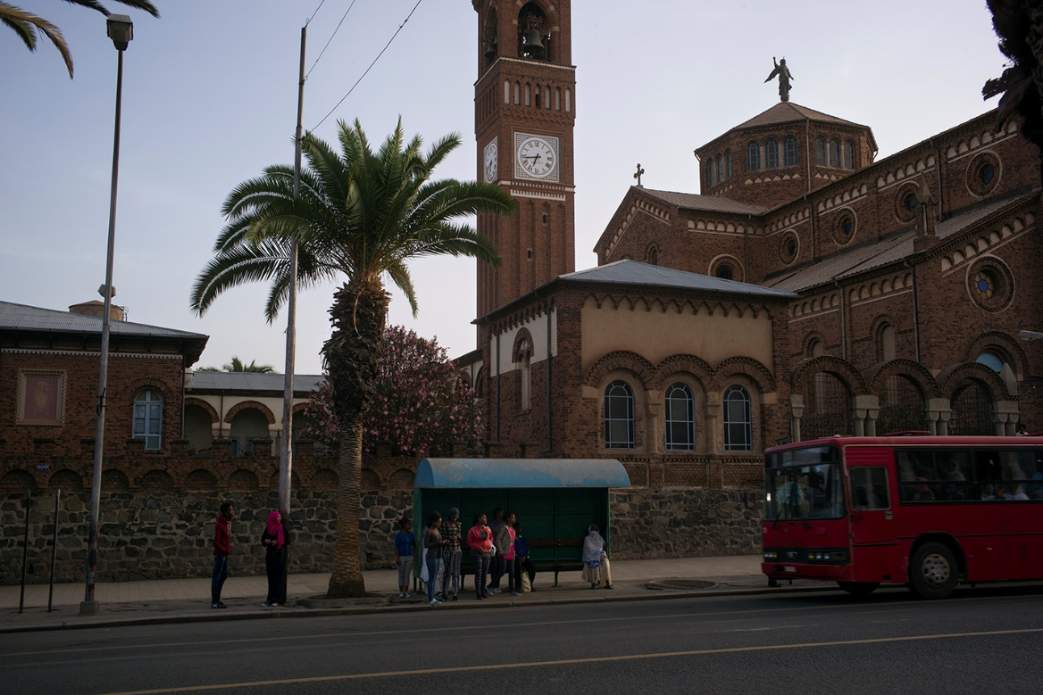VARDAG. Eritrea har börjat ge utländska journalister visum. En av tankarna bakom den nya strategin är att visa upp att det finns en vardag i Asmara - bortom rubrikerna om repression och krigslarm.
The sound of hooves against asphalt is the only sound we hear. Dried sweat testifies that a saddle has been removed from the horse’s back. It’s bony, but not starved. Behind the horse, on the rooftops, the satellite dishes are angled up toward the sky. The horse stands completely still, one of its hooves lifted.
On the street, the pedestrian crossing has been painted white for the celebration of Independence Day. The traffic signals are still shut off. There is something elusive with Eritrea. The chaos in other capital cities on the continent is missing here as much as democracy.
“Have you noticed…where are all the people in this city?” Johan suddenly says. “Doesn’t it feel like they are missing?”
While we are chitchatting about the missing human element an Eritrean who lives in Canada comes up and asks us if we have permission to photograph. I nod.
“I’m just asking for your own safety, it can turn ugly if you don’t have the right paperwork,” he says.
I nod again.
We walk past the townhouses where Dawit Isaak had plans for a future with his family. Modern structures. Lawns with sprinkler systems. Satellite dishes. Lush gardens. We also pass the location where the newspaper, Setit, once was. Setit, which is the Eritrean word for free-flowing rivers, was the first independent newspaper after independence and Dawit Isaak worked there as a reporter and eventually became a part owner, before he was imprisoned.
Across the street from the townhouse where they lived, Davit Isaak’s daughter tended school. These places are mentioned in some of his poetry. One of the newspaper’s founders says that when the first issue came from the printer, a group of school children sold 50 copies on the streets of Asmara and came right back for more.
All 5,000 copies printed in the first edition were gone in one day. The next issue sold out just as quickly. After all the years of war and the new press law of 1996, media was booming. Every other week a new publication sprouted. The country was full of optimism.
There was, however, a clause in the press law of 1996, warning against spreading “documents or classified information that was in the interest of the nation, people and security.” The details were vague. No one knew how the law would be interpreted in a real-life situation.
Before I traveled to Eritrea, I met Dawit’s daughter, Betlehem Isaak, at an outdoor restaurant in Gothenburg. We drank espresso. The sun warmed us in the cool spring air. She told me that she was seven years old when the door bell rang at home in Asmara. Two men in sunglasses asked for her dad. They were invited in for tea and bread, and then they took her dad with them. “I’ll be back,” he told his family. Betlehem turns 23 this year.
I asked to meet with her because I had planned to record a short message from her to play in interviews with Eritrean politicians. When I presented her with the idea she studied me with serious eyes and said: “I’m never going to beg them for anything. They should beg me for forgiveness, respect human rights laws and let him stand trial or release him. That’s the only thing I have to say. I want to be stern just like they seem to be while they have deprived me of my father. I want him to get a lawyer, that’s my only demand.”
While I walk on the same streets in Asmara that Dawit Isaak once walked, I think about the lively debate in Sweden over the best strategy for gaining his freedom. Several influential Eritreans have perceived the fight to get him released as degrading, and, according to them, led to Eritrea closing the door on Swedish efforts: No dialogue, no negotiations, no silent diplomacy.
According to the organization “Free Dawit,” the campaign has still not succeeded in his release, but “kept him alive.” The goal with the ongoing campaign is “to get the Swedish government to act more staunchly against Eritrea.”
But what kind of threats is Sweden supposed to use against Eritrea, I wonder. What powerful language is left after 15 years of captivity?
Critics of the strategy mean that the efforts to try and pressure Eritrea into cooperation by sanctions, or threats of sanctions, are doomed to failure as it is based on ignorance of the current Eritrean leadership. After 30 years in trenches, there is no pressure in the world that can get Eritrea down on its knees to start following Swedish orders.
After listening to all these ministers and soldiers, I don’t believe that even a military intervention in Eritrea would lead to such results. That would likely result in the Eritreans heading back up into the mountains, digging their heels in, surviving on injera bread and waiting it out for another 30 years.
It’s impossible not to compare it with my own case. I walk the streets of Asmara as a free man since Sweden, from the moment I was captured, prioritized the relationship with Ethiopia. Sweden immediately came to the conclusion that a dialogue with the dictatorship would offer the best chance for a desired outcome: the release of two Swedish citizens. Letting Ethiopia feel like they were in charge, and that way, it saved the face of the regime. Focus was on getting the Swedish citizens home, not to humiliate a dictatorship. I feel like I’m seeing signs of a change in Swedish politics. Perhaps the newly appointed ambassador, Per Enarsson, is loosening up some of the knots on the tangled relations between Sweden and Eritrea.
In the last declaration on foreign policy, Dawit Isaak wasn’t even mentioned. When the European Union recently gave Eritrea €200 million in aid, his name wasn’t mentioned either. Upsetting, according to some; smart, say others.
In Canada, the Foreign Ministry’s website warns all exiled Eritreans against paying the tax the Eritrean embassies are collecting around the world.
The Foreign Ministry of Sweden chose to keep the tax on the down low. A sign of change in strategy? The last gasp after 15 years of harsh rhetoric?
Meanwhile, that strategy will reach its end when the UN Commission of Inquiry on Human Rights will consider the regime guilty of human rights violations against their own people. The lack of a proper justice system, a free press, a constitution, free elections and a military service extended for decades will be classified as slavery and crimes against humanity. Anticipating what a future Eritrean response will look like feels like watching a crash in slow motion.
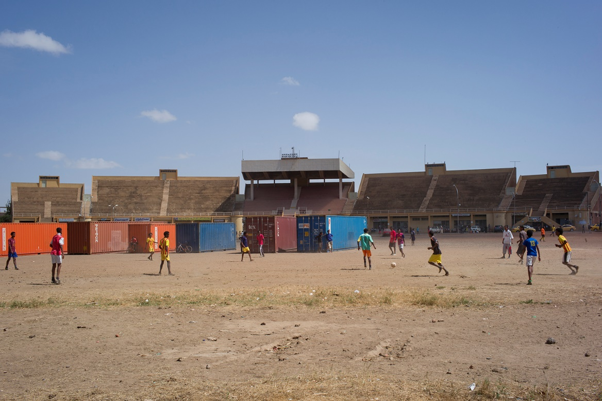
—
At a gravel soccer field in Asmara, in front of a huge yellow grandstand , about a hundred youngsters are playing soccer, kicking up a dust cloud. One of the players gives it all he’s got and sends the ball flying way over the containers, which mark the goal. Their jerseys are emblazoned with the words “Arsenal” and “Manchester United.”.
In the distance, a young man is taking a break in the shadows of the Acacia trees.
“If I want to become an international soccer pro? Yeah, you always have to dream. It’s important with ambitions,” he says and smiles mischievously.
Next year he’ll turn 18 and him and his friends will travel to Sawa for their three-month military training and graduation.
“If you have good results during final exams, your can study to become a doctor, agronomist or engineer,” he says, adding that if one gets bad grades, he has to stay in [the military] for 18 months.
Every Sunday he’s here, playing soccer with his friends.
“I have to go,” he says and runs with light steps over the dusty-red dirt.
At the corner of the gravel field, a man operating a backhoe is removing piles of dirt. In a few weeks a large military parade with thousands of soldiers will march by here. A marching band will play and Eritrea’s President Isaias Afewerki, dressed in khaki, will hold one of his most uncompromising speeches in a long time.
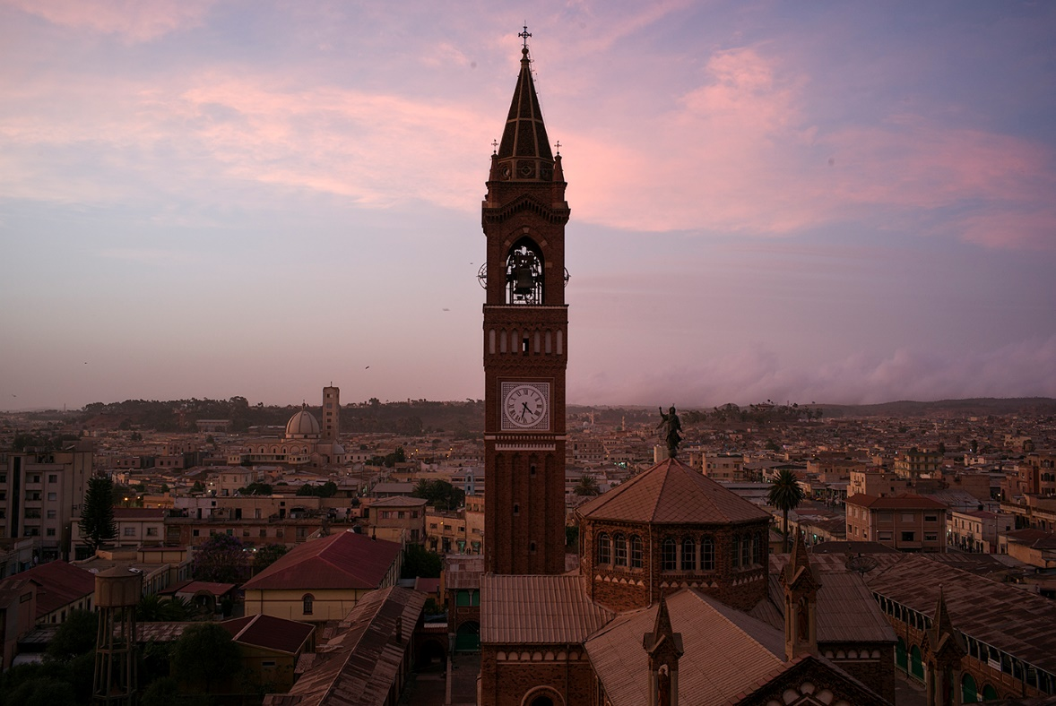
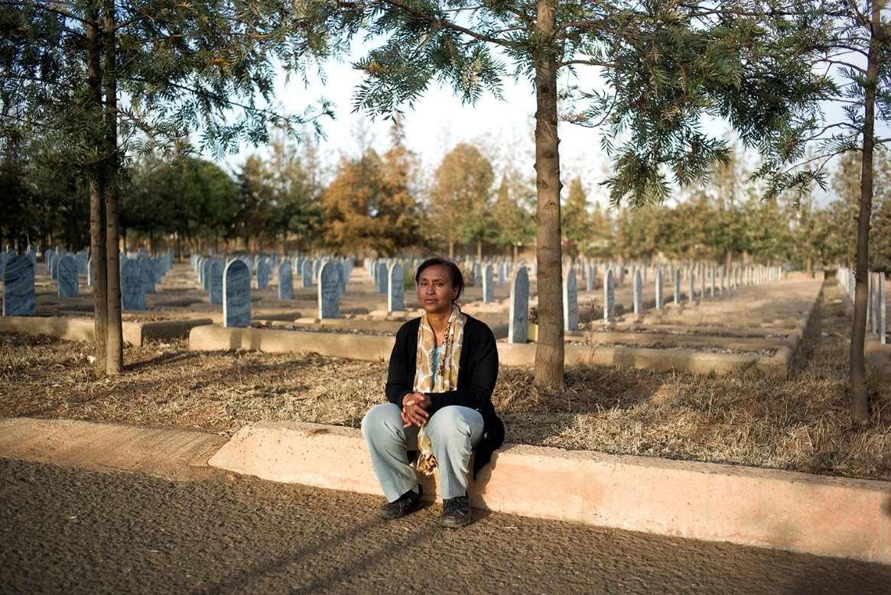
***
The newly planted trees reach for the sky and offer shade for the stray dogs who have made a home at one of the monuments. The white, half-moon-shaped grave markers are lined up on the cemetery for the martyrs. In front of every marker is a pile of pebbles. The yellow grass is so dry it crackles under my shoes when I walk around to read the dates and names. While in Sweden we were worrying that our computers would crash at the entrance of the new millennium, the Eritreans buried tens of thousands of their own.
Vetera, Kalshu Mohamed sits at one of the graves.
“I feel alive when I’m here. I live with their hopes and am reminded about what they sacrificed. This place gives me strength to carry on what the dead started, to fight until the end for my country with all my power and knowledge,” says the now 54-year-old woman.
She is one of the few visitors who walk along the asphalt paths through the cemetery. The reason why there are so few visitors is that the memory of the dead is still so fresh in everyone’s minds, people say.
“I can’t express what I feel when I’m here but I have to do a lot more than what I’m doing today.”
She doesn’t visit any grave in particular. “They are all my brothers and sisters,” she says, adding that even if she would like to, she doesn’t know their real names. Everyone had nicknames back then. At the far end of the cemetery, a backhoe is digging out new spaces for more graves. A nation that has been more at war than peace plans for new martyrs.
“I remember the feeling when I as an eight-year-old and saw women with large afros and weapons hanging over their shoulders, walking—proudly—through my village.”
Kalshu Mohamed joined the EPLF (Eritrean People’s Liberation Front) in October, 1978 and the first year as a rebel was a life on the run, constantly retreating higher and higher up in the mountains.
“It was a tought time. Everyone was retreating and everything was rationed— soap, clothes, food. We walked day and night because we received word that the enemy was closing in.”
Back then she didn’t know that for years she would work in the world’s longest underground hospital.
“I took care of the injured, cooked for them, cleaned injuries, built laboratories and everything else needed. Men and women, we dragged rocks, carried weapons and cut firewood together.”
The underground hospital had everything: generators, operating rooms, classrooms, a theater, even.
“We had every Wednesday off and then we drank our own beer, performed theater, sang, played volleyball and danced.”
During the long nights, while the Russian Antonov planes bombed, they often listened to lectures by other soldiers, doctors or foreign guests.
“The hospital was my university. We studied philosophy, political science and learned about the world outside Eritrea.”
Sometimes the hospital was bombed.
“It was a nightmare to evacuate, we constantly worried about the wounded and hope they’d survive.”
The cohesiveness during the war is usually considered the reason for victory. But some people say that the total discipline and the political schooling were also the key to why it went the way it did.
How does a group of people change to a peace organization after 30 years of war?
At the end of the war, Kalshu Mohamed started working for the Ministry of Information.
“I listened to the radio and heard the reports from the battles in Massawa, and when the victory came, I was happy, of course, but I also cried. I mourned all of those who were no longer alive.”
The celebration was shortlived and she understood that now they had to do everything in their power to rebuild their nation.
“Everything was destroyed and people were in the wind, but we started with what we had.”
Twenty-five years later, Kalshu Mohamed wishes more had been done.
“I think we all hoped that the improvements, the development, would go faster. But what we hoped for and what happened are two different things.”
When her children ask questions about the war, she finds it hard to explain.
“I tell them what we ate and how we were listening for the bombers. They look at me, wide-eyed, but to them it’s like a bedtime story. They will never be able to realize what we went through. How we, literally, lived in caves for decades.”
Her dream during the war, aside from the obvious—an independent country—was that her children would grow up in peace.
“My generation sacrificed everything for our children and we continue to sacrifice. Unfortunately the dream is something that hasn’t become reality yet, but it will. One day, one day it will,” Kalshu Mohamed says and stands up, looking over the rows upon rows of graves.
The sun is slowly going down and over Asmara and the cemetery of the martyrs bathes in a golden light. Kalshy Mohamed fixes her shawl and starts walking toward the exit. Then she stops, turns around and says in a low voice:
“Look around, no bombs fell today, no civilians burned to death in their houses. Peace. It is so incredibly beautiful.”
This was the last story in a series of three in Martin Schibbye’s and Johan Persson’s reportage from Eritrea

Part 1: One country – two realities
Part 2: Voices from the other side
Part 3: The dictatorship that came in from the cold

