ዝኸበርኩም/ክን ኤርትራውያን ነበርቲ ኣሪዞና፡ ንኣመንቲ ክርስትና ርሑስ ብዓል ልደት እናተመነና ሰላምን ሓድነትን ዝመልኦ ሓዲሽ ዓመትን ክኾነልኩምን/ክንን፡ ኣብ መነባብረኹም/ኽን ከኣ ዓወትን ኣሳልጦን ንኽትረኽቡ/ባ ጽቡቕ ምንዮትና ንገልጸልኩም/ክን። ስለዚ ብሓዲሽ ዓመት ምኽንያት ብምግባር ኩልና ኤርትራውያን ብሓባር ክሕጎስን ክንጻውትን፡ ማሕበረ-ሰብ ኤርትራውያን ፍኒክስን ከባቢኣን ህቡብ ኤርትራዊ ድምጻዊ ልኡል ፍስሃየ ምስ ኤርትራዊ ሙዚቀኛ ኢዮብ መዓሾ ወጋሕ ትበል ለይቲ ከጻውትኹም ንታሕሳስ 26, 2015 ካብ ሰዓት 6፡00 ድሕሪ ቀትሪ ክሳብ ሰዓት 2፡00 ናይ ንጉሆ ቀሪብናልኩም ከምዘሎና ንበስረኩም። ዝግበረሉ ቦታ 9402 North Central Ave Phoenix AZ 85012 እዩ። መእተዊ (Admition) $20.00 ድራር ብናጻ። ብድሓን ምጹ/ጻ።
ሉኡል ፍስሃየ ገበረመድህን ኢዮብ መዓሾ
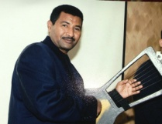 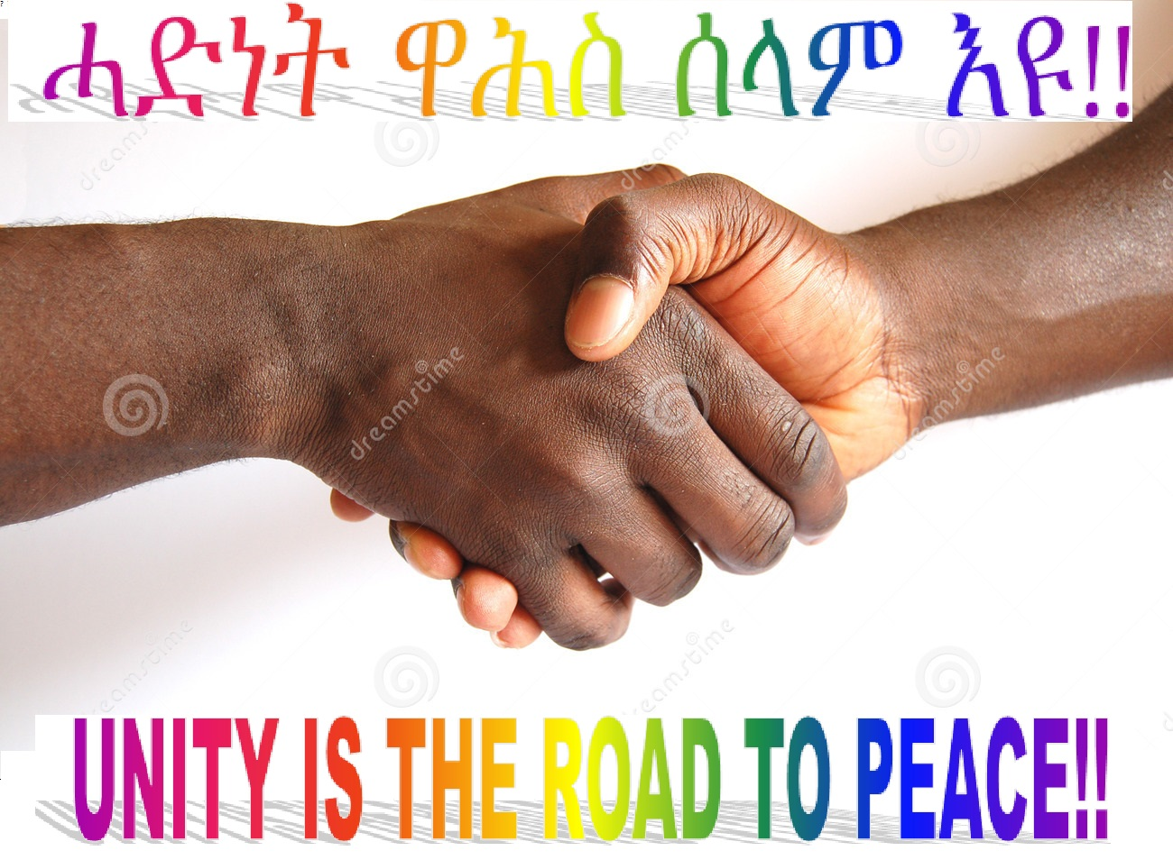 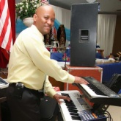
ንተወሳኺ ሓበሬታ ብዚ ዝስዕብ ንናይ ብዓል ሽማግለ ተወከሱ/ሳ።
1. ሙሴ ተኽለ (602) 908- 0241 2. ታደሰ ሳህሉ (602) 575-6975
3. ተኪኤ ገብረኣብ (602) 459-6774 4. ወልደሰላሴ ገብረመድህን (623) 210-6439
5. ኣብርሃም ግርማይ (480) 233-5039
The Eritrean Community in Phoenix will be hosting New Year's Eve Party on Saturday, December 26th, 2015 at 9402 North Central Ave Phoenix, AZ 85012. The Eritrean Community in Phoenix will present you legend Singer Loul Fsehaye and legend Musician Eyob Measho. We are cordially inviting to all Eritrean and friends to join us all night holiday celebration and cultural dance from 6:00PM to 2:00AM. We also will be having Eritrean cuisine and a champagne opening ceremony for welcoming of 2016. We would like to recommend for everyone to arrive on time to show our united, peace & love. Admission fee is $20.00 Dinner free.
Thank you on behalf of Eritrean community in Phoenix.
For more information call the preparatory committee.
1. Mussie Tekle (602) 908-0241 2. Tekie Gebreab (602) 459-6774
3. Tadesse Sahlu (602)575-6975 4. Woldeslassie Gebremedhin (623) 210-6439 5. Abreham Grmay (480) 233-5039

