Successful Eritrean Public Seminar in Boston MA and Providence RI:
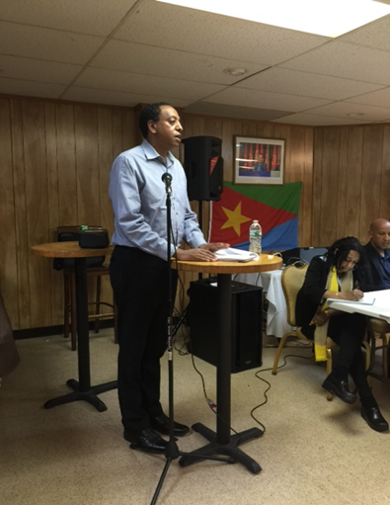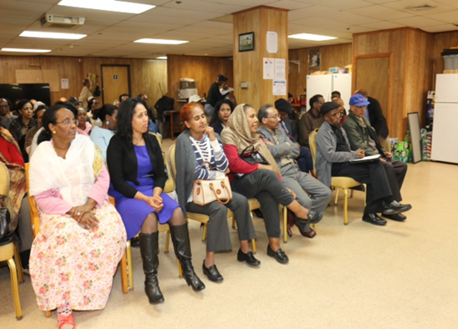
Boston - Mr. Dawit Haile, Head of Public and Community Affairs Eastern Region of the United States, gave extensive briefings on current developments in the Homeland and the region as a whole. In a speech he delivered in the Seminar, Mr. Dawit, appreciated the Boston Eritrean Community for its active involvement and participation cultivating and preserving Eritrean culture and identity, support one another and heavily investing time, energy and financial resources to nurture the children and the youth.
Mr. Dawit highlighted the current imminent threat that comes from Eritrea's sworn enemies. They continue their concerted effort to destabilize Eritrea by using ploys of human right violation as well as open aggression. However, the Eritrean government and the people are progressing in achieving a peaceful, just and prosperous Eritrea. Furthermore, several strategic action plans that enable every single Eritrean to actively engage in building a sustainable and viable economy were outlined. The audience had the chance to ask and reflect on issues that matter to them individually and their views about the situation at home. Discussions aimed at strengthening the youth, women, cultural and civic center, National Council of Eritrean Americans as well members of the YPFDJ.
Dr. Tesfay Aradom, from the Eritrean Community in Boston, also gave briefings on the UN Monitoring Group and the Commission of Inquiry reports. He gave a detailed examination of the lies, innuendos and fabrication as they appear in the report. Dr. Tesfay emphasized the fact, as a people, we have to remain active and intellectually and emotionally vigilant in order to defend our nation’s independence and sovereignty and achieve our national goals

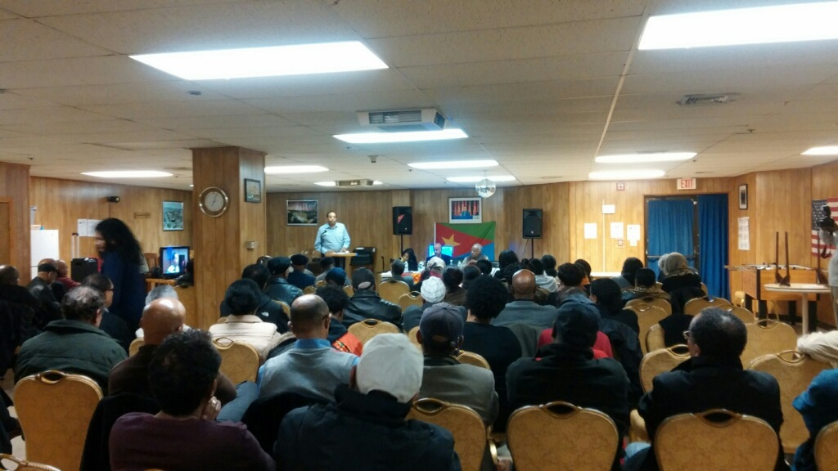

In related news on Sunday November 22 Mr. Dawit Haile held a town hall meeting with several members of the Rhode Island Eritrean community and addressed relevant settlement social challenges.

