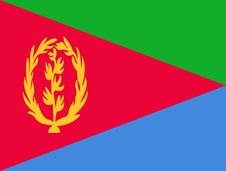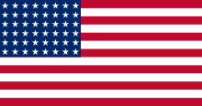

HIZBAWI MEKETE
The National Council of Eritrean Americans of Greater Boston cordially invites you to a public seminar with:
Mr. Dawit Haile, Head Public and Community Affairs, Eastern Region Eritrean Embassy and
Dr. Tesfay Aradom, from Boston Eritrean Community
The seminar will discuss Eritrea’s current affairs.

Date: November 21, 2015
Place: Eritrean Cultural Development Center (ECDC)
85 Dartmouth St. Malden, MA 02148

Time: 5:00 pm
