The city of San Jose, California. Proclaimed May 24th as Eritreans independent Day; and Hoist the Eritrean Flag at the city hall.

By Esayas Temegen
May 26, 2015

On the 21st of May 2015 Eritrean Americans residing in the city of San Jose, California. Formally Raised the Eritrean Flag, in the presence of the city council member Raul Peralez.

Council Raul in his part presented the certificate of proclamation of Mayor Sam Liccardo to our community leader, Brother, Fetsum; and recited the entire text to the crowed. In return the enthusiastic crowed exhibited its appreciation to the city-with cultural dance and song.

For Eritreans it is a long journey from Nakfa, [where the first flag was hoisted by The [E.P.L.F.] - to here in North America.

It is a great pride to have our symbol of independence and heritage, that the coming generation inherits- finally raised alongside the national Flag of the U.S.A. and the flag of California State, for everyone to see. In the city we resided for more than thirty years. The city known as the capital city of the Silicon Valley of the World; and the center of innovation and modernism.

The national Flag is a big deal here in the U.S.A.; Americans like to wave their flag as a custom, in every occasion and whenever they can: in front of their yard; on top of their cars; or while riding on a motor bike; at a game in a stadium. Including wearing it as a logo on a T-Shirts and Jackets is more common practice.

The Eritrean Flag will stay flaying high at the city - hall through the week of The Eritrean Independence Day.
Since it coincided with the memorial Day-holiday of the U.S.A. The day in which Americans give gratitude to their fallen heroes,[Mealtti Seweatt] as it is known in Eritrea, it turned out to be an occasion we celebrate together with the locals.
When you gaze at the flag… you feel an appreciation for the tens of thousands brave Eritrean men and women fighters who laid their life in every alley of the land.
….you feel an appreciation for those who lost their limbs, arms and their eyes, or in a wheel chair;
….you feel an appreciation for those who survived the ferocious war of independence, and are walking among us, with a scar from shrapnel or a bullet in their body.
The flag is a reflection of a national pride. It is an image of a nation. It reminds and teaches citizens about the hardship and the sacrifices that a citizen will encounter to liberate and keep a nation.

This is the second year that Eritreans made their presence known by raising their Flag at the city hall,during the week of the independence day celebration.

Eritrean Americans of San Jose are grateful to mayor liccardo and council Raul Peralez, for their help in achieving this grand occasion; and for their acknowledgment of the Eritrean community good work and positive contribution to the City, for the last thirty years.
Awet n’hafash!
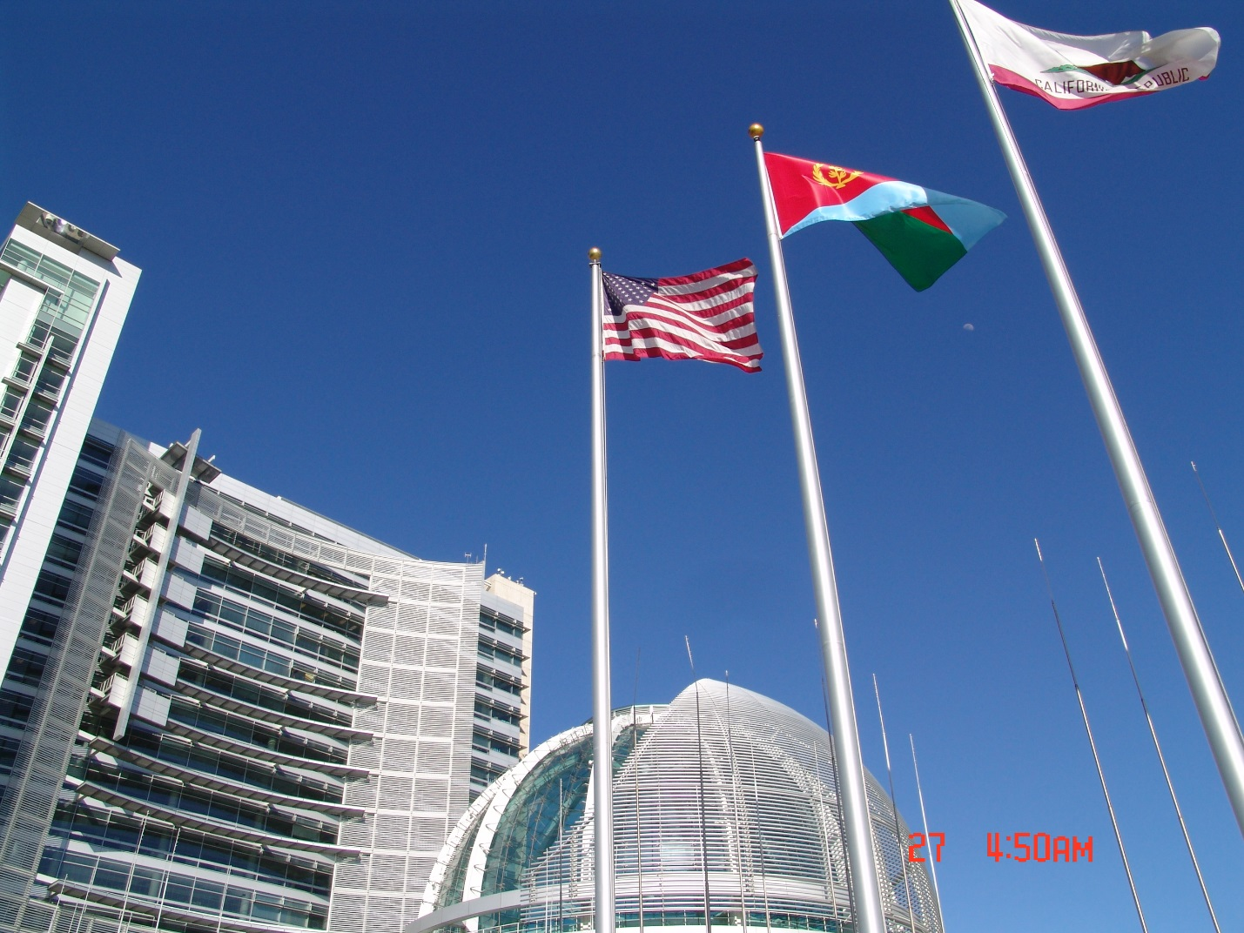
Below is an excerpt of the Proclamation by the City of San Jose:
WHEREAS: Eritrea is one of the newest countries in the Horn of Africa, bordered by the Red Sea, Djibouti, Sudan and Ethiopia; and became independent on May 24, 1991; and
WHEREAS: Eritrea declared its Independence 24 years ago; the Eritrean community in San Jose hopes to increase public awareness of those fallen, shared poetry, dance, art and good citizenship that include sections of the society, including youth, women and children;
to liberate the country; and
WHEREAS: Eritrean communities worldwide observe May 24th every year as an opportunity to learn about Eritrean culture and their community through
NOW, THEREFORE, I, Sam Liccardo, Mayor of San José, together with Councilmember Raul Peralez and our colleagues on the City Council, on this 21st day of May, do hereby proclaim May 24th as “ERITREAN INDEPENDENCE DAY”
And commend the local Eritrean community for their shared immigrant experience of tolerance and inclusion.
Signed:
- The Honorable Sam Liccardo, MAYOR
- Raul Peralez, Councilmember
- Toni Taber, City Clerk 