Yemen conflict risks exploding into 'proxy war' between Saudi Arabia and Iran, warns Philip Hammond
- Abd-Rabbu Mansour Hadi was pictured arrived in Riyadh late last night
- President was greeted by Saudi Defense Minister Mohammed bin Salman
- Saudi warplanes are continuing to bomb Yemen's rebel-held capital, Sanaa
- At least 39 people have been killed in coalition airstrikes so far in the city
- Hadi fled Yemen as the Houthi militants advanced to within a few miles of his refuge in the southern port city, Aden
By Larissa Brown For The Daily Mail and John Hall for MailOnline
Published: 09:37 GMT, 27 March 2015 |

Foreign Secretary Philip Hammond today warned of a 'proxy war' exploding in the Middle East as Saudi warplanes continued to blitz rebel positions in Yemen.
Around 100 fighter jets from Saudi Arabia bombed Iranian-backed Houthi fighters as the rebels advanced further south and fought fierce clashes with government forces.
Mr Hammond said there were fears of a 'proxy' war developing in Yemen between Saudi Arabia, the leading Sunni power, and Iran, the leading Shia power.
Last night Yemen's President Abd-Rabbu Mansour Hadi arrived in Saudi capital Riyadh after leaving his refuge in Aden as Houthi rebels advanced to within a few miles of the southern port city.
Throughout yesterday, warplanes from Saudi Arabia and Arab allies struck at the Shiite Houthis and allied army units, who have taken over much of Yemen and seek to oust Hadi.
Warplanes resumed bombing the Houthi-held capital Sanaa yesterday evening, shaking whole neighbourhoods and terrifying residents. Up to 39 civilians have been reported killed in Sanaa.
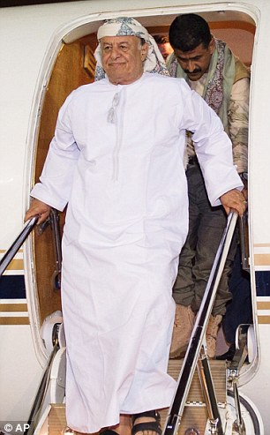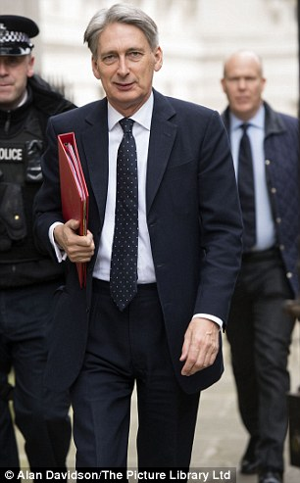

Greeting: Yemen's President Hadi (left) arrived in Saudi Arabia's capital Riyadh last night after leaving his refuge in Aden. Today Foreign Secretary Philip Hammond (right) warned of a 'proxy war' exploding in the Middle East as Saudi warplanes continued to blitz rebel positions in Yemen
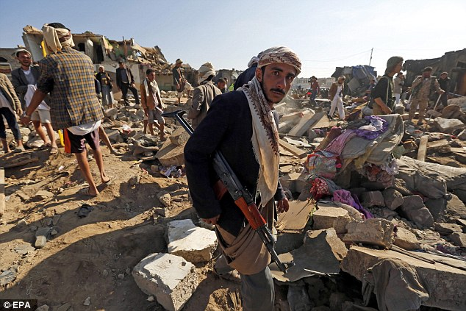
An armed Houthi militiaman stands over the rubble of houses destroyed by a Saudi air strike in Sanaa
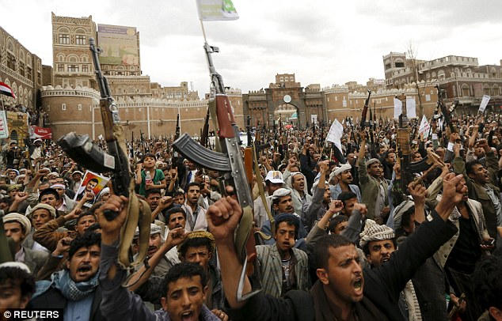
Fury: Shiite rebels hold up their weapons during a rally against the Saudi airstrikes in Sanaa
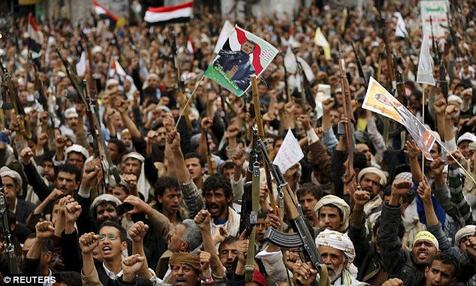
Anger: Shiite Muslims are pictured holding their weapons in the air during an anti airstrike rally in Sanaa
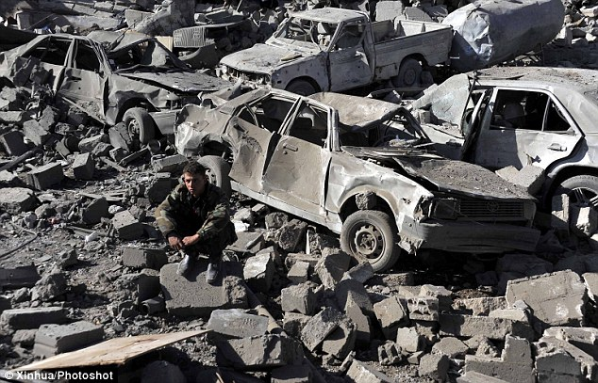
Rubble: A man is photographed sitting at a bomb site near the air force base in Sanaa
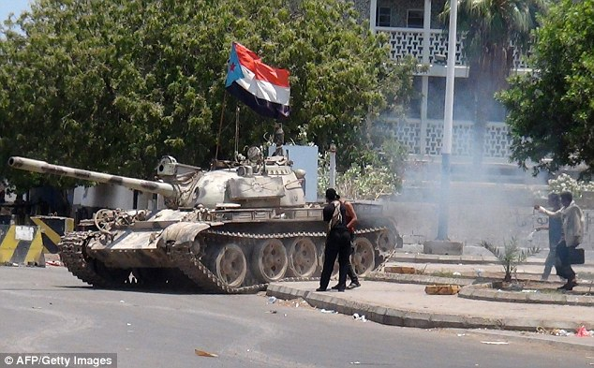
Power: A tank bearing the flag of southern separatist movement, which was confiscated from a military depot, is driven on a street in the southern Yemeni city of Aden this afternoon
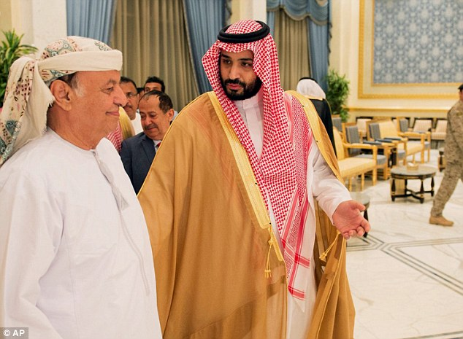
Safety: Yemen's President Abed Rabbo Mansour Hadi (left) walks with Saudi Defense Minister Mohammed bin Salman as he arrives in Riyadh yesterday evening
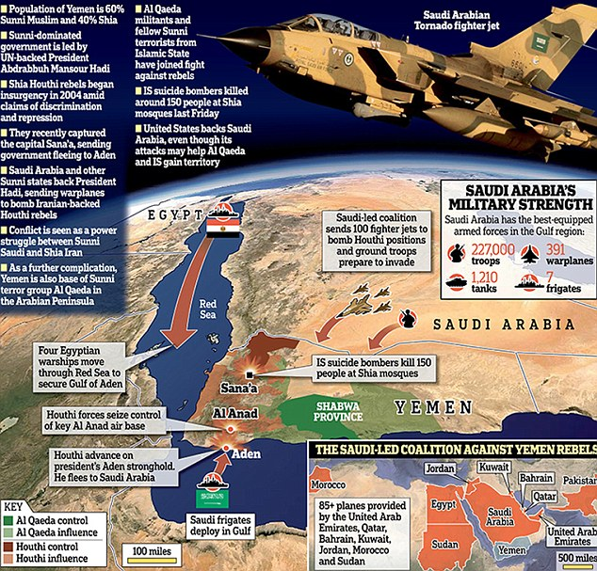
Speaking in the US this afternoon, the Foreign Secretary said: 'The Saudis are very exercised by the idea of an Iranian-backed regime in Yemen.
'They cannot accept the idea of an Iranian-backed regime in control of Yemen, which is why they felt compelled to intervene the way they have.
'We know there has been Iranian support for the Houthi and we are all concerned to avoid this becoming a proxy war.'
MPs today said the escalation of the conflict, which threatens to engulf the entire region into a wider war, was 'heart-breaking' and said the British government could not stand by and see it 'burn'.
MP Keith Vaz, chair of the Home Affairs Select Committee, called for the UK to take immediate action to help stabilise the region-wide crisis.
He said: 'The crisis before us is heartbreaking. We in the UK cannot just watch as another country burns in the Middle East, strengthening the forces of extremist and violence.
'The Houthi rebels have brought the country to its knees. Yemen is facing an economic and humanitarian catastrophe. We are witnessing an implosion in one of the most strategically vital countries in the world.'
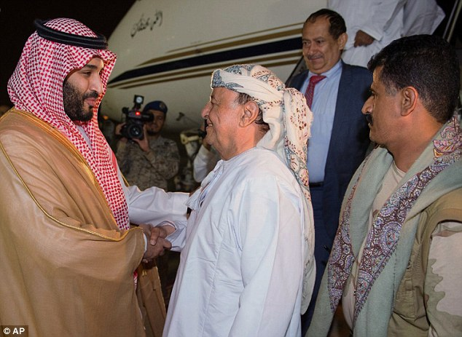
Calm: Saudi state news showed pictures of Hadi smiling and holding hands with the Saudi defence minister. Hadi later said he would go on to Egypt to attend an Arab summit tomorrow
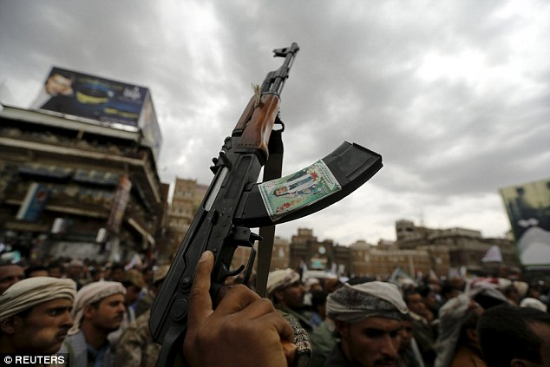
A Houthi rebel holds up his weapon during a rally against air strikes in Sanaa yesterday afternoon
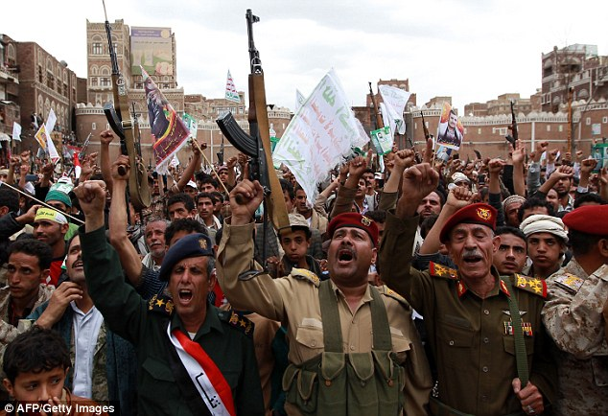
Members of the Yemeni security forces and allied tribal gunmen brandish their weapons during a gathering in Sanaa to show support the Houthi militia and against the Saudi-led intervention in the country
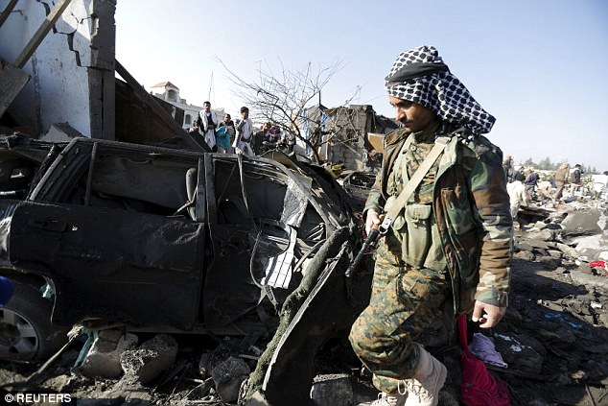
A Houthi fighter walks at the site of an air strike at a residential area near Sanaa Airport yesterday
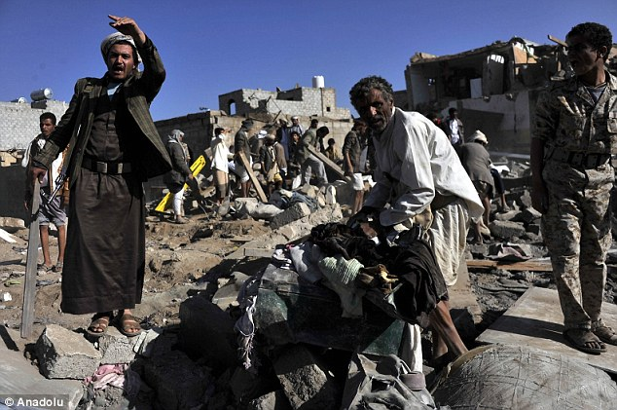
Carnage: Yemeni men search for survivors in the rubble of buildings following airstrikes by the Saudi-led 10-member coalition of Gulf states
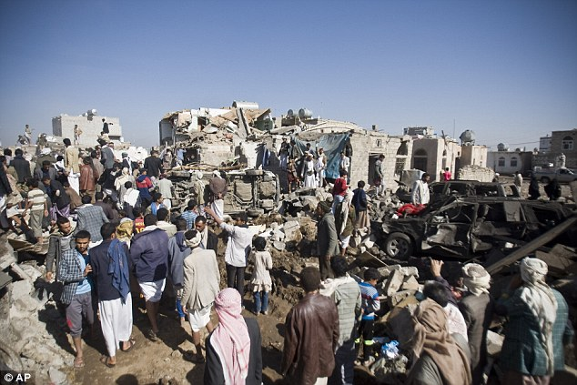
People search for survivors under the rubble of houses destroyed by Saudi airstrikes near Sanaa Airport
British elite soldiers – in Yemen to train government troops to fight Al Qaeda, which has established its most dangerous branch in the country – pulled out last Friday.
This followed a decision by the US to evacuate their remaining military personnel as the country teetered on the brink of civil war between the internationally recognised government of President Abdrabbuh Mansour Hadi and the Houthi rebels.
Today Mr Vaz, former Chair of the All Party Parliamentary Group on Yemen, added: 'While other countries are launching air strikes, for us to withdraw from the conflict is not the answer.'
He called for the UK to call for an emergency meeting of the United Nations Security Council and to provide assistance to the government in Yemen.
He warned: 'We in the West must realise that if Yemen falls, the rest of the Gulf will be in real danger. If we see that happen, it will be cities like London and Paris which will face the consequences.'
In a dramatic escalation of the stakes, a Sunni coalition of Arab states led by Saudi Arabia launched airstrikes against Iran-backed Shia Houthi rebels yesterday.
They have swept south through the country, forcing the UN-backed President to flee to Saudi.
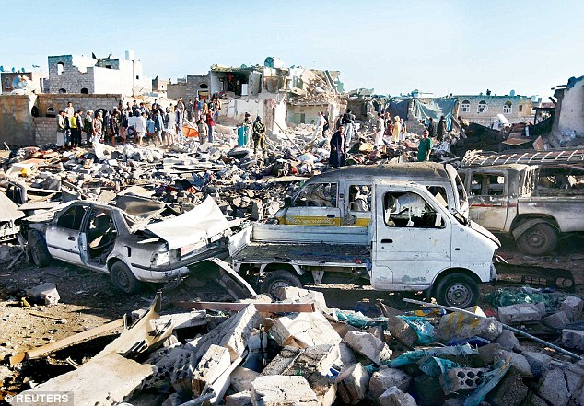
Saudi Arabia launched airstrikes against Iran-backed Shia Houthi rebels, pictured people gather at the site of an explosion near Sana'a Airport
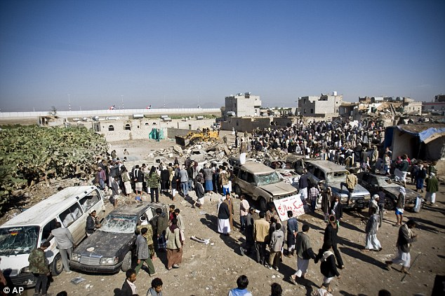
People search for survivors under the rubble of houses destroyed by Saudi airstrikes near Sanaa Airport
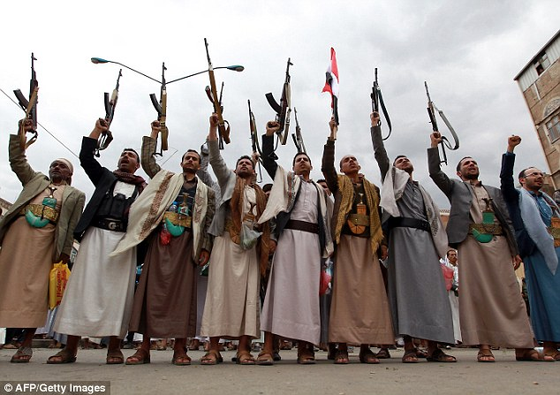
Tribal gunmen loyal to the Houthi movement brandish their weapons during a gathering in Sanaa yesterday
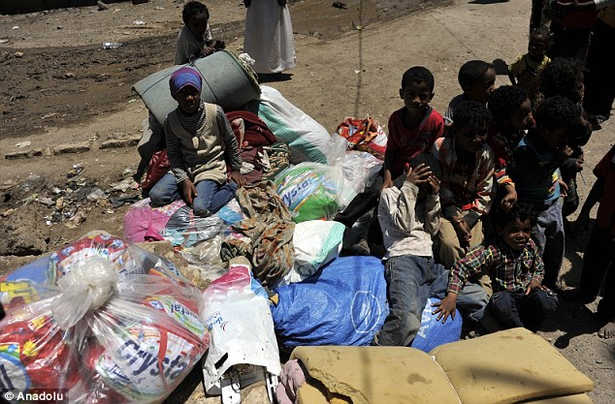
On the run: Young African asylum-seekers, living near the Sanaa International Airport, are photographed with their belongings as they leave the city following airstrikes by a 10-member coalition of Gulf nations
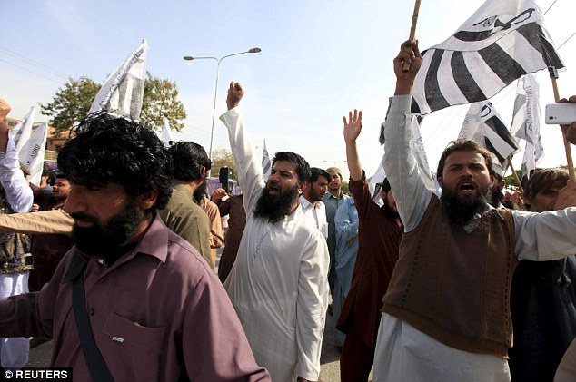
Supporters of the Jamaat-ud-Dawa Islamic organization chant slogans in support of Saudi Arabia over its intervention in Yemen, during a demonstration in Islamabad, Pakistan today
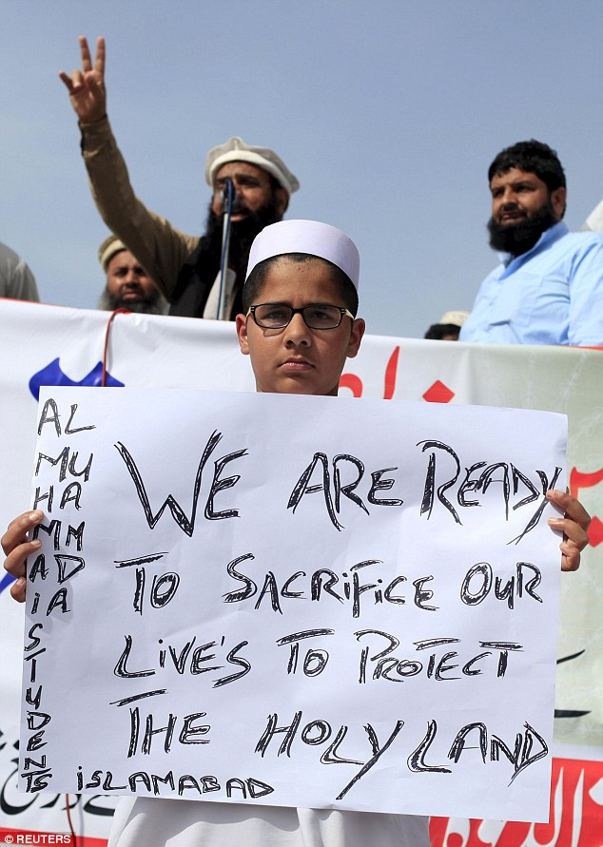
A supporter of the Jamaat-ud-Dawa Islamic organization holds a banner in support of Saudi Arabia over its intervention in Yemen, during a demonstration in Islamabad, Pakistan today
Saudi air strike destroys homes in Yemen
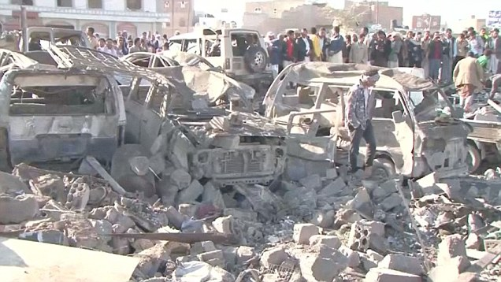
Saudi warplanes targeted Houthi forces controlling Yemen's capital and their northern heartland today as Morocco joined in the fight along with a coalition of Sunni-led states.
The airstrikes were condemned by Iran, which described the operation as an 'invasion' and a 'dangerous step' that will worsen the crisis.
Yemeni Foreign Minister Riyadh Yaseen, asked if the campaign would last days, weeks or more, told Saudi-owned al-Arabiya television: 'I expect that this operation will not go on for long, I think it will be days.'
A full blown conflict in Yemen could plunge the entire region into turmoil and send the price of oil soaring.
Western allies fear a Shiite takeover of the country will cause further instability in the region and could lead to either Al Qaeda or Islamic State seizing control of another weakened state.
Al Qaeda has seized parts of the remote south and east, and stands to gain ground if the Yemeni military continues to split and surrender in its military campaign against it.
The US was training Yemen's military to fight Al Qaeda but the withdrawal of troops from both the UK and the US amid deepening security chaos has called into question their counter-terrorism strategy.
They have pledged their support to Saudi Arabia, with the US providing logistical and intelligence support. The UK has not ruled out support in the future.
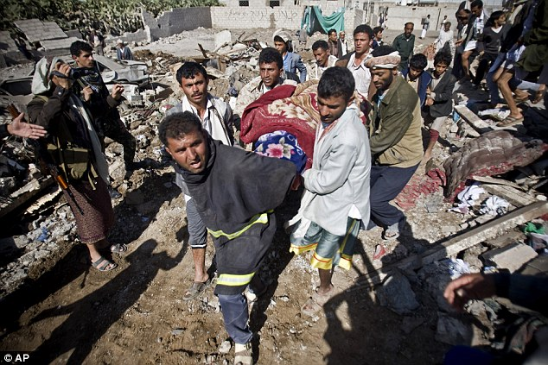
Grieving: People carry the body of a woman covered with a blanket from under the rubble of houses destroyed by Saudi airstrikes near Sanaa Airport
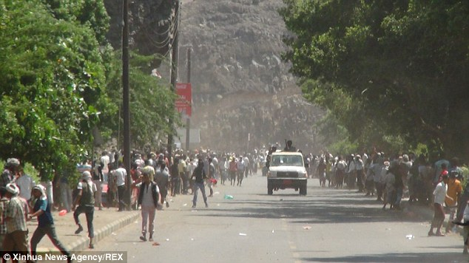
People flee clashes near Aden International Airport in Yemen earlier this week. The Shiite Houthi group took control of the airport after the retreat of tribal militia on Wednesday evening
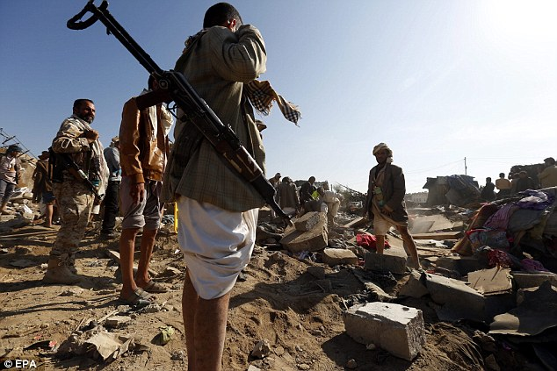
Armed members of Houthi militias keep watch as people search for survivors under the rubble of houses that allegedly were destroyed by a Saudi air strike in Sanaa
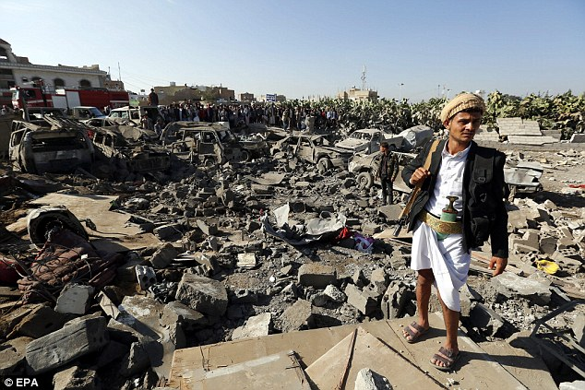
An armed member of Houthi militia keeps watch as people gather beside vehicles destroyed by a Saudi airstrike in Sanaa
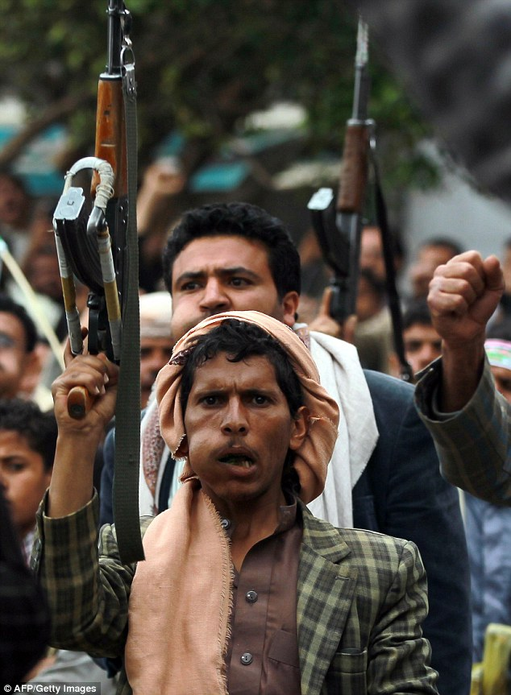
Armed tribal gunmen loyal to the Houthi movement chew Qat - a mild drug used daily by most Yemenis
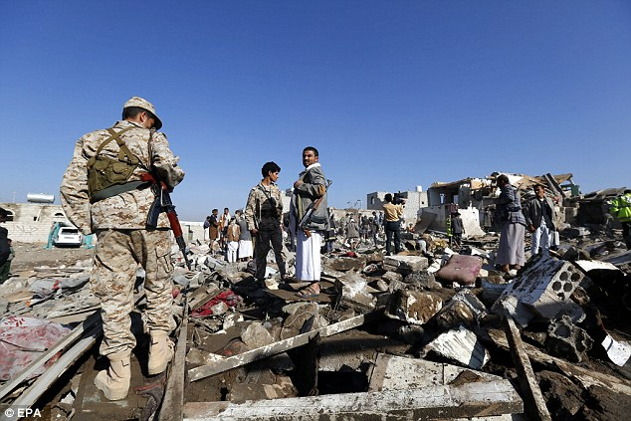
Armed members of Houthi militia gather over the rubble of houses destroyed by a Saudi air strikes in Sanaa
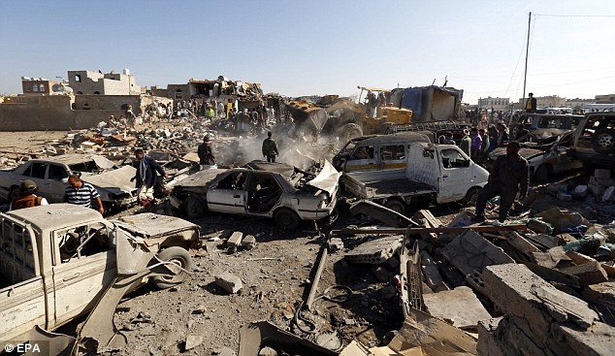
Following last night's Saudi airstrikes on the Houthi-held capital, Sanaa resident Fawzia Nedras said: 'My whole family and I are preparing to sleep in the basement, as it's the safest part of the house
This morning thousands of Houthi supporters gathered to condemn the air strikes at the gate to Sanaa's old city, waving Houthi banners and chanting 'Death to America!'
Al-Arabiya said Saudi Arabia was contributing 100 warplanes to operation 'Storm of Resolve' and more than 85 were being provided by the United Arab Emirates, Qatar, Bahrain, Kuwait, Jordan, Morocco and Sudan.
Egyptian air forces were participating and four naval ships headed to secure the Gulf of Aden. Turkey said it might provide logistical support.
Turkish President Tayyip Erdogan said later Iran had been trying to dominate the Middle East.
'It is really not possible to tolerate this. Iran has to understand,' he said, adding Tehran should withdraw any forces it had in Yemen as well as from Syria and Iraq.
Pakistan's Prime Minister Nawaz Sharif said any threat to Saudi Arabia would 'evoke a strong response' from Islamabad.
Pakistan, which borders eastern Iran, said it was considering a Saudi request that it send troops to Yemen.

