Esayas Temsgen
The taboo is broken by brave Eritreans!
Although the corporate media couldn’t swallow Eritrea’s independent, self-achieving character. Eritrea came back in their face through a high achieving global game; it doesn’t get more diplomatic and human than that.

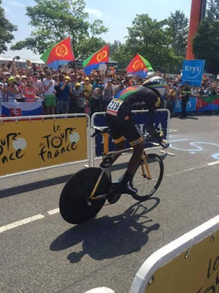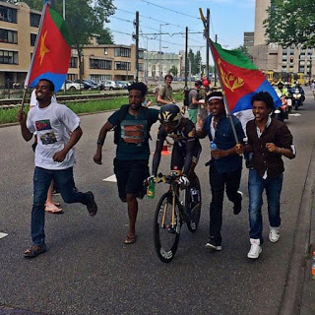

Bicycling is the most rigorous sport, it wasn’t easy; It took a drug for most previous champions to make it to the top. But for Eritreans cycling is a passion it wouldn’t come in a better time than now.
It makes us all Eritreans proud in particular and Africans in general, since it was considered all white man sport.
The taboo is broken by the brave Eritreans; Let the world see the real face of Eritrea:
Hard working high achieving; but not whining parasite.
Awet n’hafash!

