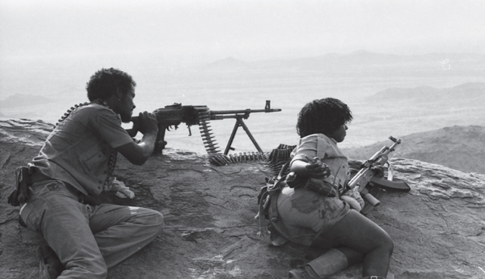

Eritrea: The gate keeper of the Eastern flank of Africa; Deserves a respect!
June, 13, 2015
By Esayas Temesgsen,
Eritreans never asked for help from the outside force nor any one came to their rescue, while they were viciously repressed, tortured, lynched; scorched earth atrocity was practiced on their land by the alternate governors of Expansionist Ethiopia.
They rather preferred to face the foe at any cost and defeat it: Hence, they prepared a plan and set a strategy that will enable them to accomplish this noble task of generational will. They eventually succeeded in liberating themselves after decades of huge scarifies under the leadership of the E.P.L.F - with a loss of tens of thousands of lives.
Never mind the viscous nature of the enemy, Eritreans have gone out of their way to feed, nurse and support the oppressed Ethiopians who came to kill them and plunder their country, as a conscripts peasants and regular army. Eritreans assist these destructive force to evolve into a productive one, by helping them to go back as revolutionary force and overthrow these canning, reckless and foreign financed leaders of expansionist Ethiopia.
As it wasn’t in their culture and revolutionary discipline then, to succumb or ask for mercy to a pressure by the international bandits, who have been in triangle of campaign to frustrate Eritreans march for freedom during the struggle; it is also true now, that Eritreans are more determined to brave the current sabotage on their economic encroachment and to exploit their in-land and off shore natural resources.
Most notably the in your- face, intimidation and international campaign to undermine Eritrea’s stewardship of the strategic sea-lane of the Red Sea.
All this mayhem that the world currently witness’s after the foiled invasion of Eritrea by the expansionist Ethiopia is the outcome of the tension that was applied by different interest groups Intentional or otherwise.
Not to mention these individuals coming out of the woodwork to blackmail Eritrea, by crowning themselves as “experts” On Eritrea. Because they wrote a book or two, as if they wrote their own history, is utter nonsense. These individuals shouldn’t look further, to start with let them look closer-in their backyard. “Ferguson, Missouri” U.S.A.
It is high time that they should stop lecturing Africa a cliché and let Africans determine their own destiny. Africans have seen enough of this poppycock, in: Iraq; Afghanistan; Libya; Egypt; Somalia; Nigeria; The Congo; Angola; South Sudan etc…

Since they miserably failed on their Somalia - Eritrea “hooey” now they appointed them self as “human right lawyers.” it is a crazy world out there; during the days, they use to park their boat and claim colony; now because that is not possible they come with this illusive title so-called “NGO.”
…. they operate under the guise of “NGO” without restraint. They have no country, no constituent and for sure they have no rule. They make the rule that fits their purpose as they go.
It is very dubious that when these human traffickers transform themselves into human right Champions, where as they are the very reason in the first place to the source of the chaos which breed discontent.
Yet they are digging deep in their hell- bent mission to destroy Eritrea. Never mind they failed to incite a religion war; never mind they failed miserably to incite a civil war; never mind they failed to motivate the youth to rise against his nation.
Since Europe is in an economy crises of its own they have to dramatize the immigration to win sympathy, and justify their business. Hence, they have encouraged mass immigration to Europe and create catastrophe to generate a headline news for the world media consumption.
This school of thought [break it, but don’t fix it.] hidden behind Democracy and human right, to dismantle nations through a private army- with ideology; is underway in front of our eyes. That has unveiled a stunning display of history in a U-turn. As a result the equilibrium is disturbed; Drawing the world community back into the twelves century- medieval society, and threatening to extinguish human civilization. Thereby exposing humanity to predatory and cruelty.
Consequently the international community has forgone the Westphalia model: an international order built on equilibrium and restraint; that carried the global family through the major world conflicts.
This is not to be compared to the so called “the thirty years war of Europe,” that took place in the mid- sixteen century. That wiped out nearly a quarter of the population of that continent. Rather, this has a dangerous and cancerous global trend than that: it could unleash global human misery for century to come.
As Eritrea and Ethiopia is concerned, since all the chaos originated as result of the conflict between the two countries …the State Department as the principal sponsor of the Alger’s Agreement of the border conflict, has a major part in it, to play a fare game:
- Have Ethiopia vacate the land it occupied; instead of funning the fire… by sharpening the contradiction between these two warring neighbors.
- Re consider the policy that is coercing Eritreans to go to Addis Ababa, Ethiopia. To obtain a Visa.
- Reverse the course of sanction, and retain a policy of engagement.
The United States have benefited from Eritrea in the past throughout the cold war, It actually owes Eritrea a compensation; for its use of the land and the sea- to win the cold war against the U.S.S.R. monitoring its Space and other activities from its sophisticated communication base at Asmara, Eritrea.
It is not fair for the United State to portray Eritrea as a foe rather than a friend. A country which it has benefited a great deal from. A country that has never engaged- in an armed conflict of any kind with. It is also not judicial to slam Eritrea with unnecessary sanction that caused such a chaos on its society and blame its government for the outcome.

Awet n’hafash

