The “New Thirty Years War” in the Middle East: A Western Policy of Chaos?
By Steven MacMillan
Global Research, August 15, 2015

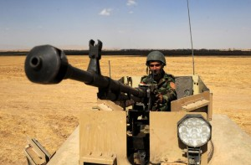
The Middle East has been in a state of chaos for years now, with each passing year bringing a new wave of instability, carnage and human suffering to the people of the region. From Afghanistan to Iraq, Libya to Syria, Western foreign policy has directly caused or exacerbated much of the chaos we see in the region today and has contributed to a growing trend of instability.
A pertinent question of our time however is whether this instability and destabilization is a result of inept strategy by Western nations, or a calculated strategy by the West to intentionally create chaos, balkanize nations and increase sectarian tensions in the region?
The “New Thirty Years War”
Certain individuals within the US establishment have been drawing the comparison between the Middle East today and the Thirty Years War in Europe in the 17th century, with Prof. Larry Goodson of the US Army War College being one of the latest individuals to make the comparison. Even though the parallels between Europe and the Middle East are by no means exact, it has become somewhat of a talking point within Western geostrategic circles.
The Thirty Years War is a complex historical period, pertaining to numerous wars and conflicts fought by an array of power blocs for a variety of reasons. According to the Encyclopædia Britannica: “Although the struggles that created it erupted some years earlier, the war is conventionally held to have begun in 1618, when the future Holy Roman emperor Ferdinand II, in his role as king of Bohemia, attempted to impose Roman Catholic absolutism on his domains, and the Protestant nobles of both Bohemia and Austria rose up in rebellion.”
The war quickly spread to embroil the majority of Europe’s major powers who either believed there was an opportunity to conquer neighbouring powers or were drawn into the conflict by a force invading their lands, and is regarded by historians as one of the most destructive periods in European history. Villages, towns and cities were raped and pillaged by mercenaries who were fighting for different power blocs, devastating the European continent.
The Thirty Years War was brought to an end when a series of treaties was signed in 1648 known as the Peace of Westphalia, establishing a new political order in Europe in the form of co-existing sovereign states (although some historians dispute the significance of Westphalian sovereignty). James Bissett, the former Canadian Ambassador to Yugoslavia, Bulgaria and Albania, described the Westphalian system in a 2007 speech as laying “down the basic tenets of sovereignty—the principle of territorial integrity and of non-interference in the affairs of national states… The Westphalian order has frequently been violated, but age has not diminished the principles themselves.”
In July of 2014, the former director of policy planning for the US Department of State and the President of the Council on Foreign Relations (CFR), Richard Hass, compared the Middle East of today to 17th century Europe, in his article “The New Thirty Years War”. Hass proclaims that the Middle East will likely be as turbulent in the future unless a “new local order emerges”:
For now and for the foreseeable future – until a new local order emerges or exhaustion sets in – the Middle East will be less a problem to be solved than a condition to be managed.
As I reported a year ago, this “new local order” may be in the form of a Middle Eastern Union.
Fragmenting the Middle East
Ubiquitous evidence indicates that there is an agenda by at least some strategists within the US to destroy the nation state and balkanize the region into feuding rump states, micro-states and mini-states, which will be so weak and busy fighting each other that they will be unable to unify against foreign colonial powers – most notably Western multinational corporations. After a prolonged period of destruction and chaos in the region, the people of the Middle East may be so weary of the horrors of war that they will accept a Western imposed order as a means of ending the fighting, even though the very same Western forces have been responsible for creating much of the intolerable chaos.
The strategy of balkanization can be traced back to at least the early 1990’s, when British-American historian Bernard Lewis wrote an article published in the 1992 issue of the CFR’s publication, ‘Foreign Affairs’, titled: Rethinking the Middle East. He envisages the potential of the region disintegrating “into a chaos of squabbling, feuding, fighting sects, tribes, regions and parties.” Even though Lewis writes in his article that this is only one “possibility” of many other possibilities, it is starkly similar to the situation that we see in countries such as Iraq and Libya today:
Another possibility, which could even be precipitated by fundamentalism, is what has of late become fashionable to call “Lebanonization.” Most of the states of the Middle East—Egypt is an obvious exception—are of recent and artificial construction and are vulnerable to such a process. If the central power is sufficiently weakened, there is no real civil society to hold the polity together, no real sense of common national identity or overriding allegiance to the nation state.
Lewis continues:
The state then disintegrates—as happened in Lebanon—into a chaos of squabbling, feuding, fighting sects, tribes, regions and parties. If things go badly and central governments falter and collapse, the same could happen, not only in the countries of the existing Middle East, but also in the newly independent Soviet republics, where the artificial frontiers drawn by the former imperial masters left each republic with a mosaic of minorities and claims of one sort or another on or by its neighbours.
Speaking at the Ford School in 2013, former US secretary of state and CFR member, Henry Kissinger, reveals his desire to see Syria balkanized into “more or less autonomous regions”, in addition to comparing the region to the “Thirty Years War” in Europe:
There are three possible outcomes. An Assad victory. A Sunni victory. Or an outcome in which the various nationalities agree to co-exist together but in more or less autonomous regions, so that they can’t oppress each other. That’s the outcome I would prefer to see. But that’s not the popular view…. I also think Assad ought to go, but I don’t think it’s the key. The key is; it’s like Europe after the Thirty Years War, when the various Christian groups had been killing each other until they finally decided that they had to live together but in separate units. (from 27.35 into the interview).
Creating a “Salafist Principality” in Syria
In May of this year, Judicial Watch released a series of formerly classified documents from the US Department of Defense and Department of State after the watchdog group filed a Freedom of Information Act (FOIA) lawsuit against the two government agencies. One important document contained in the release was a 2012 Defense Intelligence Agency (DIA) report which reveals that the powers supporting the Syrian opposition – “Western countries, the Gulf states and Turkey” – wanted to create a “Salafist principality in Eastern Syria in order to isolate the Syrian regime”:
Opposition forces are trying to control the Eastern areas (Hasaka and Der Zor), adjacent to the Western Iraqi provinces (Mosul and Anbar), in addition to neighbouring Turkish borders. Western countries, the Gulf states and Turkey are supporting these efforts… If the situation unravels there is the possibility of establishing a declared or undeclared Salafist principality in Eastern Syria (Hasaka and Der Zor), and this is exactly what the supporting powers to the opposition want, in order to isolate the Syrian regime, which is considered the strategic depth of the Shia expansion (Iraq and Iran). (p.5)
The document adds:
ISI [the Islamic State of Iraq] could also declare an Islamic State through its union with other terrorist organisations in Iraq and Syria. (p.5)
Balkanizing Iraq
Fragmenting Iraq into three separate regions has been the goal of many within the US establishment since the 2003 invasion of the country, although NATO member Turkey has vocally opposed the creation of a Kurdish state in the North. In 2006, a potential map of a future Middle East was released by Lieutenant-Colonel Ralph Peters which depicted Iraq divided into three regions: a Sunni Iraq to the West, an Arab Shia State in the East and a Free Kurdistan in the North.
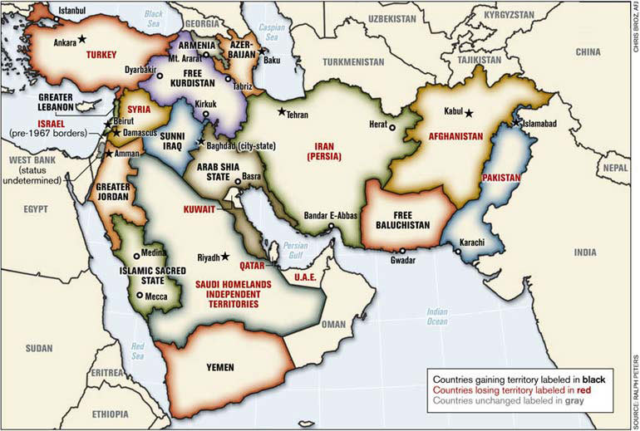
Even though the map does not reflect official Pentagon doctrine, it gives a glimpse into the minds of some of the top military strategists and corroborates with many other Western voices on the strategy for Iraq. As geopolitical analyst Eric Draitser noted in a recent article for New Eastern Outlook, the President Emeritus of the CFR, Leslie Gelb, argued in a 2003 article for the NY Times that the most feasible outcome in Iraq would be a “three-state solution: Kurds in the north, Sunnis in the center and Shiites in the south.”
Syria is shown as still being a unified country in the above map, although this may be because the Syrian proxy war did not begin until years later. Israel could also come to occupy more territory in the coming decades.
Different Country, Same Strategy
The same pattern of balkanization and chaos that we see in Iraq and Syria is also true in Libya. Following the NATO’s 2011 war in the North African nation, the country descended into an abyss of chaos and has essentially been split into three parts, with Cyrenaica comprising the East of the country, and the West split into Tripolitania in the Northwest and Fezzan in the Southwest. Libya is now a failed state which is devoid of central government and is stricken by tribal warfare, where rival militias who were once fighting alongside each other are now battling against one another.
The Iranian nuclear deal could mark a new beginning for Western geopolitical strategy in the Middle East, where they would work with regional powers to promote stability and refrain from military intervention (or intervention through proxies). Let’s hope this is true, and the West will halt the plethora of destabilization programs it has engaged in for years.
But the most probable scenario will be a continuation of the balkanization strategy that we have all come to expect; until a “new local order emerges” – an order that will be designed by, and for, Western interests of course.
Steven MacMillan is an independent writer, researcher, geopolitical analyst and editor of The Analyst Report, especially for the online magazine “New Eastern Outlook”.
Copyright © Steven MacMillan, New Eastern Outlook, 2015

