Directorate of Information and Communication
AFRICAN UNION | 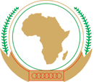 | UNION AFRICAINE
 |  | UNIÃO AFRICANA

Addis Ababa, Ethiopia P. O. Box 3243 Telephone: +251 11 551 7700 / +251 11 518 25 58/ Ext 2558

Web site: www.au.int

Press Release Nº249/ 2014

Eritrea Civil Society Community Unanimous on ECOSOCC.
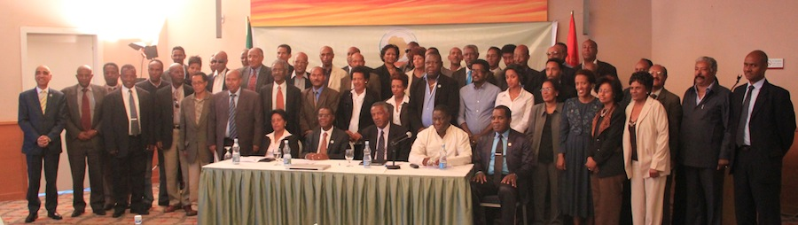
Asmara, Eritrea, 25th September 2014 – The East African phase of the ECOSOCC Sensitization and Motivation campaign for the African civil society community to register and participate in ECOSOCC was concluded today with a session in Eritrea. The campaign for the Eritrean civil society community which was held in Asmara Palace Hotel, Asmara, Eritrea, was attended by a large and wide variety of civil society groups in Eritrea.

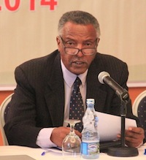
Speaking on behalf of the various CSO groups and associations, Mr. Tsegai Mogos, the Deputy General Secretary of the National Confederation of Eritrean workers (NCEW) noted that it was a great pleasure to have the AU delegation on ECOSOCC in Eritrea and expressed the hope that the campaign will receive “enthusiastic support and respect for the noble cause of the (ECOSOCC) Council in Eritrea. … In Eritrea, the enthusiastic partnership existing between government and civil society organizations is very dynamic and promising because the relationship has its foundations in the period of the armed struggle for liberation where civil society rallied alongside the liberation front and played a crucial role in the successful struggle for independence.” He observed that the National Confederation of Eritrea Workers (NCEW) is familiar with ECOSOCC through its membership of the Organization of African Trade Union Unity (OATUU) which, has institutional framework of partnership with the AU through the Citizens and Diaspora Directorate (CIDO), but stressed that this was not sufficient. “Eritrean CSOs need to have more active participation in ECOSOCC future activities.”

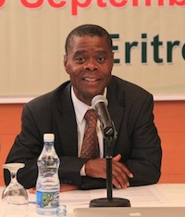
Ambassador Lazarous Kapambwe, Advisor to the AU Chairperson, in his remarks thanked the Government and People of Eritrea, particularly the civil society community for the warm welcome accorded to the AU delegation. He highlighted the mission objective as designed to implement the directive of the Executive Council of the Union that was inspired by the need to ensure that ECOSOCC is established as a truly representative body comprising representatives of the CSO community in all Member States of the Union. He traced the history of the sensitization campaign and noted accordingly:

It is important to stress here that the campaign in Eritrea is one of the last stops and thus assumes significance as one of the crowning events of this crucial and important exercise that has attracted wide attention and support all over the continent. The effective contribution of Eritrean civil society will thus have added significance as a morale booster for creating a final momentum. It is the expectation of the AU that Eritrea will mark this significance with its impact on the process and that its civil society community will participate en masse in the current ECOSOCC election process and accelerate the momentum towards the establishment of a 2nd Permanent General Assembly of ECOSOCC. The Commission of the AU looks forward to working effectively with the Eritrean civil society community to achieve this noble goal.

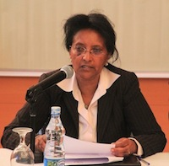
On behalf of the Government of Eritrea, Mrs. Elsa Haile, the Director of International Organizations Division of the Ministry of Foreign Affairs, noted that “Eritrea is an active member of the African Union (AU) and remains fully committed to the Union’s vision of “an integrated, prosperous and peaceful Africa, driven by its own citizens and representing a dynamic force in the global arena.” Eritrean National Associations, at home and aboard, have a long and proud history of standing for equality and social justice within this spectrum. The ongoing sensitization campaign was therefore, an important step in pushing forward the long overdue constitution of the second General Assembly of ECOSOCC and in ensuring the representativity of the Council. She was confident that the program in Asmara will increase awareness of the Eritrean National Associations regarding the work of ECOSOCC and broadly of the AU, and would encourage them to participate in the activities of the Union.

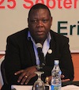
The opening session was followed by the main session on the sensitization campaign with two broad presentations. The first by Mr. Joseph Chilengi, a member of the 1st Permanent General Assembly. Mr. Chilengi stressed that the foundations for the successful operation of ECOSOCC and effective contribution to the integration and development agenda of the continent was now established. The requirement now is for the African civil society community to fully embrace the ECOSOCC mission and advance its purposes.

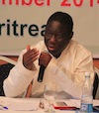
Dr. Jinmi Adisa, the Director of the Citizens and Diaspora Directorate (CIDO) that oversees the program of mainstreaming the participation of non-state actors in the AU, recalled the Summit decision in Malabo that inspired the sensitization exercise, the logic behind it and its aims and objectives. He took participants through the Statutes of ECOSOCC, its definition of CSOs, eligibility requirements for participation in the ECOSOCC Assembly as well as application processes and procedures. He noted that ECOSOCC provides a unique opportunity for CSO groups to understand and strengthen the framework of participation in the policy-making process particularly as it exposes them to the intricate demands of negotiation and compromise with the wider range of stakeholders. Participation in ECOSOCC is a mutual learning process that enhances civil society understanding of governmental actors and vice versa. This learning process will make the development enterprise a more wholesome undertaking involving all segments of society.
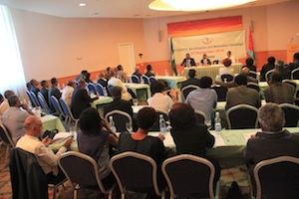
The interactive session that followed paved way for sincere exchange of ideas and fruitful discussions on ECOSOCC and AU agenda. Eritrean CSOs embraced the ECOSOCC mission and accepted the need to register in the election process and to contribute effectively to its operations. The CSO underlined the need for the sensitization process to be continuous not just for ECSOCOCC but for the AU as a whole. They noted that the AU has a lot of work to do in the area of “image-building” within the African continent as a large proportion of the African public are not familiar with AU programs and activities.

The CSOs also underscored the need for the AU to complement the ECOSOCC enterprise with training and capacity building for CSOs and to create, in partnership with governments of Member States, avenues for local funding of CSOs. Participants at the meeting also agreed on the need to create a national ECOSOCC Chapter as an instrument of accountability and representativity. They further requested that CSOs be given observers Status of ECOSOCC to audit the activities of the Organ and inspire greater identification.

Finally, participants drew attention to the issue of the Eritrea-Ethiopia border conflict and stressed the need for the AU to be courageous, evenhanded, fair, just and assertive in terms of implementation of the UN decisions regarding the border dispute. They also requested that the AU should be more earnest and methodical in treatment of peace and security issues.

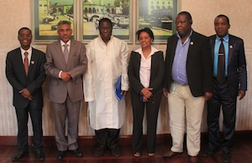
Following the sensitization meeting, the AU delegation paid a courtesy visit to Mr. Yemane Gebremeskel, Director of the Office of the President of the State of Eritrea, to brief him on the mission purpose and outcomes of the sensitization mission. The Director thanked the AU delegation for the mission and stressed Eritrea’s commitment to the AU and ECOSOCC. He pledged the government’s readiness to encourage CSOs to participate in the ECOSOCC process and to support the integration and development agenda of the continent.

The campaign ended with a dinner hosted by the Eritrean Ministry of Foreign Affairs for the AU delegation and the CSO community.

For any further information please contact :

Mr. Michael Fikre, Directorate of Information and Communication, Email: MichaelF@africa-union.org, m_fikre@hotmail.com, cell: +
Or visit : http://pages.au.int/ecosocc

For further information contact
Directorate of Information and Communication | African Union Commission I E-mail: dinfo@african-union.org I Web Site: www.au.int I Addis Ababa | Ethiopia
Follow us
Face book: https://www.facebook.com/AfricanUnionCommission
Twitter: https://twitter.com/_AfricanUnion
YouTube: https://www.youtube.com/AUCommission
Learn more at:
http://www.au.int

