23RD ERITREAN INDEPENDENCE CELEBRATION
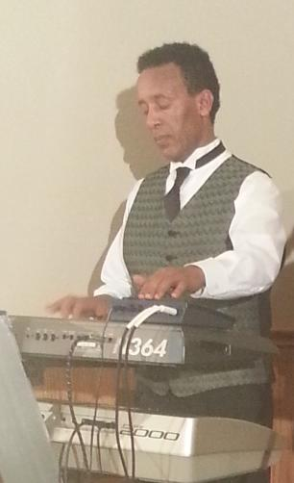
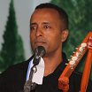
VOCALIST & KIRAR KEYBOARD
MESFIN NAIZGHI MILLION ABRAHA

DATE…………………………….18th MAY 2014

TIME……………………………..07:00 pm. (door opens)

PLACE……………………………MOOSE LODGE
35 CHARTERHOUSE CRS.
LONDON ONTARIO

PRICE……………………………$20.00 (DINNER INCLUDED)

LIVE MUSIC AND A LOT OF FUN COME AND CELEBRATE

ALL PROCEEDS TO THE FAMILY OF THE ERITREAN MARTYRS

