Eritrean youth in Phoenix Arizona conducted successful seminar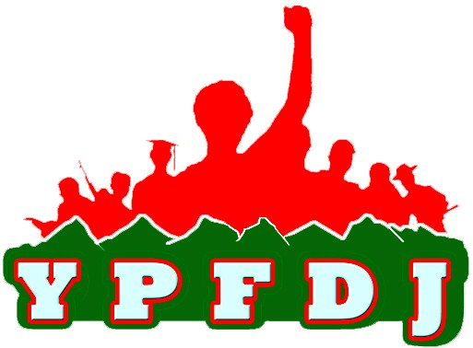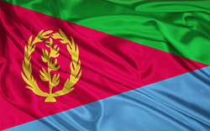

Sunday May 04, 2014, The Eritrean youth residing in the state of Arizona conducted a successful seminar in Phoenix last Sunday.
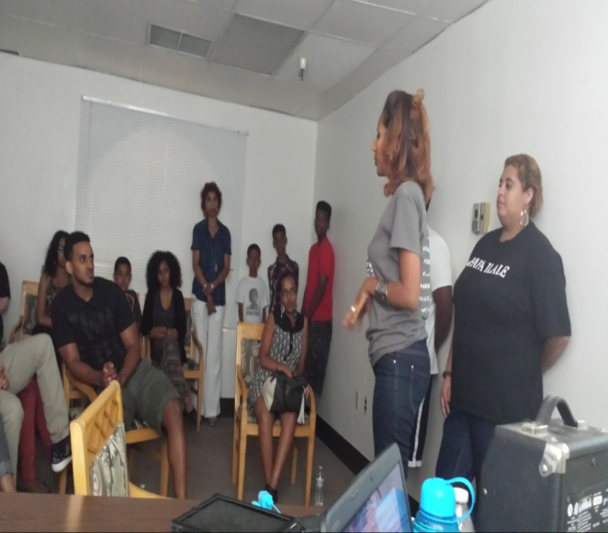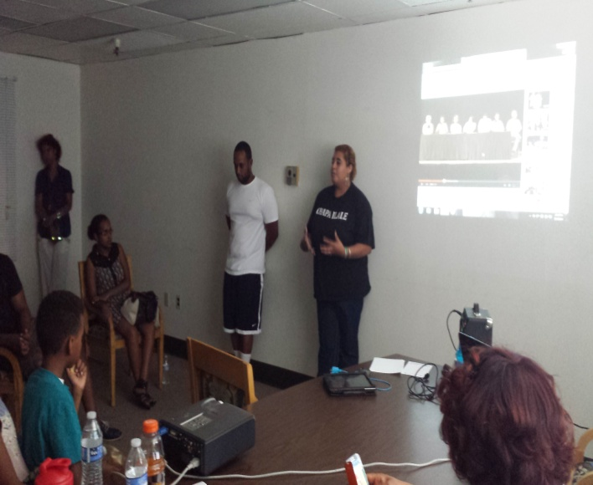
Guest speakers Mrs. Hadnet Keleta Executive member of YPFDJ and MEKETE of North America and and Mrs. Aster Tesfagaber Executive Committee of NUEW of south west USA gave detailed briefing focusing on the Eritrean Youth have always played a critical and decisive role throughout the Eritrean history struggle; a struggle that has taken generations.

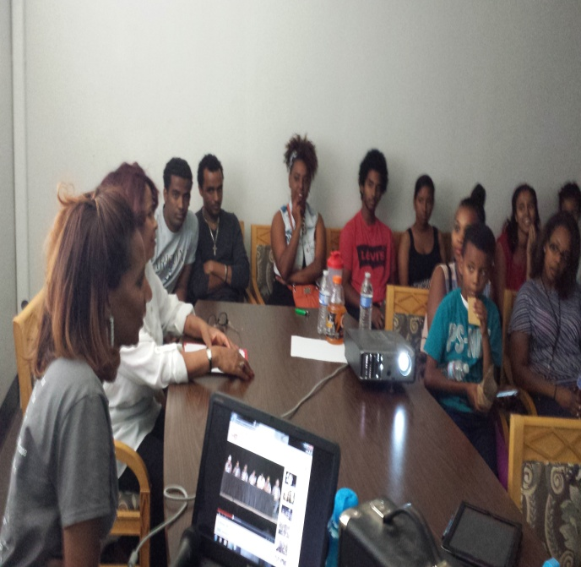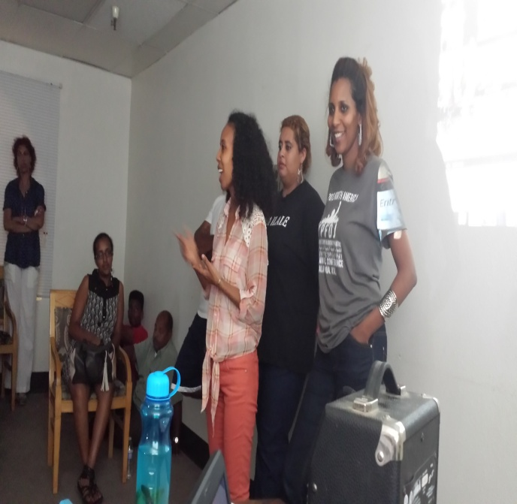
The participants of the meeting expressed their commitments in Building a strong, conscious and patriotic Eritrean youth movement and reiterated readiness to mount participation for the realization of the cherished development and diplomatic goals.
On this occasion, the Eritrean Youth committed to organize and participate in all PFDJ2, YPFDJ and Hedre in Phoenix Arizona and conducted a successful Seminar.
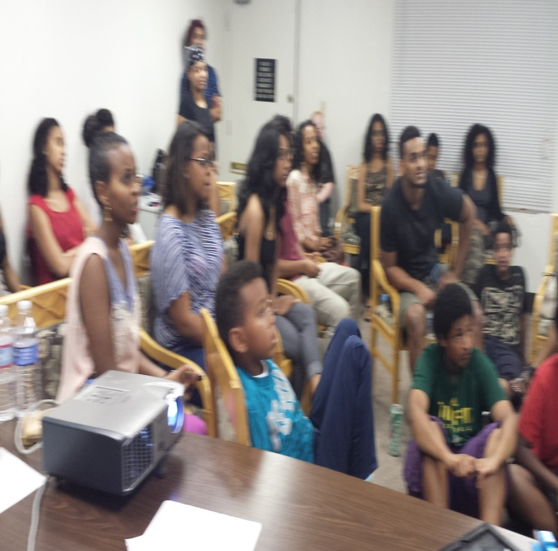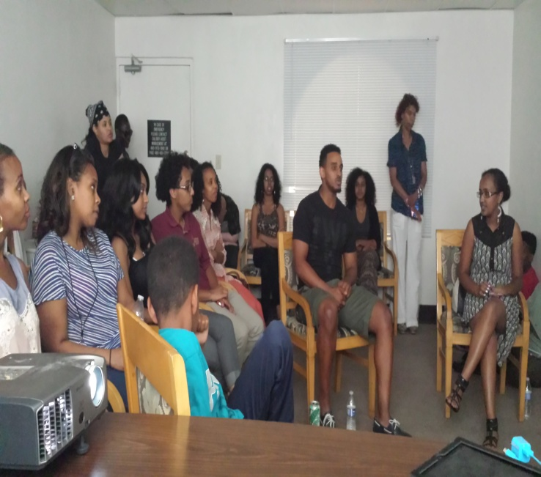
PFDJ chenfer Phx. Az.
ዓወት ንሓፋሽ !!النصر للجماهير

