Eritrean members in Phoenix Arizona conducted successful seminar

Saturday May 03, 2014, The National Union of Eritrean Women and PFDJ Chenfer Phoenix residing in the state of Arizona conducted a successful seminar in Phoenix last Saturday.

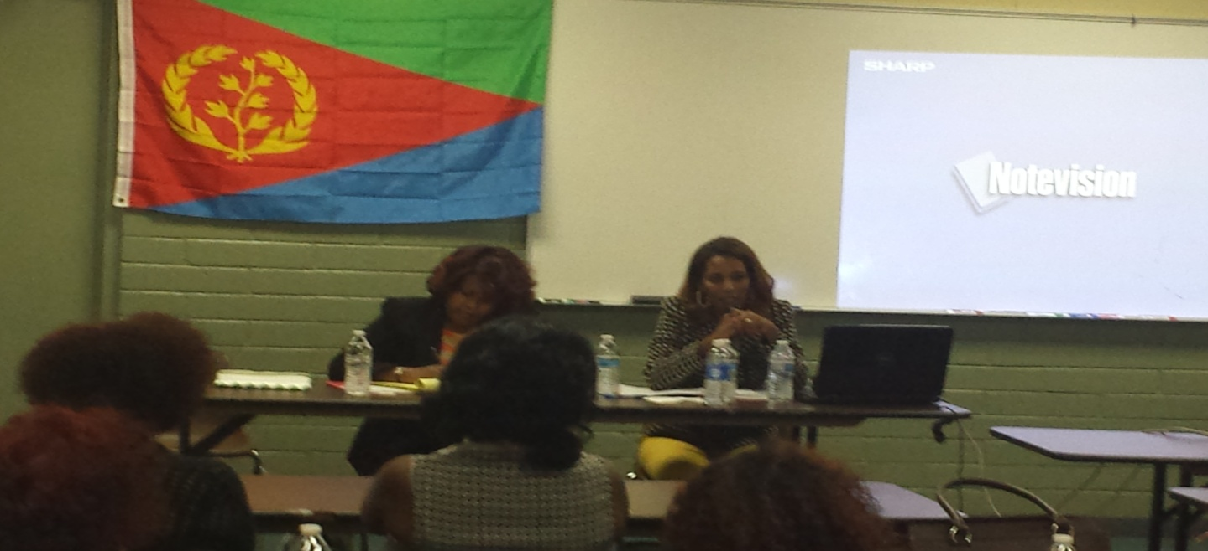

Speaking at the meeting in which higher Eritrean Women participation was witnessed, Mr. Abdurrahman Mohamed Nur, chairman of the PFDJ in Phoenix committee for popular resolve against external conspiracies, indicated that the seminar is aimed at raising communal organizational capacity and keeping intact united nationals as well as cultural values.
Guest speakers Mrs. Hadnet Keleta Executive Mekete committee of North America and YPFDJ and Mrs. Aster Tesfagaber Executive Committee of NUEW of south west USA gave detailed briefing focusing on the Diplomatic, relations with neighboring countries, Economy, organization’s activities at global, continental and local level and its future plans.
Furthermore, The meeting witnessed the conducting of seminars focusing on essence of the concept of human rights vis-à-vis the UN and its mission, as well as the issue of culture in light of the Eritrean identity.
The participants of the meeting expressed appreciation for the sustainable development accomplishments being registered in the Homeland, and reiterated readiness to mount participation for the realization of the cherished development and diplomatic goals.
On this occasion, the National Union of Eritrean Women formed in Phoenix Arizona and conducted a successful election of executive committee, public relations and Cultural values.

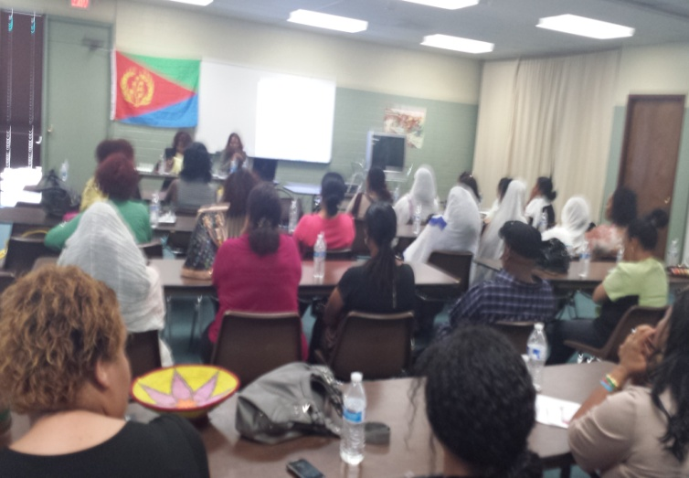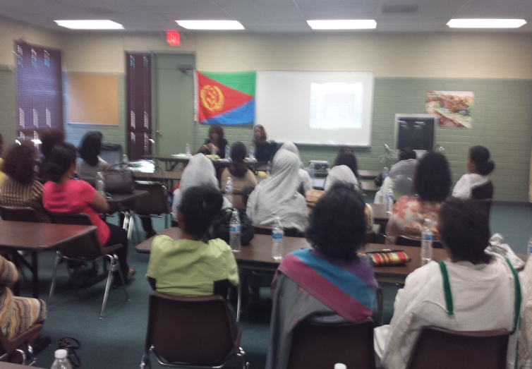
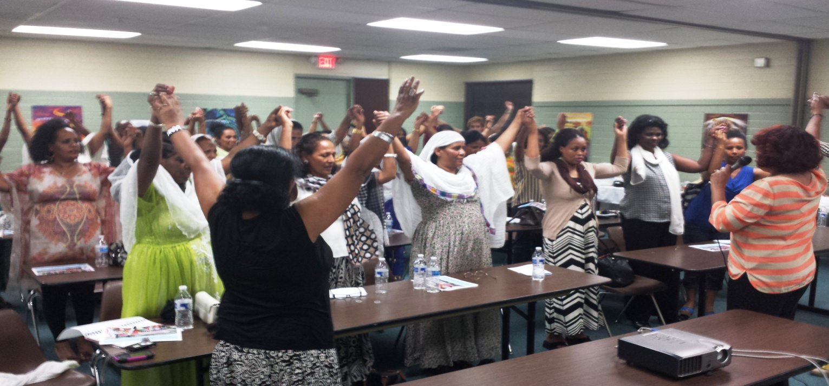

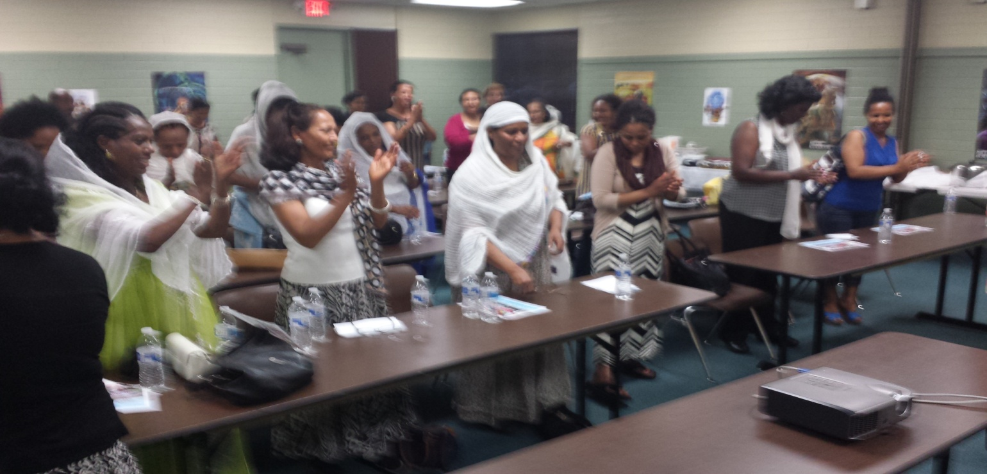

ዓወት ንሓፋሽ !!النصر للجماهير

PFDJ chenfer Phoenix Arizona USA.

