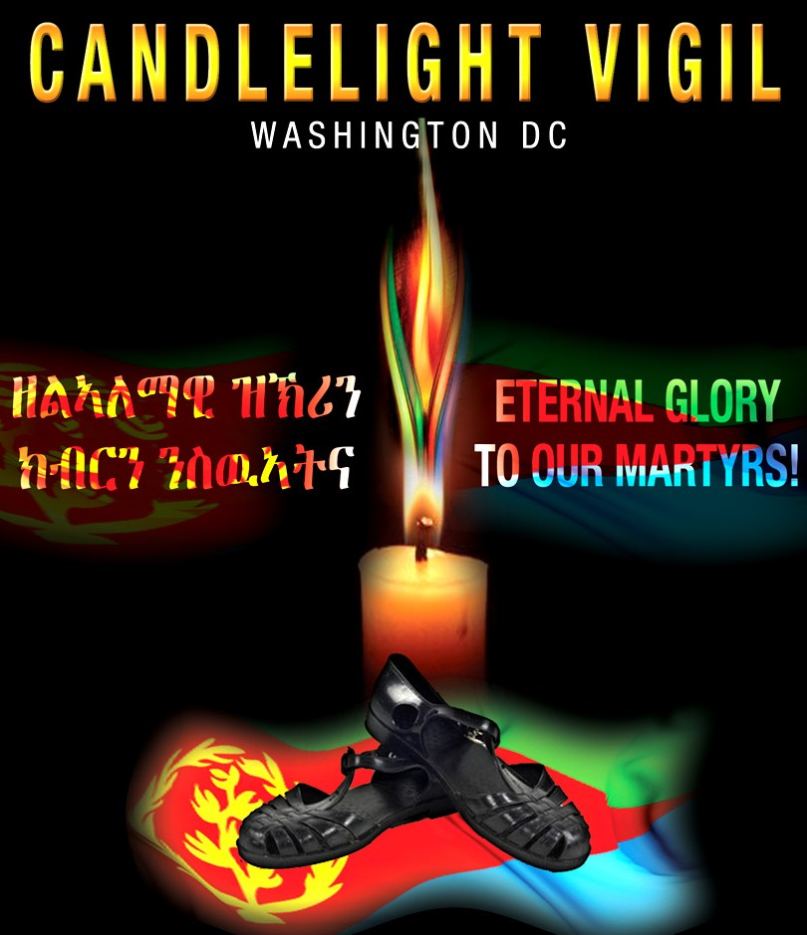
JUNE 20TH 2014
6:00 TO 9:00PM

SYLVAN THEATER
15TH & INDEPENDENCE AVENUE, SW
WASHINGTON, DC

