West and mainstream media are creating its own monsters in the diaspora communities. A dangerous political game in the long-run!
July 17, 2014 Posted by: admin

West and mainstream media are creating its own monsters in the diaspora communities. A dangerous political game in the long-run!
Nowadays we are witnessing the term “human rights” are given a whole new meaning by those so called human right activists (hooligans) who propagate, preach and advocate for “democracy”, “freedom of expression” and “Human rights”.
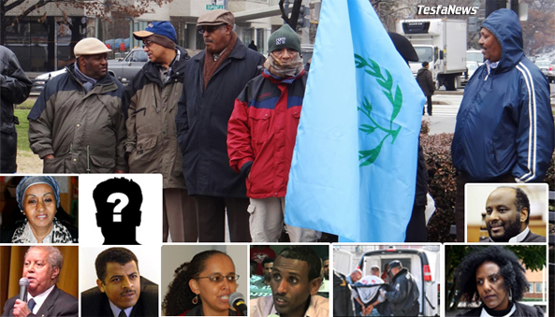
We have learned that the same legitimate Human Rights Organizations, in the diaspora communities mobilizing a group of individuals which is preferably profiled criminals, people from the bottom of society or socially excluded individuals, labeling them as “Pro-democracy activists” or “Human Rights Activists” assist the organization they represent with funds and resources to win a certain predetermined politically motivated purpose /violence.
Reportedly in the west countries those hooligans have already cost taxpayers millions. Recent we have witnessed the arson, assault in the Eritrean communities in Sweden and vandalism of miscellaneous Eritrean community center facilities around the world. This primitive actions was executed by the same hooligans carrying out case for organizations who are presenting themselves as human rights defenders. How can this brutal terrorist act be justified by Human Rights Organizations?
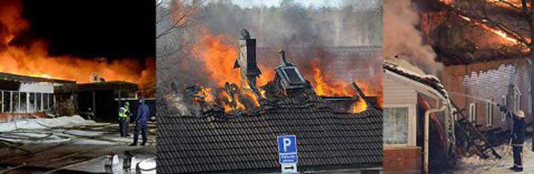
Interesting that the same Human Rights Organizations advocating for “Human rights” counteracts its own purpose and principles, by searching, mobilizing & supporting individuals and groups which are profiled criminals and hooligans in the diaspora communities.
Past experience has taught us that this criminals who lives in the diaspora, will not make any significant impact concerning Eritrea’s political road map and the nation building process in Eritrea. They may possibly prolong the development and reconstruction of the country! But nothing else!!! And Eritrea know very well how to deal with this kind of criminals reated by the west and supported by mainstream media! 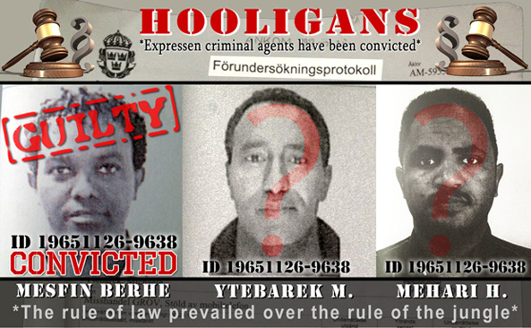

In the long , what makes this crime and behavior as social phenomenon problem and a very dangerous game is, those individuals and groups lives and acts in the western countries. And the question is, are we in west prepared to deal with those hoodlums? When they turns against their clients (Uncle Tom) agenda or become an uncontrollable monsters. Because this is exactly what we are preparing to create today and there is no doubt that this day, when things will go out of control will come!
Zero tolerance
