UNAIDS 2014: Eritrea’s Continued Progress in Combatting HIV/AIDS

Written By Admin on Jul 16, 2014 | 1:09 PM
1 comments

UNAIDS 2014: Eritrea’s Continued Progress in Combatting the HIV/AIDS Scourge

Fikrejesus Amahazion
fikrejesus87@gmail.com
Wednesday July 16th, 2014
According to UNAIDS, Sub-Saharan Africa (SSA) remains the region most heavily affected by the HIV/AIDS epidemic. Specifically, of the 35 million people living with HIV, 25 million are living in SSA, and the region accounted for 74% of all the people dying from AIDS-related causes in 2013.¹ However, amidst these stark figures and though HIV/AIDS remains one of Africa’s most significant public health challenges,² significant progress has been made. For example, prior to 2001, HIV/AIDS treatment in Africa was nearly nonexistent; yet, now some 86% of people living with HIV who know their status in SSA are receiving antiretroviral therapy (ART), and nearly 76% of them have achieved viral suppression.³
While many countries – both in SSA and around the world – have shown significant progress in combatting HIV/AIDS, Eritrea’s strong record battling HIV/AIDS stands out positively. Located in the fractious Horn of Africa, Eritrea is on pace to achieve the UN’s Millennium Development Goal related to combatting HIV/AIDS, malaria, and other diseases.⁴ Further, its HIV-related figures are distinguished as amongst the best, both within the region and comparatively across the continent (see Table 1 and Table 2).
Table 1

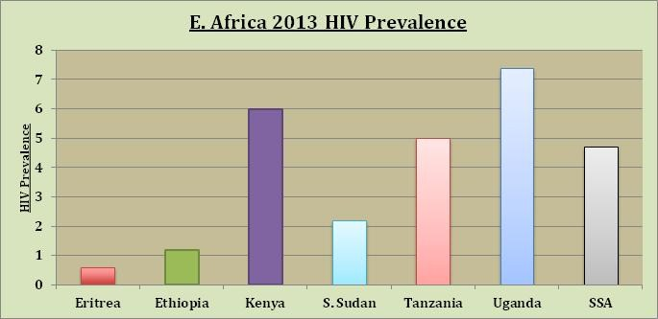
*Source: UNAIDS 2014 (Prevalence amongst 15-45 year olds)
Table 2
Percentage Decline in AIDS-related Deaths (2005-2013)

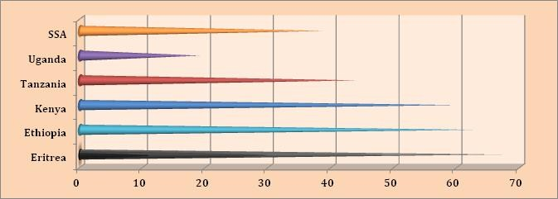
*Source: UNAIDS 2014
Eritrea’s success in combatting HIV/AIDS is founded upon multisectoral approach that also involves the targeting of harmful societal behaviors and traditions. The country has: targeted traditional and patriarchal stereotypes and practices - banning child marriage⁵ and FGM/FGC⁶; focused on improving gender equality and decreasing the burden of poverty borne by women; and sought to reduce stigma and discrimination. Further, community awareness programs have been vigorous and effective in the social marketing of condoms, communicating safe practices, offering educational programs, and providing youth or peer counseling.
The country’s commitment to the health of citizens living with HIV/AIDS is also clearly illustrated by considering the national provision of antiretroviral therapy (ART). ART helps to avert HIV/AIDS related deaths, while being a critical factor in driving down the rate of new infections.⁷ Like its other HIV/AIDS-related figures, Eritrea’s ART coverage stands out positively in comparison with SSA or its regional neighbors (see Table 3).
Table 3
Percentage of Adults with HIV receiving Antiretroviral Therapy (ART) - 2013

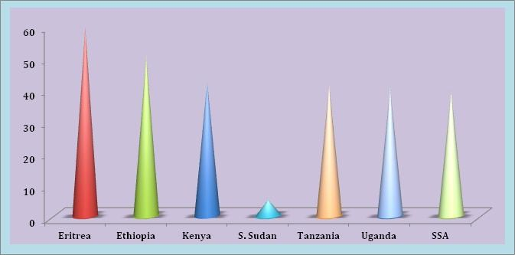
*Source: UNAIDS 2014
Overall, considering its figures in the context of its various socio-economic, development, and regional challenges or in comparison to other countries throughout Africa, Eritrea’s success becomes particularly striking. Potentially serving as a model for Africa, Eritrea’s HIV/AIDS success also illustrates what can be achieved with a self-reliant approach, a capacity to adapt, effective coordination, and cost-effective projects.⁸
At the same time, the potentially devastating consequences posed by HIV/AIDS – in terms of severe human toll and national developmental disaster – mean that Eritrea has little room for complacency. Rather, the country must continue to augment its existing programmes and further promote effective initiatives and interventions in order to control and reduce the harmful impact of HIV/AIDS.
References
_______________________________________
1http://www.unaids.org/en/media/unaids/contentassets/documents/unaidspublication/2014/UNAIDS_Gap_report_en.pdf
^{2{LINK}}
3http://www.unaids.org/en/media/unaids/contentassets/documents/unaidspublication/2014/UNAIDS_Gap_report_en.pdf
^{4 a) {LINK} and b) {LINK}}
^{5{LINK}}
6 Proclamation 158/2007: A Proclamation to Abolish Female Circumcision. Available at: {LINK}
7http://www.unaids.org/en/media/unaids/contentassets/documents/unaidspublication/2014/UNAIDS_Gap_report_en.pdf
^{8{LINK}}
UNAIDS. 2014. The Gap Report. Available at: http://www.unaids.org/en/media/unaids/contentassets/documents/unaidspublication/2014/UNAIDS_Gap_report_en.pdf
Read more: http://www.madote.com/2014/07/unaids-2014-eritreas-continued-progress.html?utm_source=feedburner&utm_medium=feed&utm_campaign=Feed%3A+madote%2FoFqt+%28Eritrea%29#ixzz37fZr0pi4

