Part 2-1

Seasonal Greetings and a personal brotherly message to all Hagerawyan Eritreans at home and in diaspora

https://www.youtube.com/watch?v=WHw1JR8LtAI

Again, I wish you a happy Milad un Nabi (Nebyu Mohammed’s birth day “peace upon on him”), a merry X-mas and a fantastic new year.
2015 nay selamn lmatn amet yigberelna!!!(Amen)

https://www.youtube.com/watch?v=oj7kLD2XrgI

Hade kem teshuate, teshuate kem hade /hade hzbi hade lbi and hade kem sh h!!!
Adi lewah, adi fKri and adi jeganu plus adi kbri. Adi copper, adi potash and adi worKi!!! More wealth to come!!!(Insh-Alah)
Habtam adey Gemgem bahri!!!

Zelalemawi zkrin, kebrin mogesn to our ancestors!!!
Zelalemawi zkrin, kebrin mogesn to semaetna!!!
kbrn mogesn nhagerawuyan(back home and diaspora)!!!
kbrn mogesn to Eritrean defence forces!!!
kbrn mogesn to mahbere deK -anstyo!!!(Back home and diaspora)
kbrn mogesn nyoung PFDJ!!!
kbrn mogesn nhagerawi Eritrean communities including various committees in diaspora!!!
kbrn mogesn nconsulars and Eritrean embassies(diplomatic missions) !!!
kbrn mogesn nhzbawi gnbar!!!
kbrn mogesn to all our jeganu leaders!!!
Kbrn mogesn to Lion of NaKfa, kbur president Esaias Afewrki!!!
Kbrn mogesn to all the Hafash!!!
Kbrn mogesn to athletes (cycling and cross country runners)

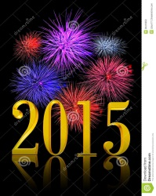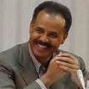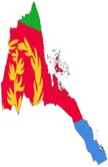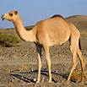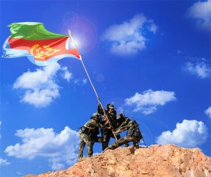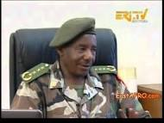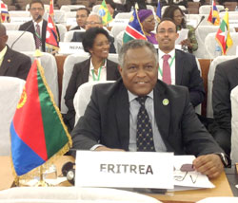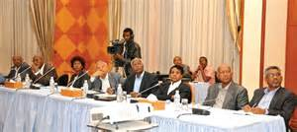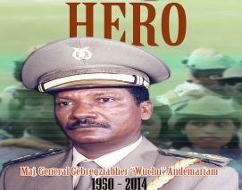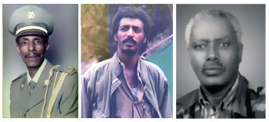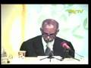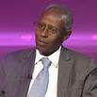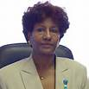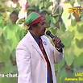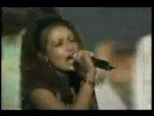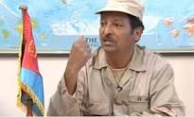
& PICTURE OF ALL HAGERAWUYAN and ERITREAN

Awot Nhafash!!!
Eritrea for ever!!!

Tsehaie Gmariam

