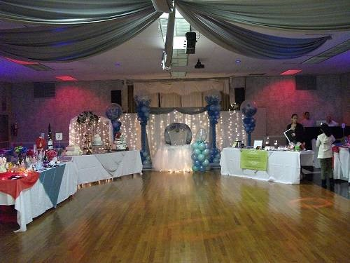
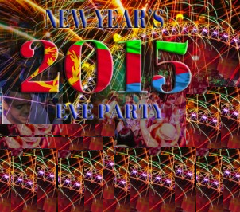
New Years Party in New York City
Asmara Ballroom
2165 Powell Avenue
Bronx, NY 10462

