Part 1

Seasonal Greetings and a personal brotherly message to all Hagerawyan Eritreans at home and in diaspora
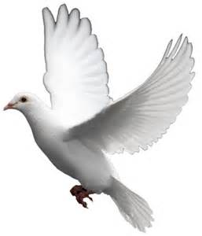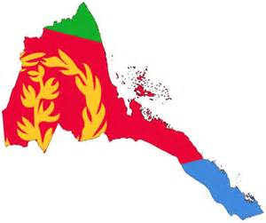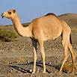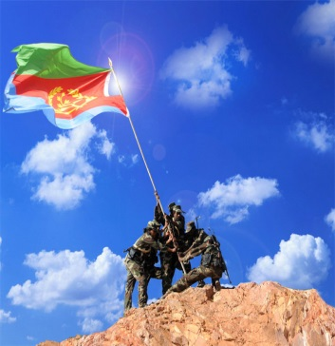
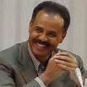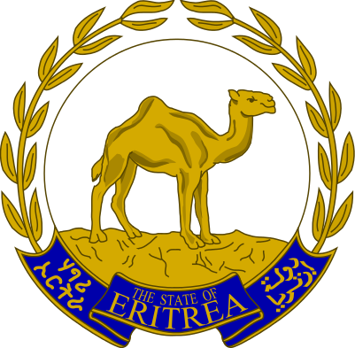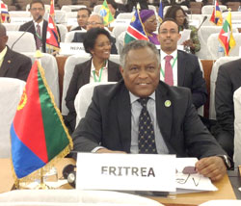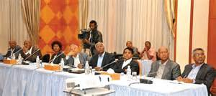

I wish you a happy Milad un Nabi (Nebyu Mohammed birth day peace upon on him), a merry X-mas and a fantastic new year.2015 nay selamen nay l-emeatn yigberelna.

Please allow me to remember all our heroes we lost this year.
BSot |”Thank you” all, for your service and rest in peace.

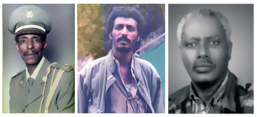

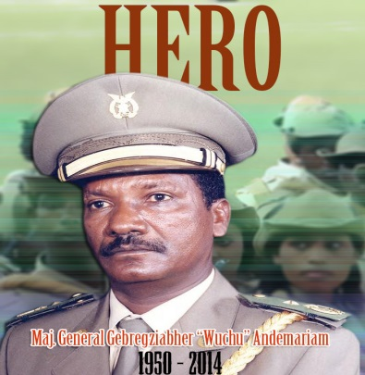

Our hero, General Wuchu, (wed Ere) one of our greatest military tactician and strategist ever who defeated the huge African army and super powers plus who saved our nation from protracted and unleashed repetitive ( un heard of in world’s battle field (war history), a nasty human wave attack by the fengi regachs.
Sir, mission accomplished. Now you are discharged from your position with greatest heroism and honours. Kbur General, during this holy day season, here we go my salute to you till I get a chance to visit you at your new home.
Sir, please pass my greetings to Indris Awote, aboy Wolde ab WoldeMariam and to all our all jeganus we lost during libation and mekete war.

Hagerawyan, what do you think, if we raise some money to our heroes young kids for their college fund and a gift to their families for this holy day season?

Awot Nhafash!!!
Eritrea for ever!!!

Tsehaie Gmariam

