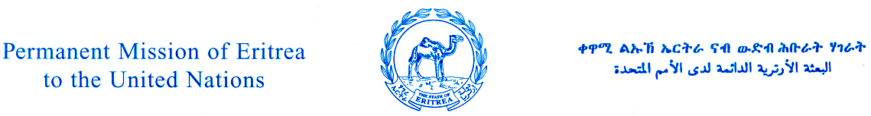

800 Second Avenue, 18th Floor ▪ New York, NY 10017 ▪ Phone: (212) 687-3390 ▪ Fax: (212) 687-3138

VACANCY ANNOUNCEMENT

The Permanent Mission of Eritrea to the United Nations is inviting Eritrean national applicants suitably qualified for the post of a Finance Officer.

Title: Finance Officer

Duty station: New York City

Date for entry on duty: As soon as possible

Deadline for applications: 15 December 2014

Qualifications required: Associate degree in Accounting or Finance with, at least, 3 years experience or a High School Diploma with a minimum of 7 years work experience in accounting and/or finance. Good knowledge of computer software (MS Word and Excel) is a must. Knowledge of Tigrinya or Arabic is a plus.

Principal duties: Under the supervision of the Deputy Permanent Representative, the Finance Officer is expected to perform the following tasks:

- Handle all financial matters of the Mission (receipts and payments);
- Prepare and submit draft annual budget to the Deputy Permanent Representative;
- Ensure that expenditures are in line with the approved budget and submit periodic reports for submission to Asmara;
- Reconcile bank statements, monthly;
- Maintain proper financial records and safeguard them;
- Make timely payments for approved invoices;
- Deposit all receipts as soon as they are received;
- Pay staff salaries on time;
- Consult and ensure that any written agreements of financial nature between the Mission and other party(ies) are signed by the Deputy Permanent Representative;
- Attend UN Administrative and Budgetary meetings;
- Perform other duties assigned by his/her superior.

Salary: Negotiable on the basis of qualification and experience. Support is provided for income tax obligations to the United States or any other government.

Please fax recent CV, including telephone numbers, to the Permanent Mission of Eritrea to the United Nations, Fax # (212) 687-3138. Only qualified short listed candidates will be notified and invited for an interview.

