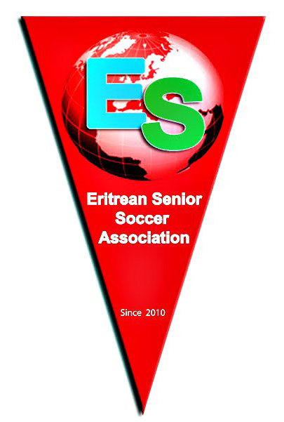
4th Annual North America Eritrean Seniors Soccer Tournament
2013 - Toronto

Tuesday, August 13, 2013

To All Eritrean Teams, Soccer Fans and Families:

For the first time in 4 years the Eritrean Seniors’ Soccer Tournament will leave Atlanta to be held at the beautiful city of Toronto, Canada, on a Labour Day weekend.

All soccer fans, youth and families are cordially invited to participate at this annual event which promises to be another exciting and fun filled tournament.

The festival like tournament will take place at Earls Court Park 1369 St. Clair Avenue West, (Lansdowne and St. Clair Avenue West).

Follow the link below.
https://maps.google.ca/maps?q=1369+st+clair+avenue+west&ie=UTF-8&hq=&hnear=0x882b340deafb530b:0xbafb614a1468b192,1369+St+Clair+Ave+W,+Toronto,+ON+M6E&gl=ca&ei=iMYcUr-wJYGwyQHL74HICA&ved=0CCoQ8gEwAA

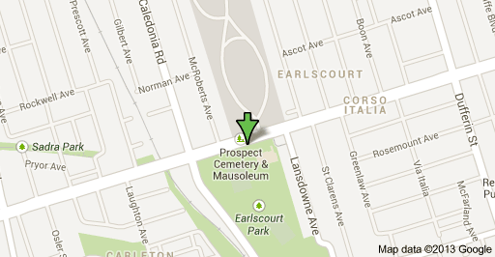
Hotel Reservation:

THE WESTIN BRISTOL PLACE TORONTO AIRPORT
950 Dixon Rd
Toronto, Ont.
M9W- 5N4
Phone: 416.675.9444

Below you will find the Reservation link for your participants to access the site:
(OR copy and paste the following link into a web browser)
https://www.starwoodmeeting.com/StarGroupsWeb/res?id=1307307343&key=3E2BC

Friday August 30th, 2013

8PM Dinner at Pero’s Lounge

Saturday August 31st, 2013

11AM – 7:30PM Soccer Tournament
8:00PM Dinner at Asseb Restaurant

Sunday September 1st, 2013

10AM – 12PM Kids Soccer Tournament
12PM – 7:30PM Seniors Soccer Tournament

There will also be BBQ at the park all day Sunday

9PM – 10:30PM Award Ceremony at Uhuru Hall
10:30PM – 3:00AM Celebration Night (Music) at Uhuru Hall - DJ Mebrahtu Ghebray

SPONSORS
ASSEB RESTAURANT
KIBREAB WENDEM

814 Bloor W, Toronto, ON M6G 1L9 ‎
(416) 535-8287

Follow the link below.
https://maps.google.ca/maps?ie=UTF-8&q=asseb+restaurant+toronto&fb=1&gl=ca&hq=asseb+restaurant+toronto&cid=0,0,9630460955288769853&ei=Dx4dUrX9HIPs2QXelYHICQ&ved=0CIcBEPwSMAs
ULTRA PHARMACY
ASGODOM TEWOLDE

411 Parliament, Toronto, ON M5A 3A1 ‎
(416) 323-0055

Follow the link below.
https://maps.google.ca/maps?q=411+parliament+street&ie=UTF-8&hq=&hnear=0x89d4cb45dfb09eb3:0xbc2e9086632ec360,411+Parliament+St,+Toronto,+ON+M5A+3A1&gl=ca&ei=0_kcUqaIDovW2QWnxIH4BA&ved=0CCwQ8gEwAA

RE/MAX WEST REALTY Inc. Brokerage
YORDANOS SOLOMON
Broker
Independently owned and operated

1678 Bloor Street West, 4th Floor, Toronto Ontario, M6P 1A9
416.951.8301

Follow the link below.
http://www.ysolomon.remaxwest.com/

UHURU BAR
ZEKARIAS/ARAYA

380 Oakwood Ave, Toronto
416.652.6594

Follow the link below.
https://maps.google.com/maps?hl=en&authuser=0&ie=UTF-8&q=uhuru+bar+toronto&fb=1&hq=uhuru+bar+toronto&cid=0,0,5114630897595828057&ei=gf4cUsvOHMjoqwH-r4HgAw&ved=0CJwBEPwSMAs

MICE AT WORK
TEFERI TEWELDE

1600 Eglinton West
Toronto, ON M6E 2G8 ‎
(416) 782-5959

Follow the link below.
https://maps.google.ca/maps?ie=UTF-8&q=mice+at+work&fb=1&gl=ca&hq=mice+at+work&cid=0,0,13115097354190537204&ei=-CAdUo60M-LH2QWSw4GwDA&sqi=2&ved=0CJUBEPwSMBA
PERO RESTAURANT
PERO

812 Bloor Street West
Toronto, ON M6G 1L9
(416) 915-7225

Follow the link below.

www.perorestaurant.com‎

MEDEBER
Variety Store
Mebrahtu Ghebray

296 Concord Ave,
Toronto ON M6H 1L2 ‎
(416) 854-8084

Follow the link below.

https://maps.google.ca/maps?hl=en&tab=wl

EST SPORTS BAR
KIBROM GAYM

926 Bloor Street West
Toronto, ON M6H 1L4
(416) 535-6457

Follow the link below.
https://maps.google.ca/maps?ie=UTF-8&q=est+sports+bar+toronto&fb=1&gl=ca&hq=est+sports+bar+toronto&cid=0,0,17606001138507695439&ei=Wy8dUqP_AeWw2gX-v4HYBQ&ved=0CJABEPwSMAs

BF Auto Sales
Ontario's quality used car dealership
FETSUM ZERAY
General Manager
3500 Danforth Ave.
Toronto, ON M1L 1E1
Cell 416-817-6855
Sales 416-304-1261

Follow the link below.

http://www.bfauto.ca/
FRETA INJERA
FREWEINI

831 Bloor St West
Toronto, ON M6G 1M3

(647) 342-5355

Follow the link below.

http://www.yelp.ca/map/freta-enjera-toronto

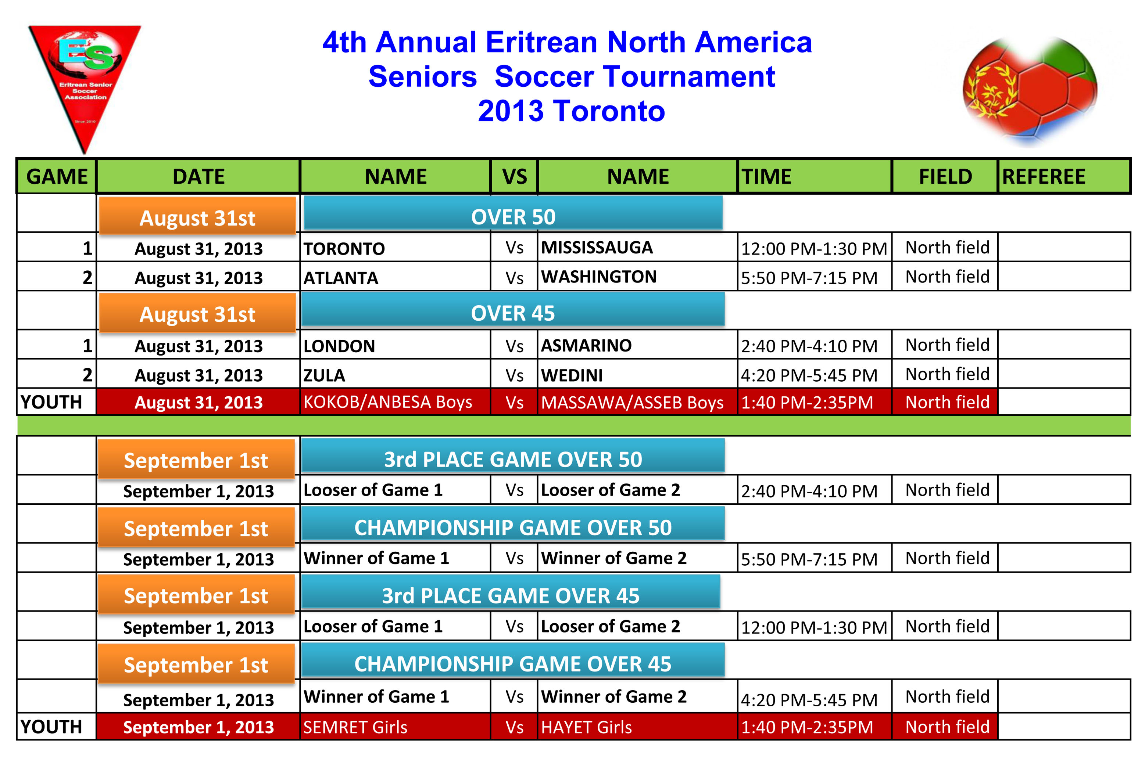

Have a great Tournament.

