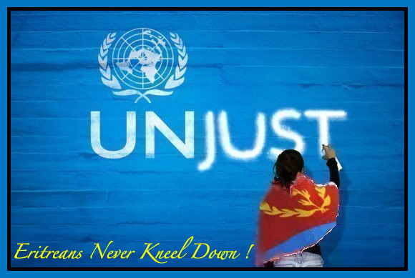
The creed of justice
The notion of a silent guardian that watches over all
Is what the United Nations claim to be.

But this is more of a synthetic identity for the United Nations.
The aspirations of this syndicate are more
crude and perverted than anything ever seen before.

How can you claim to be a savior?
When you try to disintegrate the achieved?
There is no profound reason or explanation
for this corrupt scandal but the truth.

The United Nations a server of the interest and the selfish.
An organization with no virtuous and noble beliefs.
To bring a people down.
To live on the harassment of the weak
is a mere description of your actions.
The claims you have made to my beloved country Eritrea
have been enough as they are foolish comets.
That aims for a destination but stop their journey.
You are hasty to accuse but slow to the mind
as any sane person would know not to fool the truth.
Eritrea a country pulled out of the fire to rise again for us to aspire.
But anyone knows that to try to bring this down
is as horrible an action as ignoring a problem.
You claim to be a solution factory
but all I see produced is an instigator of conflicts.
What interests me is not the fact that you try to mold down my dear Eritrea.
But the fact that you think you can for the good hearted
will always defeat the morally weak.

