Virginia Election
This year’s festival was one of the best we have seen recently. It was well organized and the attendance was very high. We saw some vendors with customary materials to be sold. I will not pass without thanking the ENHOC-DC committee for a job well done.
At the festival there was also information and voter registration desk organized by Organization of Eritrean Americans and “Eritreans for Terry McAuliffe”. At the desk was volunteer Alex Tekie giving out information and registering Virginia voters and was also collecting email addresses of voters and supporters. Terry McAuliffe is the democratic candidate for Virginia gubernatorial race.
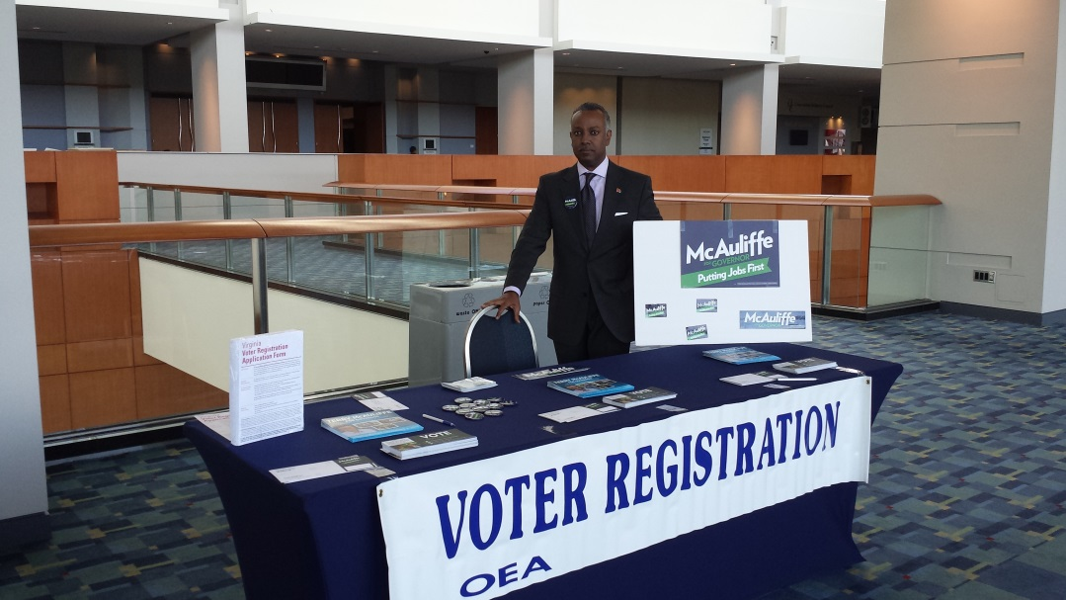
(Picture Alex Tekie)
Terry McAuliffe is s a businessman, entrepreneur, a husband and father. Terry McAuliffe knows what it takes to build a strong economy and keep Virginia's families safe and strong. But he can't get the job done without our help. We need to support him beginning now.

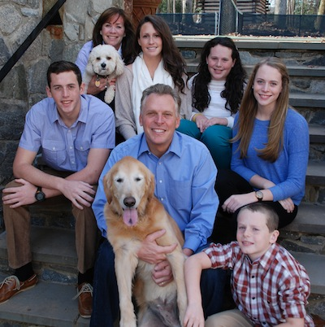

Members of Eritrean community from different organization held round table meeting with Terry in May and discussed issues that are important to our community. He is aware of the community’s need and aspirations. We also gave him our commitment to his campaign and election to the highest office in the State of Virginia.

We now have only two months and a half to make a difference in this campaign to get Terry elected. We are going to do fund raising soon and we need the cooperation of all Eritrean Americans in Virginia and beyond.

Habteab Gabriel

