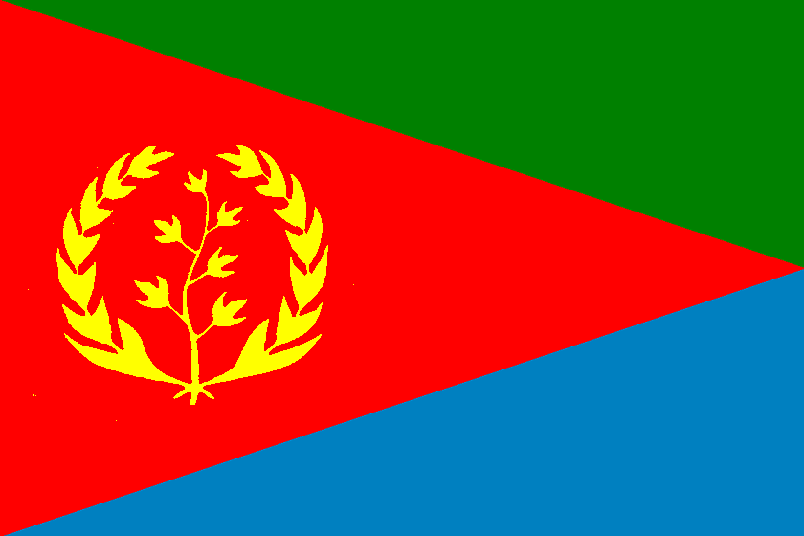

*Community picnic*

*Sunday August 4th 2013*

*Bus Departs*

*9AM AND 11AM*

*Meet @ 346 Hargrave Street*

* Eritrean Community in Winnipeg