Eritreans, Eritrean-Americans and friends in Minnesota Honors Eritrean Martyrs who fallen in the struggle for Eritrea’s independence and national sovereignty.
Following the defeat of Ethiopian government forces in 1991, the government of Eritrea declared June 20 to be an official holiday remembered to pay tribute to all Eritreans who fall in the struggle for Eritrea’s liberation.

The 30 years of struggle claimed the lives of 65,000 freedom fighters and tens of thousands of civilians. In addition, the 1998 war between Eritrea and Ethiopia claimed the lives of 20,000 Eritreans. So June 20 is a Memorial Day of the 85,000 and more lives that Eritreans sacrificed to gain their independence and secure their sovereignty from different wars of colonization and aggression.

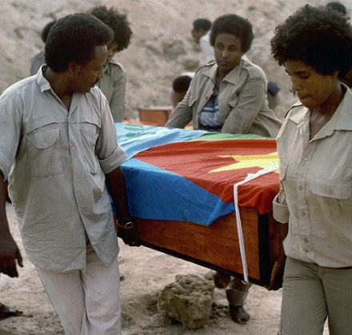

Inside Eritrea, the day is remembered by different activities that reflect the history of the martyrs and year to year people walk to the martyrs’ parks to show their respect and renew their pledge to support the families of the martyrs and build Eritrea.
Here in Minnesota, Eritreans, Eritrean-Americans and friends assemble at the Eritrean Community Center to pay tribute to the martyrs and support their families. They honor the day by doing cultural and artistic shows that reflect the history of the martyrs. The attendees present poems and songs. Some people walk miles from different neighborhoods to the community center. At the community center, food and beverages is provided to everyone.

People of all ages including children donate money that goes directly to the martyrs’ fund, and adults pledge to sponsor families of the martyrs. The National Holidays Organizing Committee of Minnesota is in charge of preparing and leading the program. The contribution of all Eritrean public organizations in the twin cities is amusing. All of them participate in the activities and contribute their gracious to shine the Memorial Day. The role of YPFDJ demonstrates the fact that Eritrean history is sustaining from generation to generation.

Eritreans have strong attachment with their war heroes because the sacrifice paid is tremendous and beyond imagination. Unlike almost all African nations who got their independence by political declarations, the people of Eritrea paid tenth of thousands of lives to get their independence. So when we talk about Eritrean martyrs Memorial Day, we are talking about the transfer of Eritreans from colonization to independence, from war to peace, and from poverty to prosperity as well as global peace and coexistence.

On June 20, all Eritreans, Eritrean Americans and friends show their re-determination and rededication to build a peaceful and prosperous Eritrea that is worthy of the sacrifices paid.

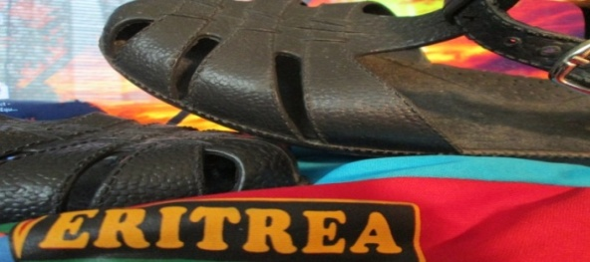

Here in the twin cities, like all Eritreans throughout the world, Eritrean citizens of Minnesota and friends assemble at the Eritrean Community Center, 1935 University Ave West, to perform a candlelight watch/vigil that meant that the martyrs sacrificed their lives to give us lasting peace and light: our independence and freedom.

And we have a national obligation to support their families and build a peaceful, united and prosperous Eritrea that live in harmony with its neighbors and the world.
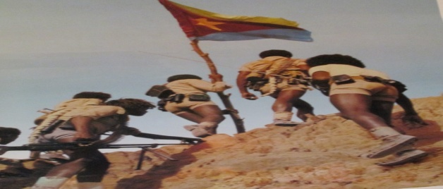
We wish glory and eternal memory for all those who sacrificed and scarify their lives for world peace, coexistence, and prosperity.
Eritrean Americans in Minnesota: June 20, 2013.

